Spaceship Titanic
Config-driven data science pipeline for high-fidelity industrial domains.

Field | Value
Domain | auto - Generic / Auto-detect (any tabular dataset)
Generated | 2026-09-29 01:31 UTC
Target | Transported
Task | classification
Data source | backup\spaceship\train.csv
Records x columns | 8693 x 14
Audit SHA-256 | 80b6a9cecb8433c77be0dd7f0622a557016e500d06ccee4e5cdcc490a2682f50

Contents
Right-click here and choose 'Update Field' to build the table of contents.

Executive Summary
Resident AI offline - a local summary follows instead.
- project: Spaceship Titanic
- domain: Generic / Auto-detect (any tabular dataset)
- task: classification
- best_model: LightGBM
- accuracy: 0.7890
- balanced_accuracy: 0.7884
- precision_weighted: 0.7917
- recall_weighted: 0.7890
- f1_weighted: 0.7883
- precision_macro: 0.7919
- recall_macro: 0.7884
- f1_macro: 0.7882
- cohen_kappa: 0.5775
- matthews_corrcoef: 0.5804
Interpretation: review the strongest metric first, then check the weakest one for signs of bias, leakage or under-fitting before trusting the model.

Key Metrics at a Glance
Metric | Value
Best model | LightGBM
Selection metric | f1_macro
Cross-validated score | 0.7953
accuracy | 0.7890
balanced_accuracy | 0.7884
precision_weighted | 0.7917
recall_weighted | 0.7890
f1_weighted | 0.7883
precision_macro | 0.7919
recall_macro | 0.7884
f1_macro | 0.7882
cohen_kappa | 0.5775
matthews_corrcoef | 0.5804
Deployment allowed | False

Data & Methodology
The pipeline ingested 8693 records across 14 columns from backup\spaceship\train.csv.
Target: Transported | Task: classification | Split strategy: group. Numeric features receive robust scaling, categoricals are encoded, and the preprocessor is fitted on the training split only.
- Best model by cross-validated f1_macro: LightGBM.
- Hyper-parameter search improved LightGBM to CV 0.7953.

Exploratory Data Analysis

Statistical moments
feature | count | mean | std | min | 25% | 50%
Age | 8514.0 | 28.8279 | 14.489 | 0.0 | 19.0 | 27.0
RoomService | 8512.0 | 224.6876 | 666.7177 | 0.0 | 0.0 | 0.0
FoodCourt | 8510.0 | 458.0772 | 1611.4892 | 0.0 | 0.0 | 0.0
ShoppingMall | 8485.0 | 173.7292 | 604.6965 | 0.0 | 0.0 | 0.0
Spa | 8510.0 | 311.1388 | 1136.7055 | 0.0 | 0.0 | 0.0
VRDeck | 8505.0 | 304.8548 | 1145.7172 | 0.0 | 0.0 | 0.0

Model Performance

Model leaderboard
model | cv_score_mean | cv_score_std | fit_seconds | accuracy | balanced_accuracy | precision_weighted | recall_weighted | f1_weighted | precision_macro | recall_macro | f1_macro | cohen_kappa | matthews_corrcoef | roc_auc | log_loss
LightGBM | 0.7916 | 0.0026 | 1.26 | 0.7867 | 0.7863 | 0.7877 | 0.7867 | 0.7864 | 0.7878 | 0.7863 | 0.7863 | 0.573 | 0.5742 | 0.8694 | 0.4488
HistGradientBoosting | 0.7909 | 0.0024 | 1.43 | 0.7821 | 0.7816 | 0.7837 | 0.7821 | 0.7816 | 0.7839 | 0.7816 | 0.7815 | 0.5637 | 0.5655 | 0.8702 | 0.4484
LogisticRegression | 0.7889 | 0.0065 | 2.83 | 0.7769 | 0.7766 | 0.7777 | 0.7769 | 0.7766 | 0.7778 | 0.7766 | 0.7766 | 0.5535 | 0.5544 | 0.8623 | 0.4597
XGBoost | 0.787 | 0.0062 | 0.83 | 0.7867 | 0.7864 | 0.7874 | 0.7867 | 0.7864 | 0.7875 | 0.7864 | 0.7864 | 0.5731 | 0.5739 | 0.8647 | 0.4691
RandomForest | 0.7847 | 0.0075 | 4.67 | 0.778 | 0.7778 | 0.7783 | 0.778 | 0.7779 | 0.7784 | 0.7778 | 0.7779 | 0.5559 | 0.5562 | 0.8543 | 0.5787
ExtraTrees | 0.775 | 0.0074 | 2.71 | 0.7711 | 0.7711 | 0.7711 | 0.7711 | 0.7711 | 0.7711 | 0.7711 | 0.7711 | 0.5422 | 0.5422 | 0.8451 | 1.0373

Robustness & Compliance

Deployment gates
Check | Value
boundary_accuracy | n/a
abstention_accuracy | n/a
leakage_rate | 0.0000
gate:performance_pass | False
gate:recall_pass | False
gate:privacy_pass | True
gate:boundary_pass | True
gate:deployment_allowed | False
gate:note | One or more gates failed - hold deployment and review.

Figures

Charts and maps
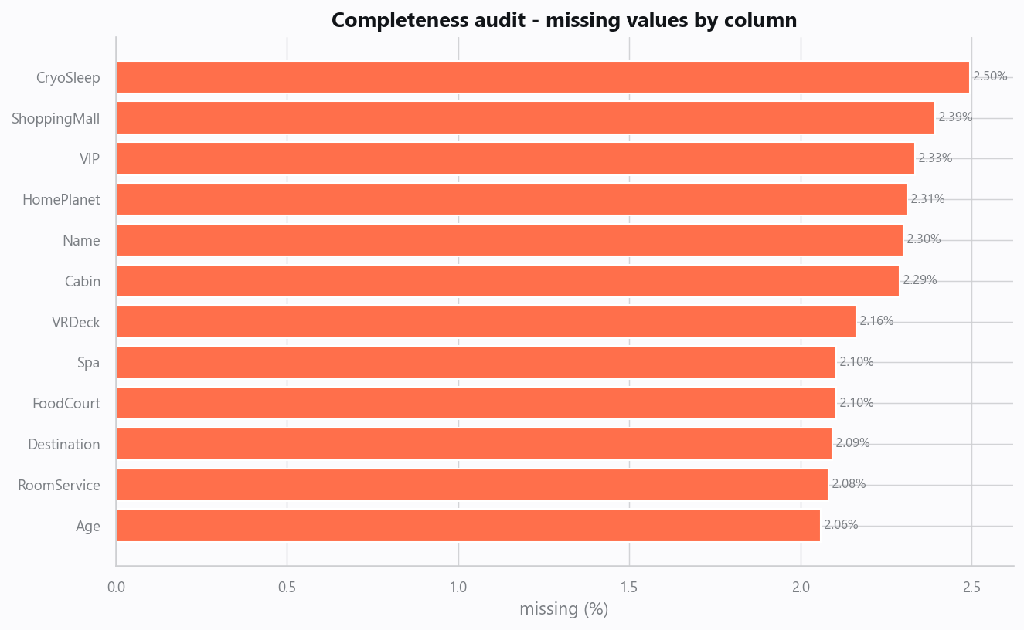
01_missingness.png
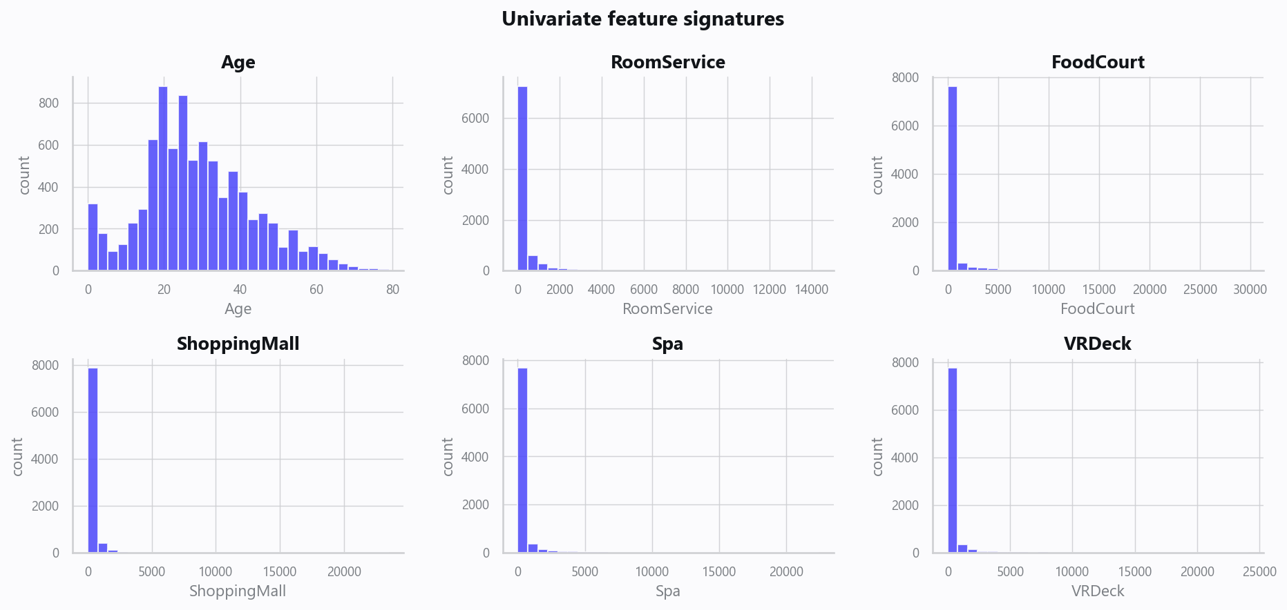
02_distributions.png
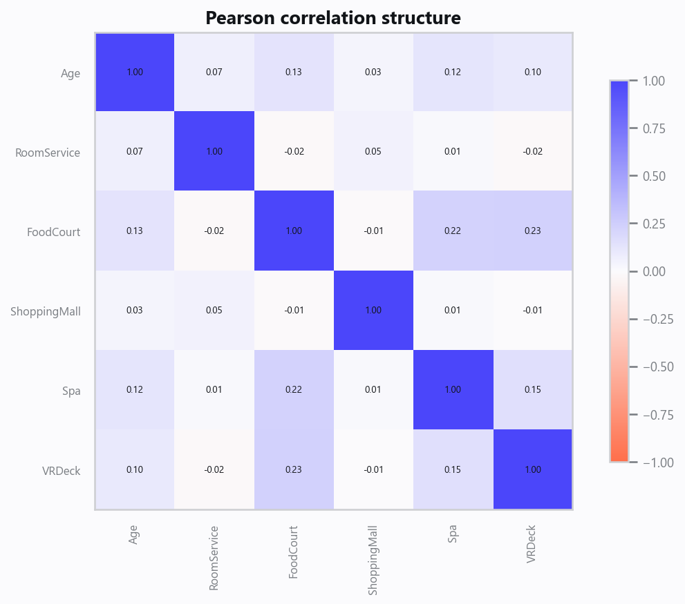
03_correlation.png
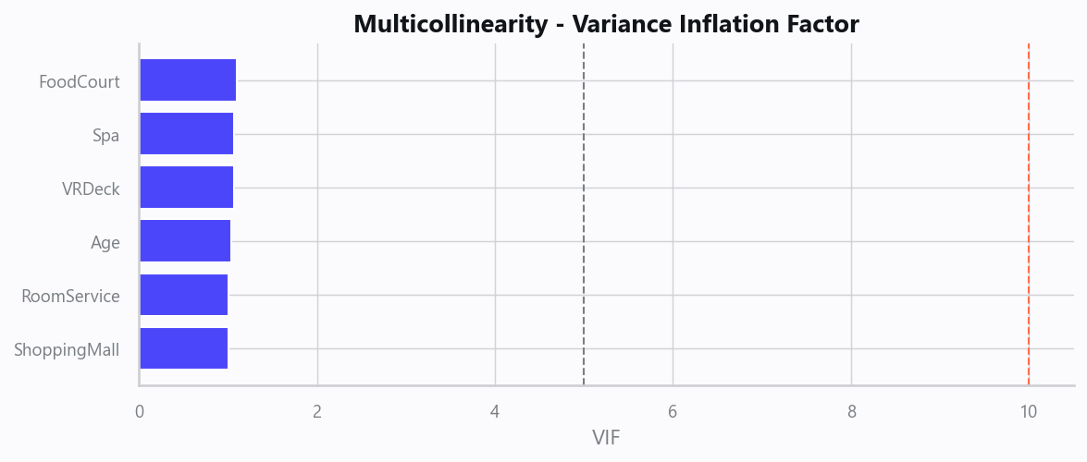
04_vif.png
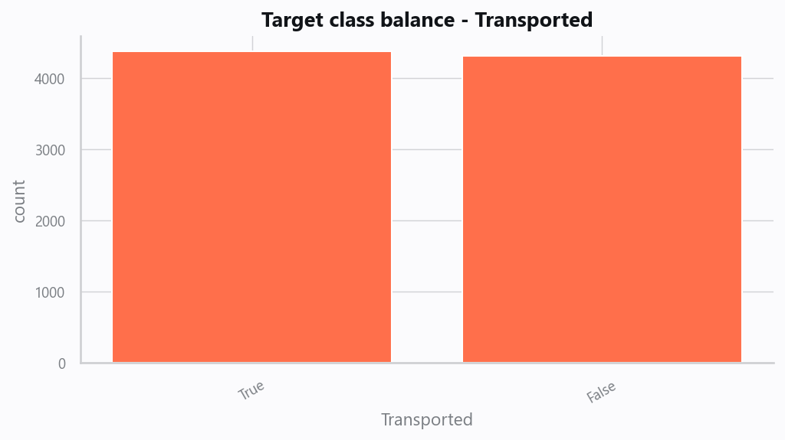
05_target.png
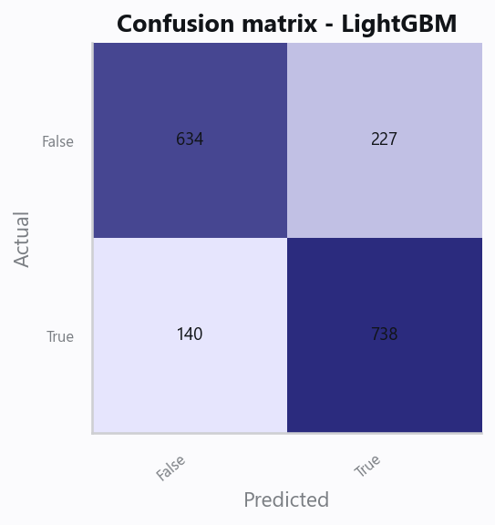
10_confusion.png
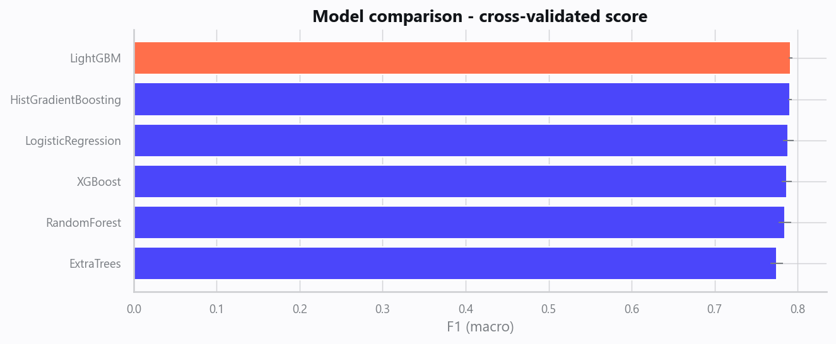
12_leaderboard.png
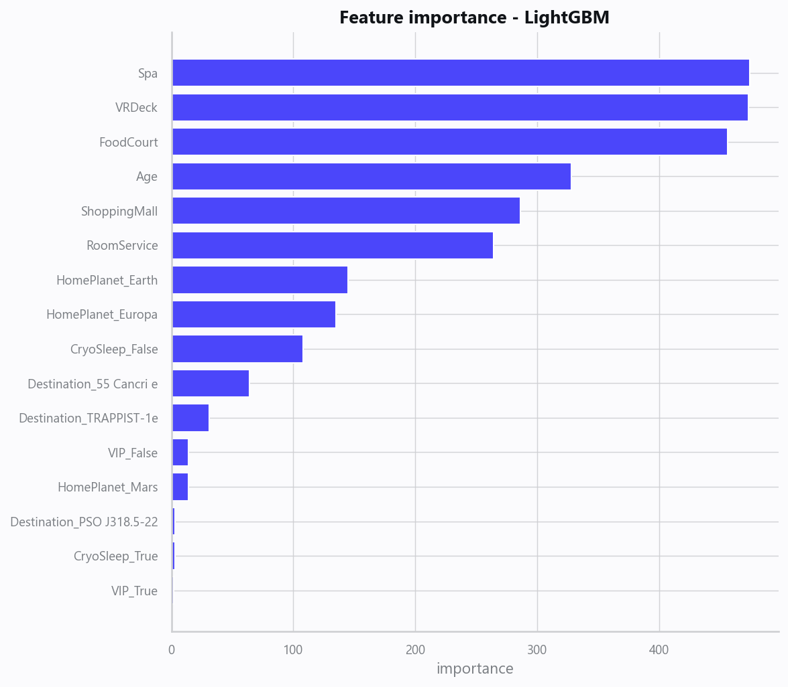
13_feature_importance.png

Limitations, Risks & Next Steps
- Results reflect the data supplied and the assumptions above; validate on a fresh sample before operational use.
- If the input was capped (see the run configuration), re-run with a larger extract to confirm stability.
- Watch for drift over time and re-train on a schedule; keep the versioned rules and audit hash with each release.

Appendix - Run Configuration
Setting | Value
domain | auto
target_column | Transported
max_rows | 0
test_size | 0.2000
cv_folds | 5
split_strategy | auto
enable_tuning | True
enable_deep_learning | False
compliance_mode | True
dataset_format | csv

