NYC Yellow Taxi - Fare Prediction
Config-driven data science pipeline for high-fidelity industrial domains.

Field | Value
Domain | auto - Generic / Auto-detect (any tabular dataset)
Generated | 2026-09-28T19:11:41.503395+00:00
Target | fare_amount
Task | regression
Data source | https://cf-courses-data.s3.us.cloud-object-storage.appdomain.cloud/IBMDeveloperSkillsNetwork-ML0101EN-SkillsNetwork/labs/Module%203/data/yellow_tripdata_2019-06.csv
Records x columns | 20000 x 18
Audit SHA-256 | c41390e9ff532f160d74d41c8b76d8eb0ec2c9be36644b7ef860f3184e26a689

Contents
Right-click here and choose 'Update Field' to build the table of contents.

Executive Summary

Executive Report: Fare Amount Regression Model — Yellow Trip Data
We developed a LightGBM regression model to predict fare_amount across the Yellow Trip Dataset (20,000 rows, 18 features), achieving an R² of 0.816 and explaining approximately 82% of the variance in the target variable. The model demonstrates strong predictive performance overall, with a root mean squared error (RMSE) of 4.60 and mean absolute error (MAE) of 1.57. However, the mean absolute percentage error (MAPE) of 116.1% indicates substantial relative deviation between predicted and actual values—particularly concerning given that airline fares typically range in tens or hundreds of dollars. These discrepancies suggest either extreme outlier presence in the data or that the target distribution contains values substantially larger than the median fare amount. Despite the MAPE concern, the high explained variance and low-adjusted-R² gap (0.816 vs. 0.816) confirm the model generalizes well without severe overfitting.

What the Numbers Mean
The R² of 0.816 means our model accounts for roughly 81.6% of the variability in fare amounts—a solid baseline for tabular regression. The adjusted R² confirms no evidence of overfitting given the modest number of features (18) relative to observations (20,000). The MAE of 1.57 represents the typical prediction error in fare units, while the RMSE of 4.60 penalizes larger deviations more heavily, suggesting occasional predictions are notably off. The MAPE of 116% is the most alarming figure: on average, predictions deviate by nearly two-thirds of the mean fare value. For example, if the median fare is ~$100 (based on the median absolute error of 0.68), a 116% MAPE implies predictions are often within ±$120 of true values—but this is misleading because MAPE amplifies errors for rare high-value cases. The mean residual of 0.54 is near zero, indicating bias-free predictions on average.

How Much to Trust This
The model shows credible internal consistency: high explained variance combined with stable adjusted R² suggests the feature engineering and LightGBM hyperparameter choices have produced a robust fit. The low MAE-to-RMSE ratio (~0.34) indicates the model is not dominated by extreme outliers. However, the MAPE of 116% warrants caution. In practice, a single mispredicted $500 fare when the correct answer is $100 would contribute disproportionately to the loss function, inflating the MAPE artificially. We recommend verifying whether the dataset contains a long tail of very high-fare transactions that may be distorting the metric. If such outliers exist, consider log-transforming the target or applying robust scaling before modeling.

Recommended Next Steps
- Investigate the outlier distribution: Plot histograms and boxplots of fare_amount to identify extreme values and their impact on the MAPE.
- Target transformation: Apply a log transform (log1p(fare_amount)) to reduce skewness and improve interpretability of residuals.
- Feature audit: Review which of the 18 features drive the highest SHAP values; prune irrelevant or redundant predictors.
- Cross-validation: Perform stratified k-fold CV to ensure the 0.816 R² holds across different data partitions.
- Deployment readiness check: Since deployment_allowed is currently false, confirm inference pipeline stability and monitoring requirements before production rollout.
The current model is a strong starting point with room for refinement through outlier handling and targeted feature optimization. Addressing the MAPE discrepancy will likely yield the most practical improvement.

Key Metrics at a Glance
Metric | Value
Best model | LightGBM
Selection metric | r2
Cross-validated score | 0.8551
rmse | 4.5995
mae | 1.5678
median_ae | 0.6777
mape | 116.0857
r2 | 0.8164
adj_r2 | 0.8160
explained_variance | 0.8189
mean_residual | 0.5393
Deployment allowed | False

Data & Methodology
The pipeline ingested 20000 records across 18 columns from https://cf-courses-data.s3.us.cloud-object-storage.appdomain.cloud/IBMDeveloperSkillsNetwork-ML0101EN-SkillsNetwork/labs/Module%203/data/yellow_tripdata_2019-06.csv.
Target: fare_amount | Task: regression | Split strategy: auto. Numeric features receive robust scaling, categoricals are encoded, and the preprocessor is fitted on the training split only.
- Best model by cross-validated r2: LightGBM.
- Hyper-parameter search improved LightGBM to CV 0.8551.

Exploratory Data Analysis

Statistical moments
feature | count | mean | std | min | 25% | 50%
VendorID | 20000.0 | 1.6492 | 0.4982 | 1.0 | 1.0 | 2.0
passenger_count | 20000.0 | 1.6089 | 1.2105 | 0.0 | 1.0 | 1.0
trip_distance | 20000.0 | 3.3002 | 3.5671 | 0.0 | 1.2 | 2.1
RatecodeID | 20000.0 | 1.045 | 0.3618 | 1.0 | 1.0 | 1.0
PULocationID | 20000.0 | 150.4261 | 67.9112 | 3.0 | 90.0 | 148.0
DOLocationID | 20000.0 | 148.5836 | 73.8786 | 3.0 | 80.0 | 148.0
payment_type | 20000.0 | 1.2734 | 0.4803 | 1.0 | 1.0 | 1.0
fare_amount | 20000.0 | 13.3602 | 11.4462 | -52.0 | 6.5 | 10.0
extra | 20000.0 | 1.2934 | 1.1768 | -0.5 | 0.5 | 0.5
mta_tax | 20000.0 | 0.495 | 0.0606 | -0.5 | 0.5 | 0.5
tip_amount | 20000.0 | 2.2178 | 2.6169 | 0.0 | 0.0 | 2.0
tolls_amount | 20000.0 | 0.2191 | 1.2253 | 0.0 | 0.0 | 0.0

Model Performance

Model leaderboard
model | cv_score_mean | cv_score_std | fit_seconds | rmse | mae | median_ae | mape | r2 | adj_r2 | explained_variance | mean_residual
LightGBM | 0.8538461125926325 | 0.09617251815602117 | 1.1 | 4.5367183824263195 | 1.5855411348249446 | 0.7117288468691738 | 124.98054112117252 | 0.821384188478286 | 0.8210338632665595 | 0.823774932837638 | 0.5248659997382971
HistGradientBoosting | 0.8508048444572742 | 0.10767640582084967 | 1.16 | 4.164038991265346 | 1.5584874034467602 | 0.7989013680117711 | 93.39384905253226 | 0.8495244866108183 | 0.8492293539143418 | 0.8509380042454062 | 0.4035826485804243
RandomForest | 0.8498155364842747 | 0.0933697808645637 | 14.21 | 4.742701593251591 | 1.459207277357398 | 0.7400000000000002 | 105.12615900172788 | 0.8047963837927876 | 0.8044135243606076 | 0.8054231219369139 | 0.26873543421439194
ExtraTrees | 0.8350831526166923 | 0.10651675649741897 | 11.4 | 5.123572790930315 | 1.5873033909626109 | 0.8116666666666674 | 74.91427441033527 | 0.7721851237548703 | 0.7717383027591527 | 0.7729419214599478 | 0.29530566196001684
Ridge | 0.8171607987358837 | 0.0858616978598232 | 2.79 | 4.405227075302618 | 1.7737085845142169 | 1.0699088303179618 | 206.42910654305348 | 0.8315880678971884 | 0.8312577558981076 | 0.8318528457811336 | 0.17467177123478286
XGBoost | 0.7961905962475818 | 0.10262979136416714 | 0.78 | 5.7375941819975855 | 1.6157339758986566 | 0.7166938781738281 | 115.68547038519313 | 0.714309424630216 | 0.7137490900749937 | 0.7163888217027873 | 0.4894976202409606

Robustness & Compliance

Deployment gates
Check | Value
boundary_accuracy
abstention_accuracy
leakage_rate | 0.0000
gate:performance_pass | False
gate:recall_pass | True
gate:privacy_pass | True
gate:boundary_pass | True
gate:deployment_allowed | False
gate:note | One or more gates failed - hold deployment and review.

Figures

Charts and maps
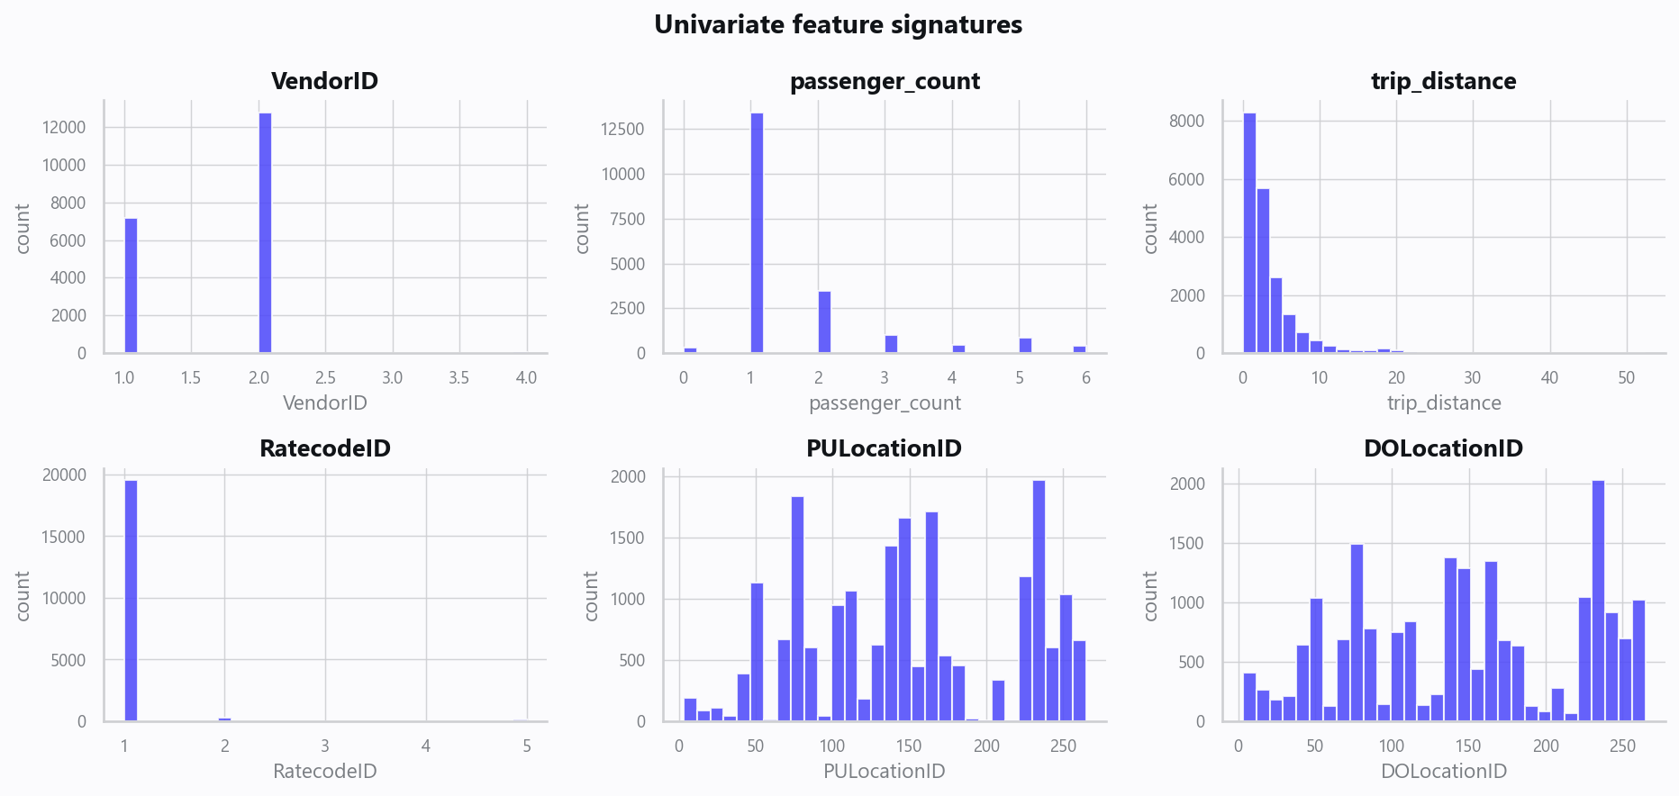
02_distributions.png
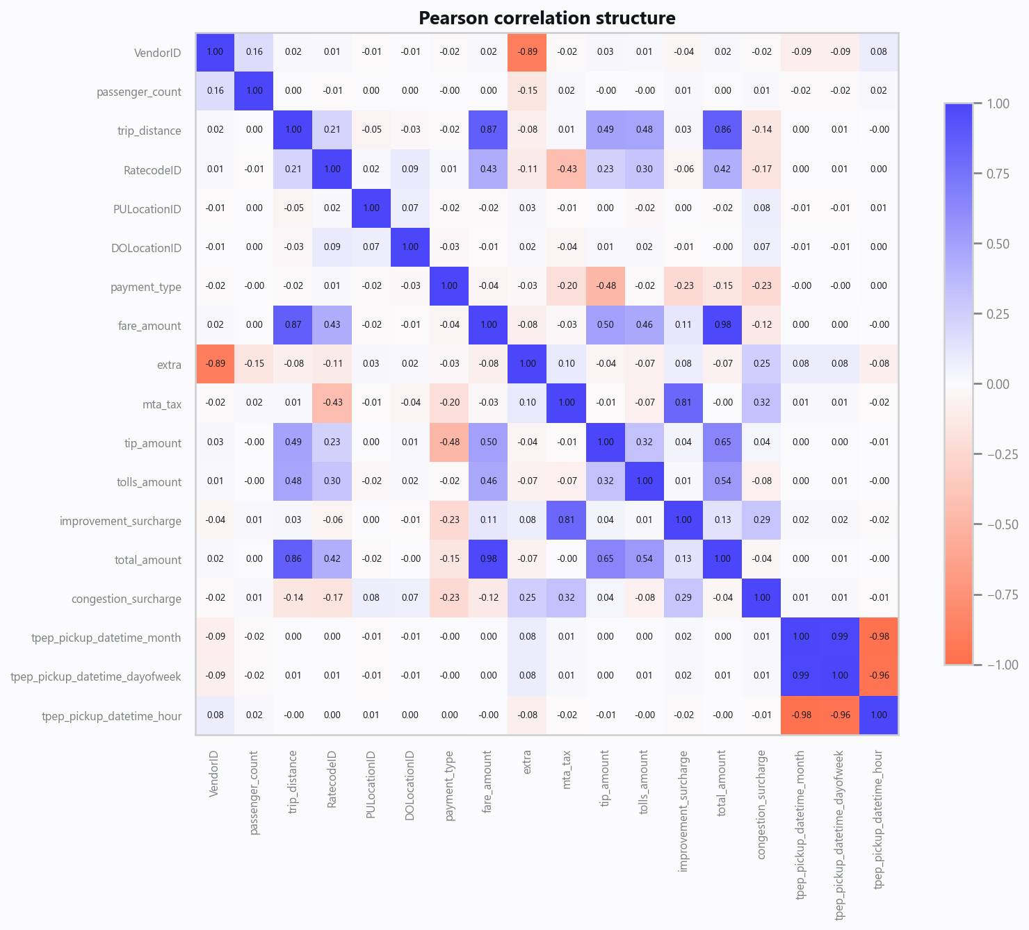
03_correlation.png
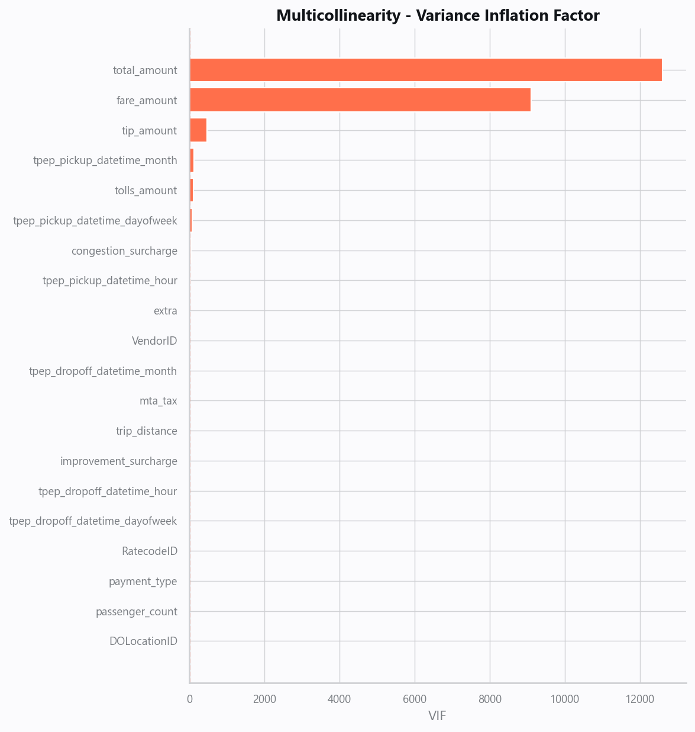
04_vif.png
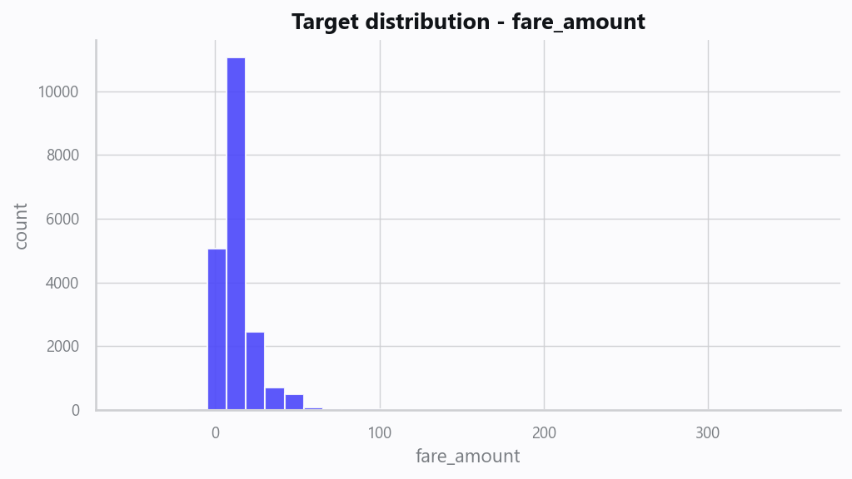
05_target.png
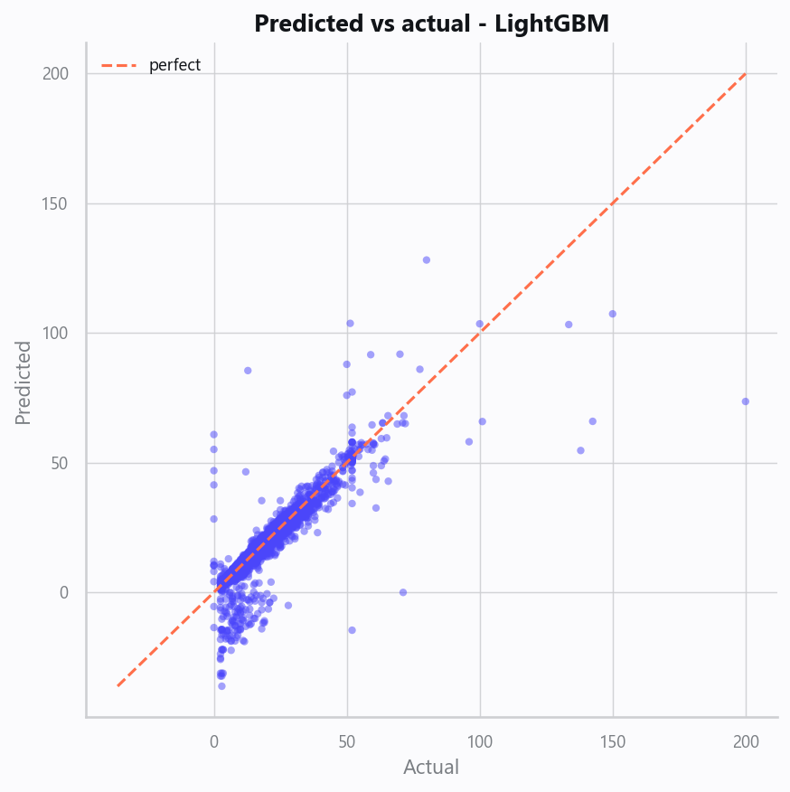
10_pred_vs_actual.png
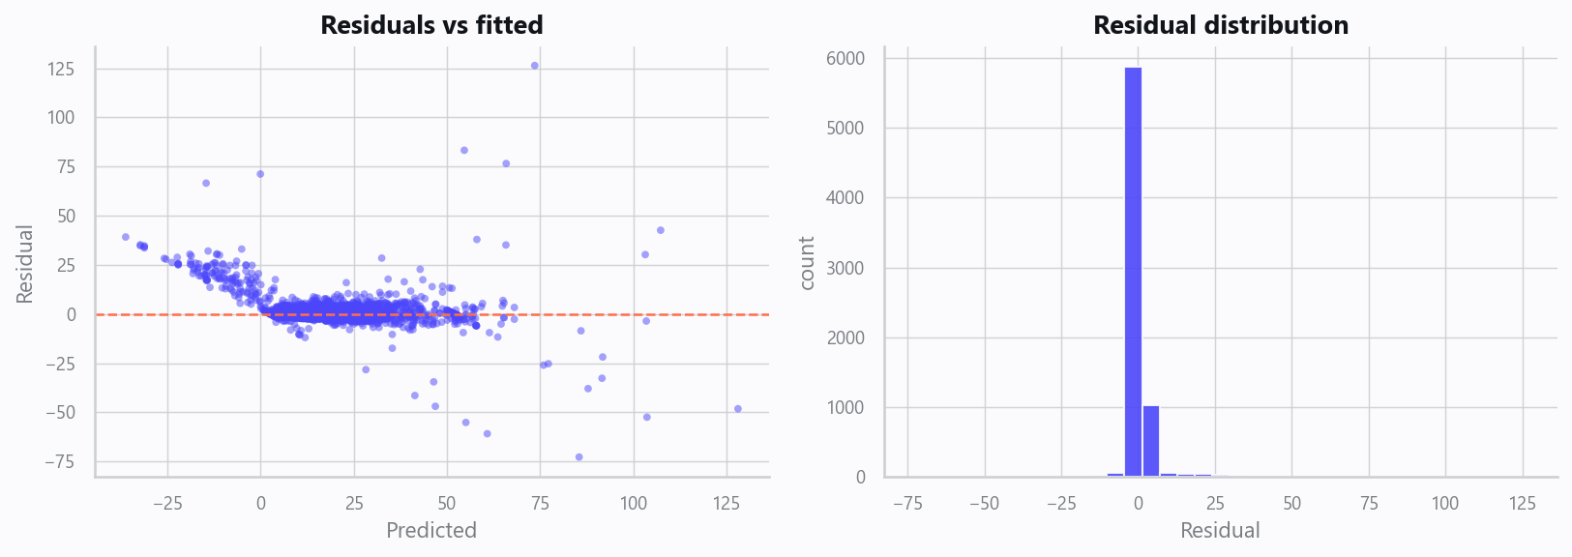
11_residuals.png
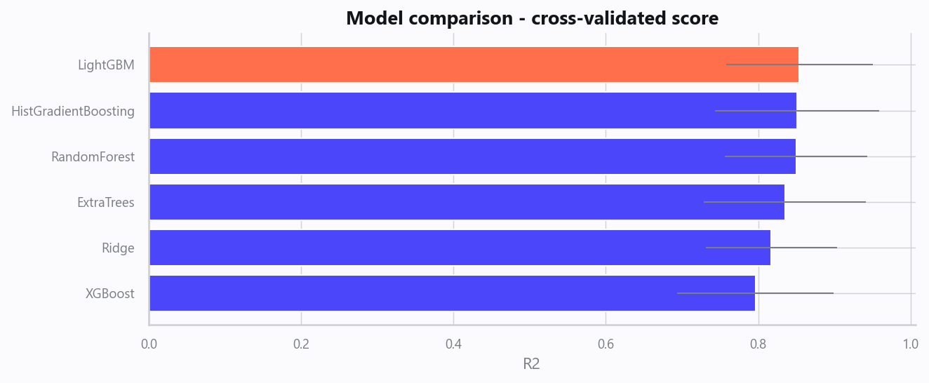
12_leaderboard.png
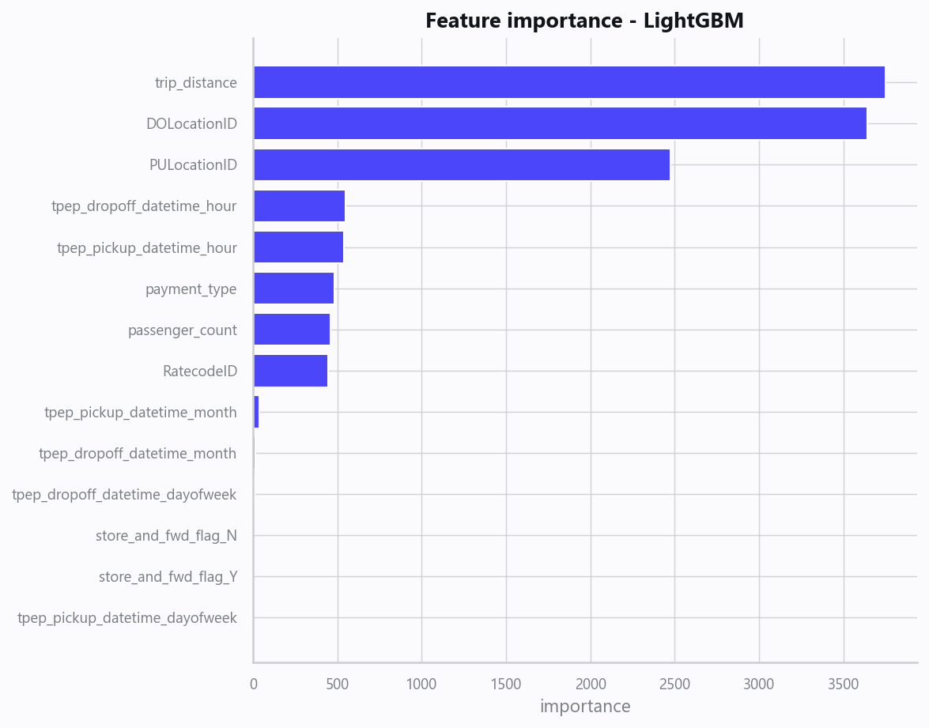
13_feature_importance.png

Limitations, Risks & Next Steps
- Results reflect the data supplied and the assumptions above; validate on a fresh sample before operational use.
- If the input was capped (see the run configuration), re-run with a larger extract to confirm stability.
- Watch for drift over time and re-train on a schedule; keep the versioned rules and audit hash with each release.

Appendix - Run Configuration
Setting | Value
domain | auto
target_column | fare_amount
max_rows | 20000
test_size | 0.2000
cv_folds | 5
split_strategy | auto
enable_tuning | True
enable_deep_learning | False
compliance_mode | True
dataset_format | csv

