Generic / Auto-detect (any tabular dataset)
Config-driven data science pipeline for high-fidelity industrial domains.

Field | Value
Domain | auto - Generic / Auto-detect (any tabular dataset)
Generated | 2026-10-08 18:23 UTC
Target | target
Task | regression
Data source | synthetic sandbox (constrained)
Records x columns | 2000 x 7
Audit SHA-256 | 5a7e09f768a5ed155dd414aba86f4770fe20feb73975e236e04f08c2b7080d76

Contents
Right-click here and choose 'Update Field' to build the table of contents.

Executive Summary
Resident AI offline - a local summary follows instead.
- project: Generic / Auto-detect (any tabular dataset)
- domain: Generic / Auto-detect (any tabular dataset)
- task: regression
- best_model: Ridge
- rmse: 2.9570
- mae: 2.3375
- median_ae: 1.9330
- mape: 7.7107
- r2: 0.8956
- adj_r2: 0.8927
- explained_variance: 0.8959
- mean_residual: 0.1412
- leaderboard_top: [{'model': 'Ridge', 'cv_score_mean': 0.8940416193974828, 'cv_score_std': 0.007828348454235494, 'fit_seconds': 0.02, 'rmse': 2.956957213032983, 'mae': 2.337535412078247, 'median_ae': 1.9329517448241553, 'mape': 7.710705001536304, 'r2': 0.8956435950271641, 'adj_r2': 0.8926850371542229, 'explained_variance': 0.8958816181733728, 'mean_residual': 0.1412196339203589}, {'model': 'ExtraTrees', 'cv_score_mean': 0.8659271983068564, 'cv_score_std': 0.01275437144963898, 'fit_seconds': 1.9, 'rmse': 3.262954803281005, 'mae': 2.5459990680294187, 'median_ae': 2.019884346435651, 'mape': 8.956784313266008, 'r2': 0.8729276255450893, 'adj_r2': 0.8693250582280686, 'explained_variance': 0.8733529398488804, 'mean_residual': 0.18877326179360282}, {'model': 'RandomForest', 'cv_score_mean': 0.865192540046543, 'cv_score_std': 0.011824916646288859, 'fit_seconds': 2.45, 'rmse': 3.2645080798829857, 'mae': 2.582726868237535, 'median_ae': 2.033049283921317, 'mape': 8.92777602688927, 'r2': 0.8728066152722991, 'adj_r2': 0.8692006172516684, 'explained_variance': 0.8730652860515923, 'mean_residual': 0.147217409479052}, {'model': 'LightGBM', 'cv_score_mean': 0.8615566835133668, 'cv_score_std': 0.01413987288267175, 'fit_seconds': 0.59, 'rmse': 3.306038107655098, 'mae': 2.6348990591908956, 'median_ae': 2.2077772378162184, 'mape': 9.108070421847584, 'r2': 0.8695498030232921, 'adj_r2': 0.8658514726966329, 'explained_variance': 0.8697275933081529, 'mean_residual': 0.12205048190320625}, {'model': 'HistGradientBoosting', 'cv_score_mean': 0.8599719730085178, 'cv_score_std': 0.014097197824574048, 'fit_seconds': 0.52, 'rmse': 3.2664064101716073, 'mae': 2.6152111099632505, 'median_ae': 2.2089621587541455, 'mape': 8.950178908906786, 'r2': 0.8726586448874297, 'adj_r2': 0.8690484518301146, 'explained_variance': 0.8729895442821316, 'mean_residual': 0.16650737416163744}]
Interpretation: review the strongest metric first, then check the weakest one for signs of bias, leakage or under-fitting before trusting the model.

Key Metrics at a Glance
Metric | Value
Best model | Ridge
Selection metric | r2
Cross-validated score | 0.8940
rmse | 2.9570
mae | 2.3375
median_ae | 1.9330
mape | 7.7107
r2 | 0.8956
adj_r2 | 0.8927
explained_variance | 0.8959
mean_residual | 0.1412
Deployment allowed | False

Data & Methodology
The pipeline ingested 2000 records across 7 columns from synthetic sandbox (constrained). A constrained synthetic sandbox was used when no real source was supplied.
Target: target | Task: regression | Split strategy: random. Numeric features receive robust scaling, categoricals are encoded, and the preprocessor is fitted on the training split only.
- Best model by cross-validated r2: Ridge.

Exploratory Data Analysis

Statistical moments
feature | count | mean | std | min | 25% | 50%
driver_primary | 2000.0 | 49.3384 | 12.0246 | 6.219 | 41.36 | 49.7304
driver_correlated | 2000.0 | 29.6998 | 9.3952 | 0.4185 | 23.4098 | 29.6745
driver_skewed | 2000.0 | 1.9209 | 1.996 | 0.0015 | 0.5238 | 1.3237
context_level | 2000.0 | 1.9755 | 1.4057 | 0.0 | 1.0 | 2.0
target | 2000.0 | 33.0091 | 9.2012 | 4.761 | 26.75 | 33.2148

Model Performance

Model leaderboard
model | cv_score_mean | cv_score_std | fit_seconds | rmse | mae | median_ae | mape | r2 | adj_r2 | explained_variance | mean_residual
Ridge | 0.894 | 0.0078 | 0.02 | 2.957 | 2.3375 | 1.933 | 7.7107 | 0.8956 | 0.8927 | 0.8959 | 0.1412
ExtraTrees | 0.8659 | 0.0128 | 1.9 | 3.263 | 2.546 | 2.0199 | 8.9568 | 0.8729 | 0.8693 | 0.8734 | 0.1888
RandomForest | 0.8652 | 0.0118 | 2.45 | 3.2645 | 2.5827 | 2.033 | 8.9278 | 0.8728 | 0.8692 | 0.8731 | 0.1472
LightGBM | 0.8616 | 0.0141 | 0.59 | 3.306 | 2.6349 | 2.2078 | 9.1081 | 0.8695 | 0.8659 | 0.8697 | 0.1221
HistGradientBoosting | 0.86 | 0.0141 | 0.52 | 3.2664 | 2.6152 | 2.209 | 8.9502 | 0.8727 | 0.869 | 0.873 | 0.1665
XGBoost | 0.8448 | 0.0124 | 0.26 | 3.4227 | 2.6961 | 2.1244 | 9.216 | 0.8602 | 0.8562 | 0.8614 | 0.315

Robustness & Compliance

Deployment gates
Check | Value
boundary_accuracy | n/a
abstention_accuracy | n/a
leakage_rate | 0.0000
gate:performance_pass | False
gate:recall_pass | True
gate:privacy_pass | True
gate:boundary_pass | True
gate:deployment_allowed | False
gate:note | One or more gates failed - hold deployment and review.

Figures

Charts and maps
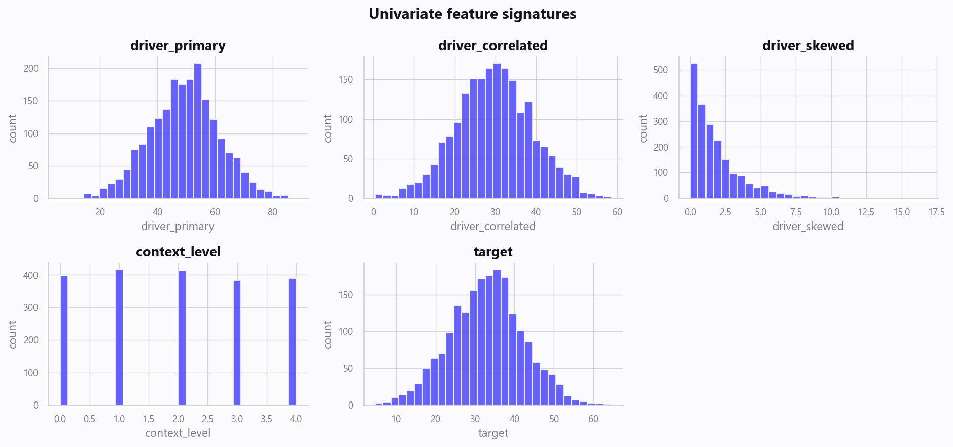
02_distributions.png
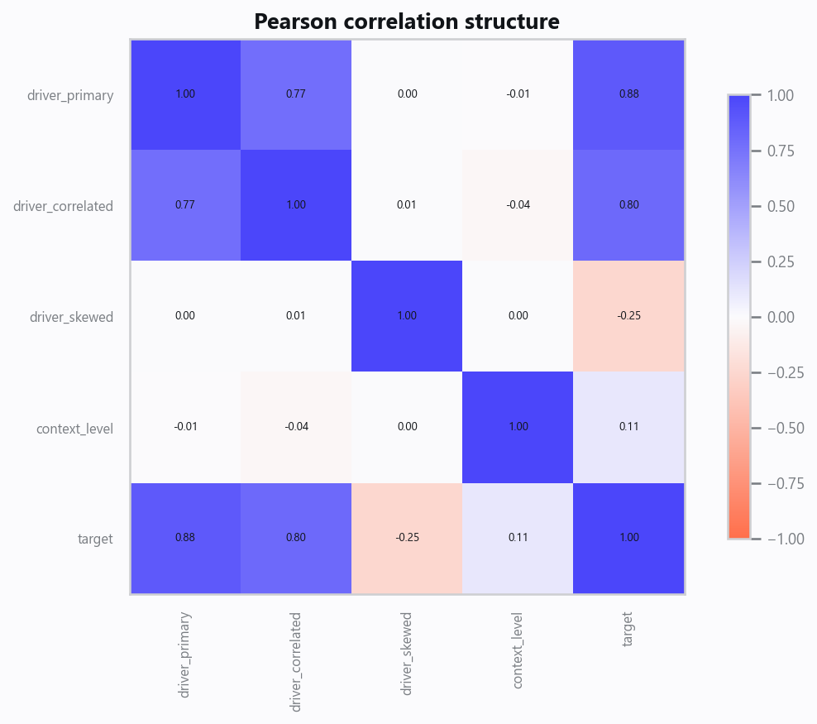
03_correlation.png
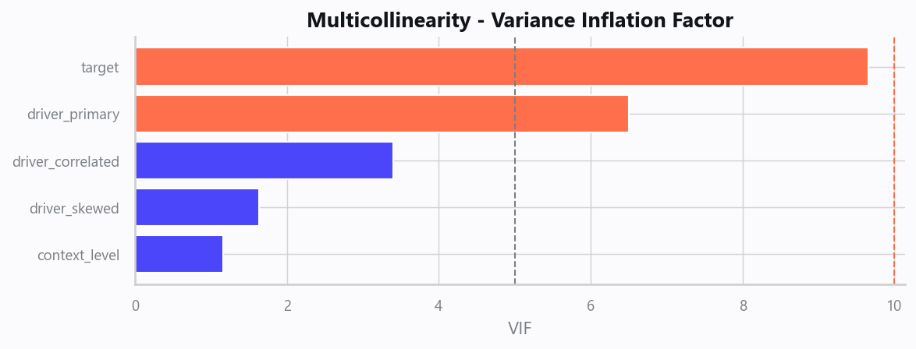
04_vif.png
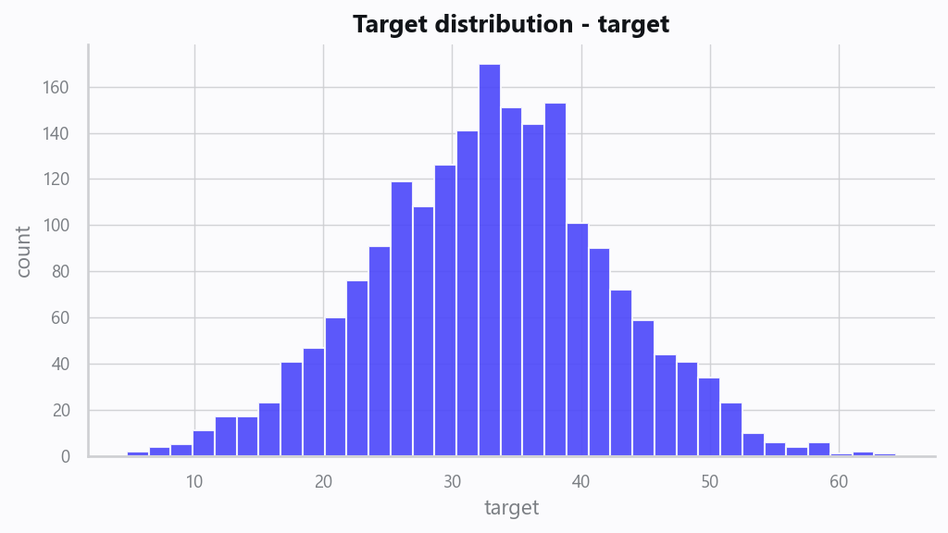
05_target.png
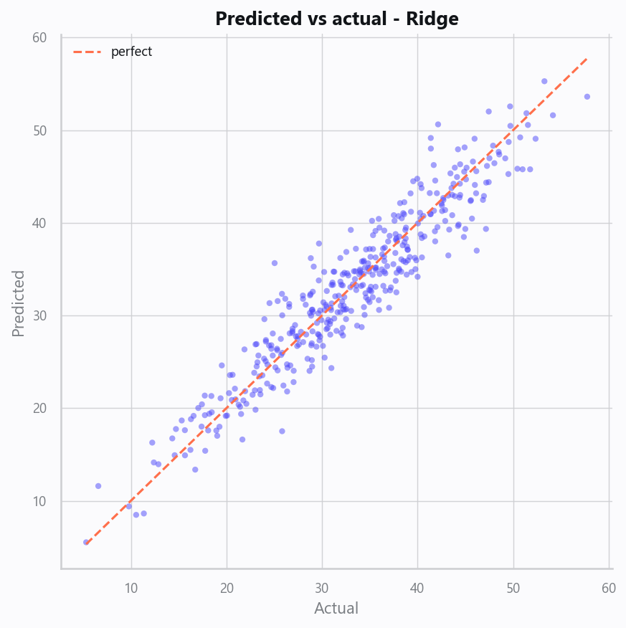
10_pred_vs_actual.png
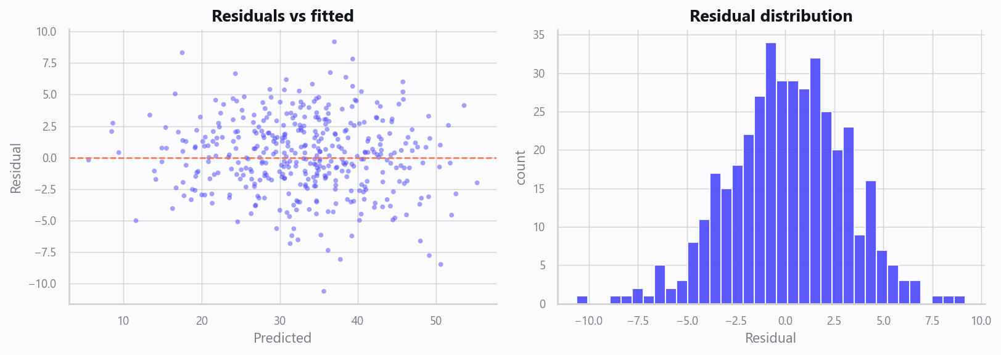
11_residuals.png
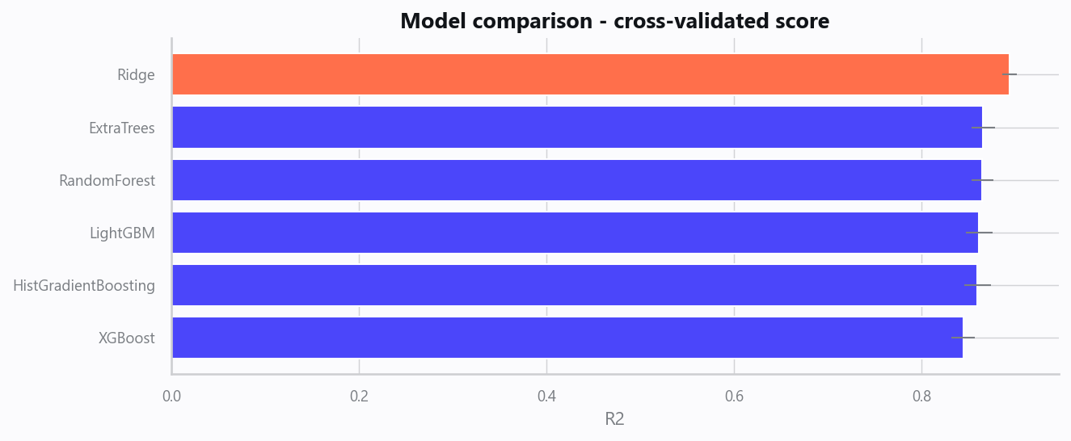
12_leaderboard.png
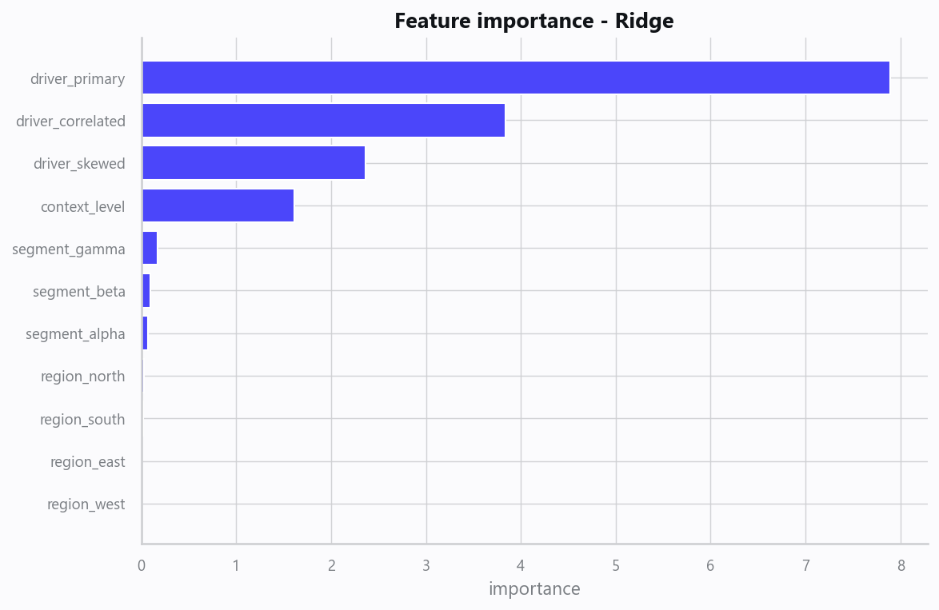
13_feature_importance.png

Limitations, Risks & Next Steps
- Results reflect the data supplied and the assumptions above; validate on a fresh sample before operational use.
- If the input was capped (see the run configuration), re-run with a larger extract to confirm stability.
- Watch for drift over time and re-train on a schedule; keep the versioned rules and audit hash with each release.

Appendix - Run Configuration
Setting | Value
domain | auto
target_column
max_rows | 0
test_size | 0.2000
cv_folds | 5
split_strategy | auto
enable_tuning | False
enable_deep_learning | False
compliance_mode | True
dataset_format | csv

