Forecasting: Demand & Energy Time-Series
Config-driven data science pipeline for high-fidelity industrial domains.

Field | Value
Domain | 9 - Forecasting: Demand & Energy Time-Series
Generated | 2026-10-08 18:23 UTC
Target | demand_kw
Task | regression
Data source | synthetic sandbox (constrained)
Records x columns | 2000 x 25
Audit SHA-256 | 0dca8fead1f25ec5cd9aa899d97228f1d933ada2ccb2d64ba70520ab77cc7124

Contents
Right-click here and choose 'Update Field' to build the table of contents.

Executive Summary
Resident AI offline - a local summary follows instead.
- project: Forecasting: Demand & Energy Time-Series
- domain: Forecasting: Demand & Energy Time-Series
- task: regression
- best_model: ExtraTrees
- rmse: 193.1662
- mae: 154.5160
- median_ae: 137.2891
- mape: 4.1603
- r2: 0.9318
- adj_r2: 0.9282
- explained_variance: 0.9464
- mean_residual: 89.3630
- leaderboard_top: [{'model': 'ExtraTrees', 'cv_score_mean': 0.9556865356027933, 'cv_score_std': 0.002915224411719874, 'fit_seconds': 2.41, 'rmse': 193.16615087935415, 'mae': 154.5160004166667, 'median_ae': 137.2890666666667, 'mape': 4.16032066747842, 'r2': 0.9317536419469459, 'adj_r2': 0.9281522510206633, 'explained_variance': 0.9463596851897719, 'mean_residual': 89.36296641666586}, {'model': 'HistGradientBoosting', 'cv_score_mean': 0.9509026842111407, 'cv_score_std': 0.003412781523463197, 'fit_seconds': 0.68, 'rmse': 196.9095183624951, 'mae': 157.27155226836473, 'median_ae': 131.4075026112589, 'mape': 4.28074989074011, 'r2': 0.9290829195144703, 'adj_r2': 0.9253405933674766, 'explained_variance': 0.9420433937473438, 'mean_residual': 84.17860652582215}, {'model': 'LightGBM', 'cv_score_mean': 0.9494400405875062, 'cv_score_std': 0.0047875067717562695, 'fit_seconds': 0.61, 'rmse': 193.73038347241805, 'mae': 153.56695809348471, 'median_ae': 129.8548861689162, 'mape': 4.191548093395858, 'r2': 0.9313543684921052, 'adj_r2': 0.927731907726517, 'explained_variance': 0.9419195174248598, 'mean_residual': 76.0027134119269}, {'model': 'RandomForest', 'cv_score_mean': 0.9492772891290118, 'cv_score_std': 0.00365183089872743, 'fit_seconds': 4.1, 'rmse': 192.7614605117443, 'mae': 152.75933866666662, 'median_ae': 125.94828333333498, 'mape': 4.143053308153998, 'r2': 0.9320392997866147, 'adj_r2': 0.928452983152663, 'explained_variance': 0.9398862223239121, 'mean_residual': 65.49994999999926}, {'model': 'XGBoost', 'cv_score_mean': 0.9446257561589793, 'cv_score_std': 0.004022577374094554, 'fit_seconds': 0.58, 'rmse': 210.2658936645753, 'mae': 169.42989409179685, 'median_ae': 146.51068359374995, 'mape': 4.629749525090185, 'r2': 0.9191360232941865, 'adj_r2': 0.91486879497198, 'explained_variance': 0.9327164001002288, 'mean_residual': 86.16823471679687}]
Interpretation: review the strongest metric first, then check the weakest one for signs of bias, leakage or under-fitting before trusting the model.

Key Metrics at a Glance
Metric | Value
Best model | ExtraTrees
Selection metric | r2
Cross-validated score | 0.9557
rmse | 193.1662
mae | 154.5160
median_ae | 137.2891
mape | 4.1603
r2 | 0.9318
adj_r2 | 0.9282
explained_variance | 0.9464
mean_residual | 89.3630
Deployment allowed | True

Data & Methodology
The pipeline ingested 2000 records across 25 columns from synthetic sandbox (constrained). A constrained synthetic sandbox was used when no real source was supplied.
Target: demand_kw | Task: regression | Split strategy: temporal. Numeric features receive robust scaling, categoricals are encoded, and the preprocessor is fitted on the training split only.
- Best model by cross-validated r2: ExtraTrees.

Exploratory Data Analysis

Statistical moments
feature | count | mean | std | min | 25% | 50%
temperature_c | 2000.0 | 10.218 | 4.4052 | -1.19 | 6.8175 | 10.26
irradiance_wm2 | 2000.0 | 222.0861 | 264.7873 | 0.0 | 0.0 | 27.75
humidity_pct | 2000.0 | 59.8304 | 12.0054 | 23.2 | 52.175 | 59.3
dayofweek | 2000.0 | 3.016 | 2.0004 | 0.0 | 1.0 | 3.0
demand_kw | 2000.0 | 3434.8504 | 715.7512 | 1771.46 | 2804.8825 | 3507.73
hour_sin | 2000.0 | 0.0026 | 0.7074 | -1.0 | -0.7071 | 0.0
hour_cos | 2000.0 | 0.002 | 0.7071 | -1.0 | -0.7071 | 0.0
demand_lag_1 | 1999.0 | 3434.6182 | 715.8549 | 1771.46 | 2804.435 | 3507.32
demand_lag_24 | 1976.0 | 3427.7122 | 712.6846 | 1771.46 | 2797.85 | 3499.065
demand_lag_168 | 1832.0 | 3394.8146 | 699.8752 | 1771.46 | 2768.0725 | 3467.765
demand_roll_mean_24 | 1999.0 | 3429.156 | 312.3811 | 2335.77 | 3262.1535 | 3407.481
demand_ema_24 | 1999.0 | 3426.749 | 355.7964 | 2335.77 | 3167.0675 | 3421.9268

Model Performance

Model leaderboard
model | cv_score_mean | cv_score_std | fit_seconds | rmse | mae | median_ae | mape | r2 | adj_r2 | explained_variance | mean_residual
ExtraTrees | 0.9557 | 0.0029 | 2.41 | 193.1662 | 154.516 | 137.2891 | 4.1603 | 0.9318 | 0.9282 | 0.9464 | 89.363
HistGradientBoosting | 0.9509 | 0.0034 | 0.68 | 196.9095 | 157.2716 | 131.4075 | 4.2807 | 0.9291 | 0.9253 | 0.942 | 84.1786
LightGBM | 0.9494 | 0.0048 | 0.61 | 193.7304 | 153.567 | 129.8549 | 4.1915 | 0.9314 | 0.9277 | 0.9419 | 76.0027
RandomForest | 0.9493 | 0.0037 | 4.1 | 192.7615 | 152.7593 | 125.9483 | 4.1431 | 0.932 | 0.9285 | 0.9399 | 65.4999
XGBoost | 0.9446 | 0.004 | 0.58 | 210.2659 | 169.4299 | 146.5107 | 4.6297 | 0.9191 | 0.9149 | 0.9327 | 86.1682
Ridge | 0.9424 | 0.0056 | 0.02 | 169.1596 | 135.5688 | 117.587 | 3.8073 | 0.9477 | 0.9449 | 0.9479 | 10.5111

Robustness & Compliance

Deployment gates
Check | Value
boundary_accuracy | n/a
abstention_accuracy | n/a
leakage_rate | 0.0000
gate:performance_pass | True
gate:recall_pass | True
gate:privacy_pass | True
gate:boundary_pass | True
gate:deployment_allowed | True
gate:note | All gates satisfied - safe to proceed with human oversight.

Figures

Charts and maps
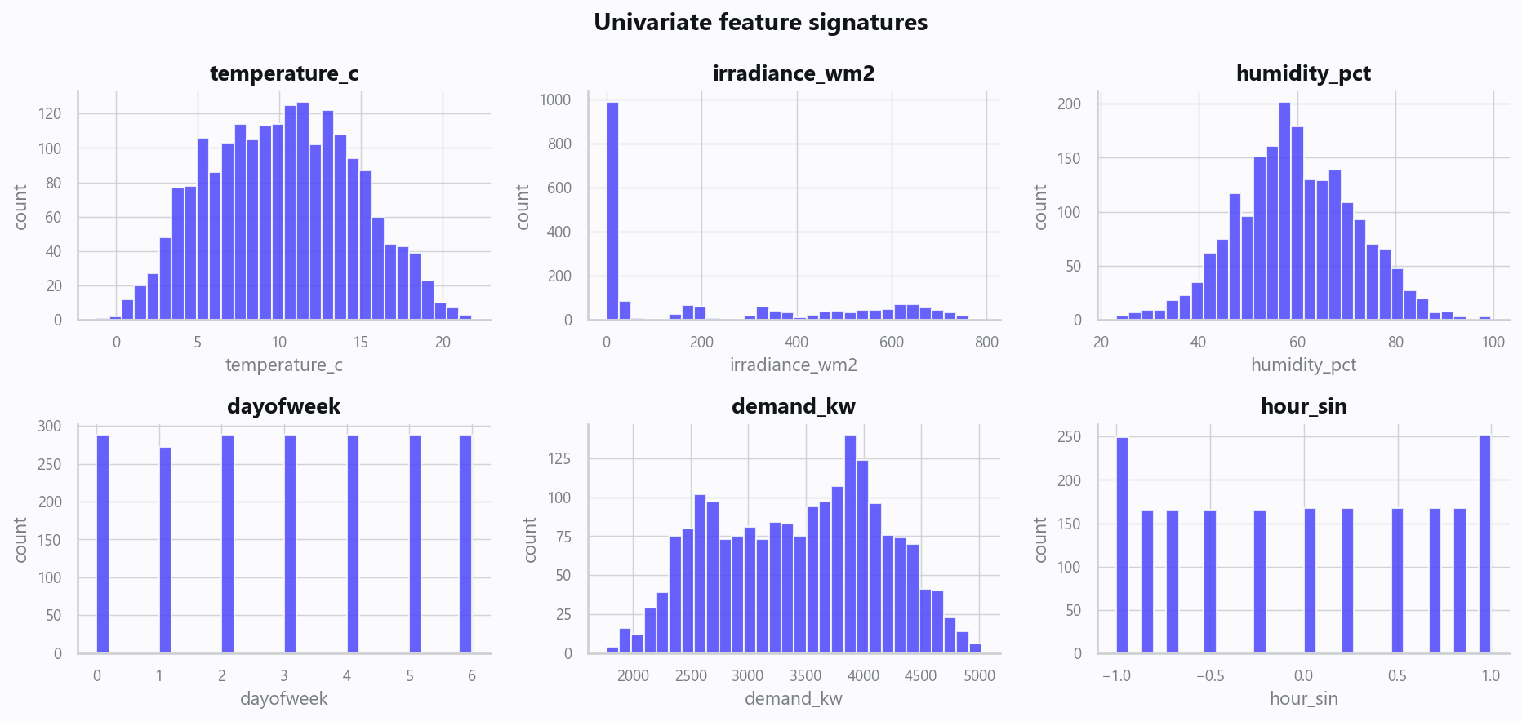
02_distributions.png
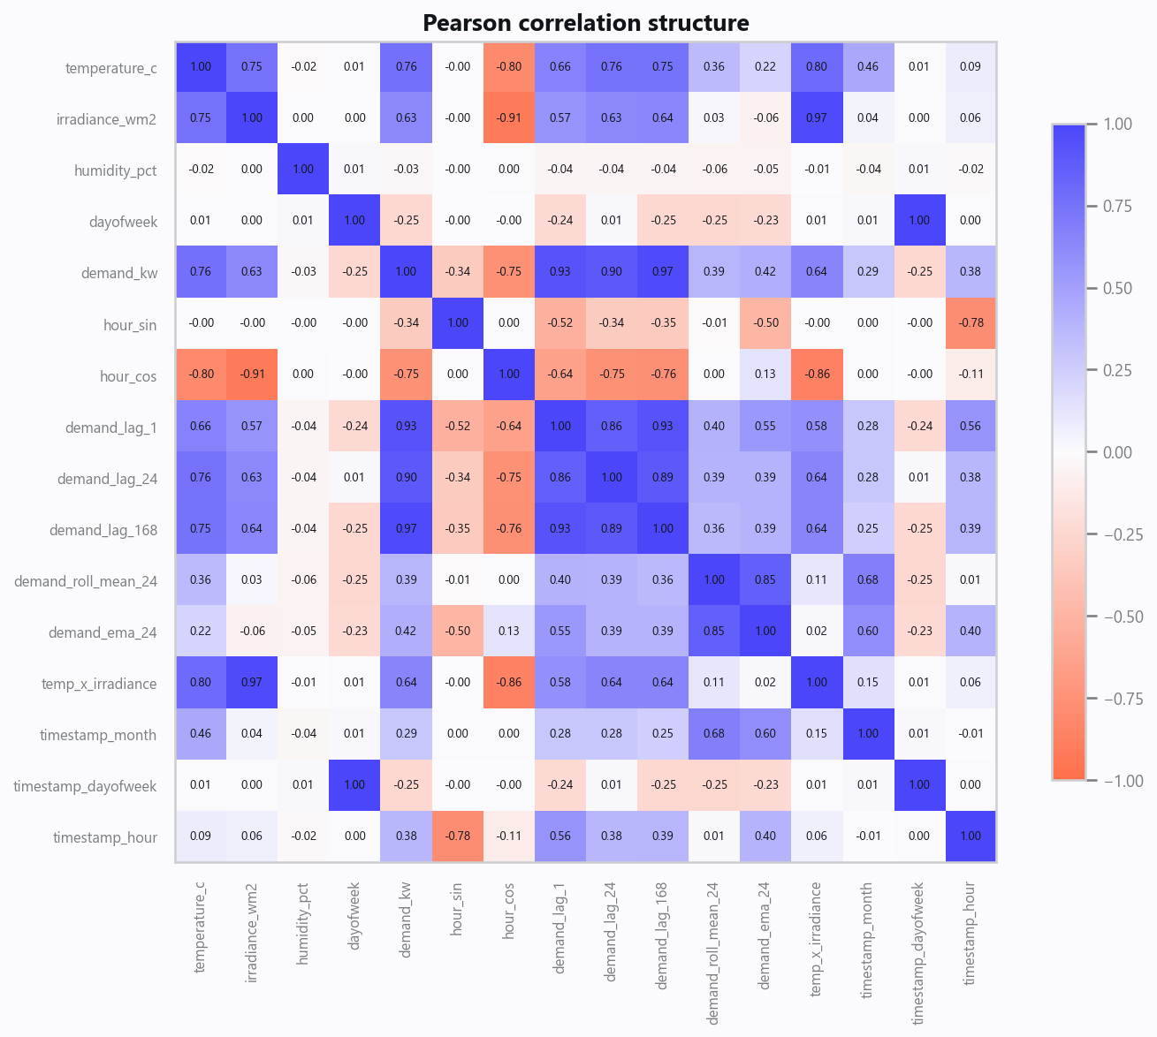
03_correlation.png
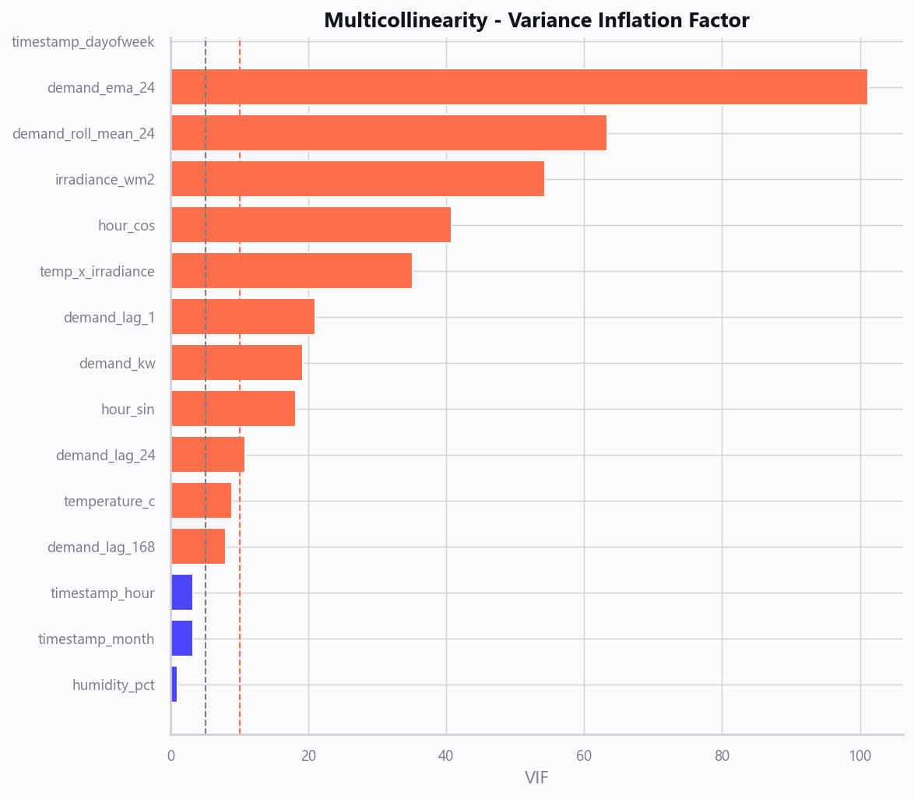
04_vif.png
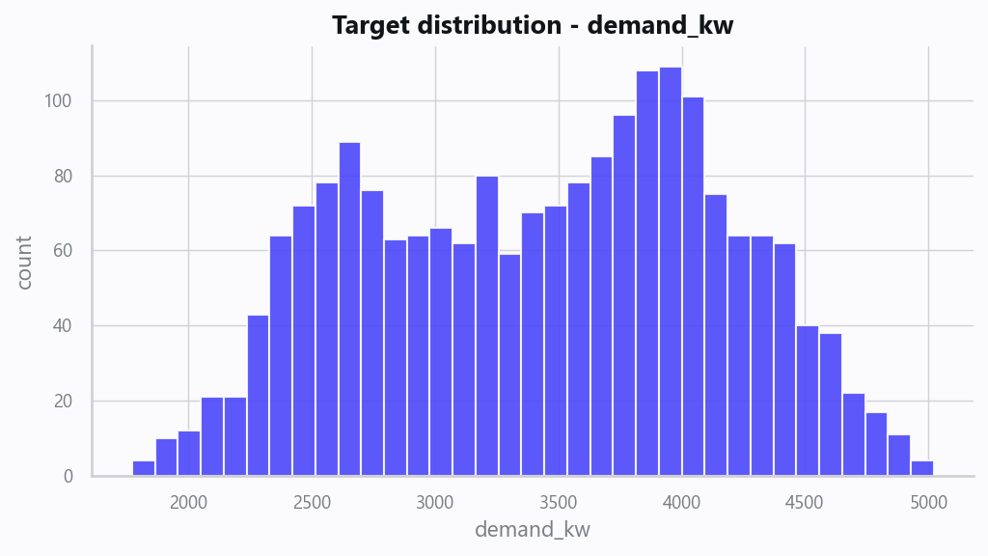
05_target.png
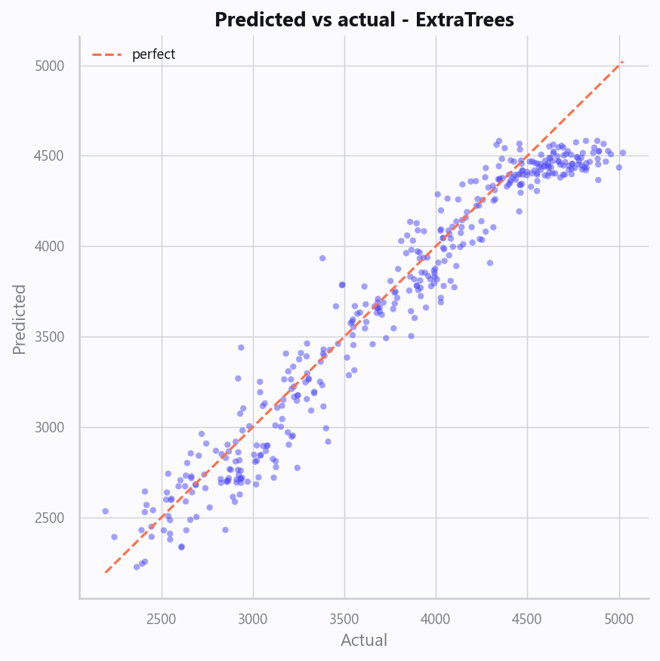
10_pred_vs_actual.png
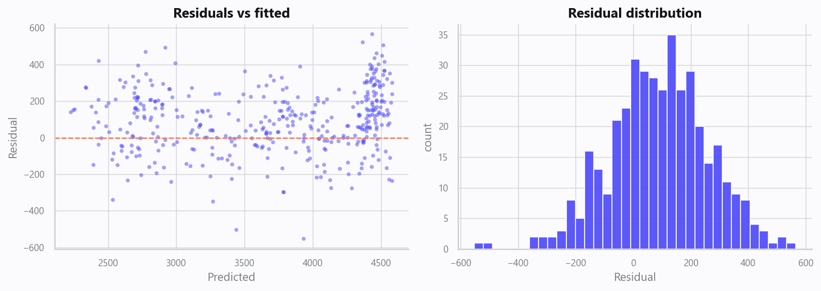
11_residuals.png
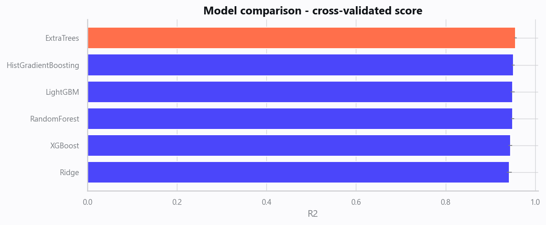
12_leaderboard.png
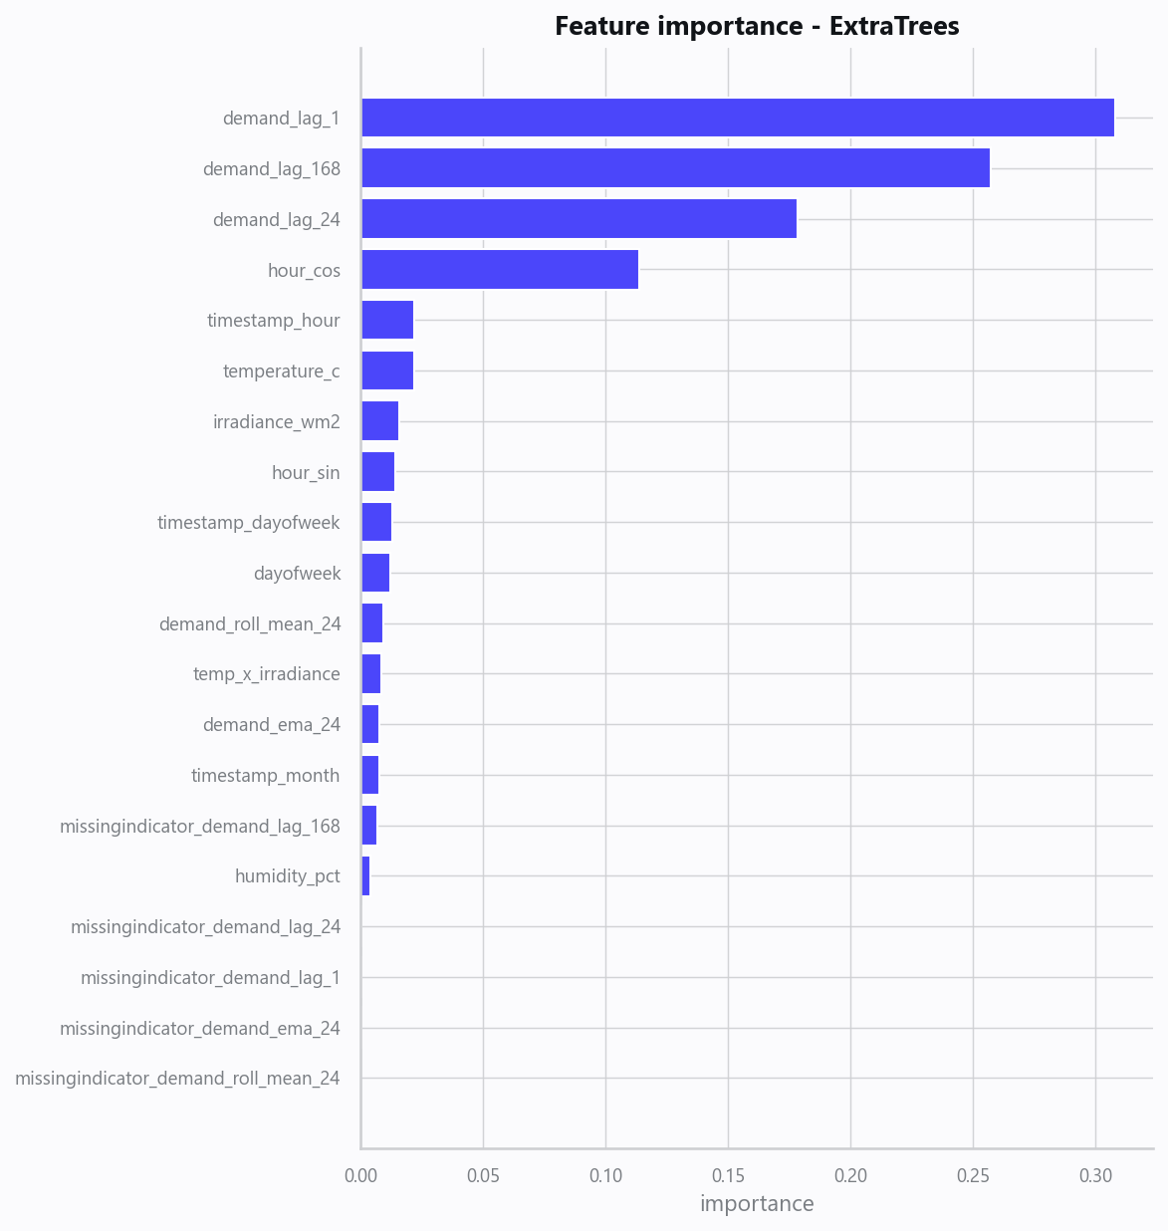
13_feature_importance.png
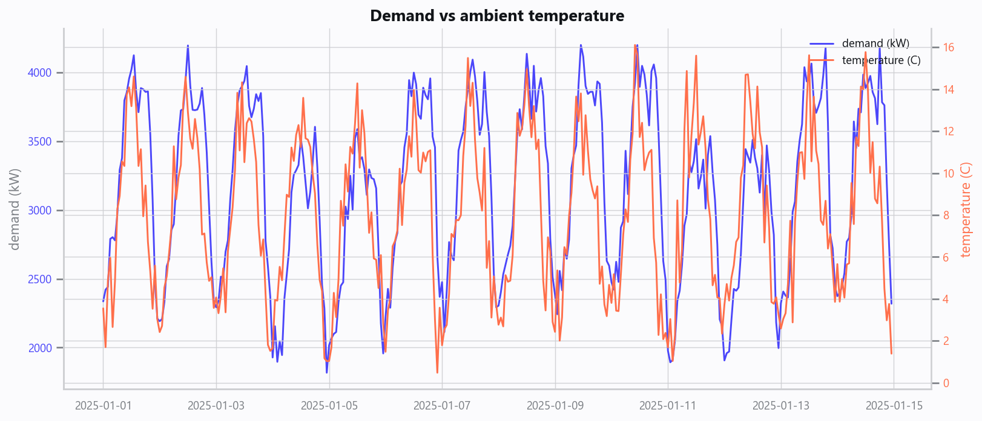
20_demand_vs_temperature.png
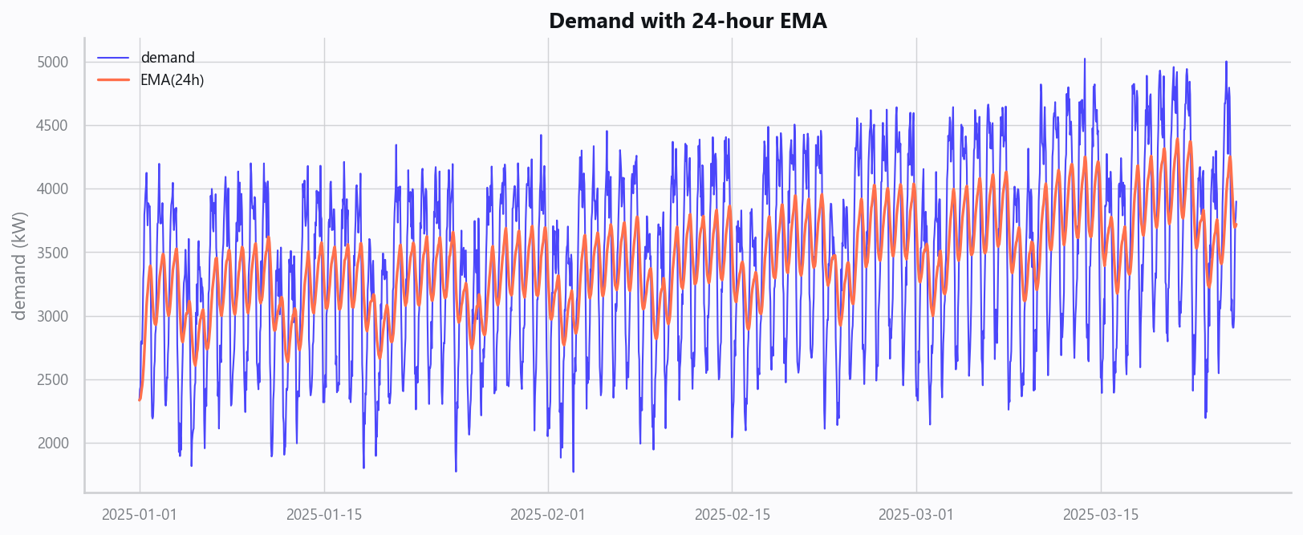
21_demand_ema.png

Domain Rules & Explainable Ground Truth
rule_id | field | operator | threshold | label
FC-001 | temperature_c | > | 32 | Heatwave Demand Risk
FC-002 | demand_kw | > | 8500 | Peak Demand Alert

Limitations, Risks & Next Steps
- Results reflect the data supplied and the assumptions above; validate on a fresh sample before operational use.
- If the input was capped (see the run configuration), re-run with a larger extract to confirm stability.
- Watch for drift over time and re-train on a schedule; keep the versioned rules and audit hash with each release.

Appendix - Run Configuration
Setting | Value
domain | 9
target_column
max_rows | 0
test_size | 0.2000
cv_folds | 5
split_strategy | auto
enable_tuning | False
enable_deep_learning | False
compliance_mode | True
dataset_format | csv

