Industrial AI: APM & Reliability (Remaining Useful Life)
Config-driven data science pipeline for high-fidelity industrial domains.

Field | Value
Domain | 8 - Industrial AI: APM & Reliability (Remaining Useful Life)
Generated | 2026-10-08 18:23 UTC
Target | rul_hours
Task | regression
Data source | synthetic sandbox (constrained)
Records x columns | 2000 x 26
Audit SHA-256 | 7b501e38a129f1335385ada6f9efcd14dc1f37a4aca98490becbb4ad9c10da88

Contents
Right-click here and choose 'Update Field' to build the table of contents.

Executive Summary
Resident AI offline - a local summary follows instead.
- project: Industrial AI: APM & Reliability (Remaining Useful Life)
- domain: Industrial AI: APM & Reliability (Remaining Useful Life)
- task: regression
- best_model: ExtraTrees
- rmse: 414.9999
- mae: 275.7019
- median_ae: 172.4507
- mape: 23.2257
- r2: 0.9207
- adj_r2: 0.9176
- explained_variance: 0.9289
- mean_residual: -133.1397
- leaderboard_top: [{'model': 'ExtraTrees', 'cv_score_mean': 0.9017707060314887, 'cv_score_std': 0.01697532628316363, 'fit_seconds': 2.39, 'rmse': 414.9998753235885, 'mae': 275.70186750000045, 'median_ae': 172.4506666666705, 'mape': 23.225720192192632, 'r2': 0.9207145491914172, 'adj_r2': 0.9176174612692068, 'explained_variance': 0.928874977619694, 'mean_residual': -133.13973750000062}, {'model': 'RandomForest', 'cv_score_mean': 0.8984467078876376, 'cv_score_std': 0.010412313976845817, 'fit_seconds': 4.72, 'rmse': 410.50391281930763, 'mae': 273.0131058333337, 'median_ae': 173.60933333333367, 'mape': 23.25833265809548, 'r2': 0.9224231449288455, 'adj_r2': 0.9193927990276285, 'explained_variance': 0.9308161383965503, 'mean_residual': -135.02359250000052}, {'model': 'HistGradientBoosting', 'cv_score_mean': 0.897106348846598, 'cv_score_std': 0.013583352883977901, 'fit_seconds': 0.58, 'rmse': 445.7118500597106, 'mae': 287.6913094678292, 'median_ae': 191.96015174259742, 'mape': 22.303473311591823, 'r2': 0.908545321174863, 'adj_r2': 0.904972872783256, 'explained_variance': 0.9162937984206553, 'mean_residual': -129.73566948966686}, {'model': 'LightGBM', 'cv_score_mean': 0.8957040673142884, 'cv_score_std': 0.01367176580583357, 'fit_seconds': 0.68, 'rmse': 448.8378766566621, 'mae': 281.8889705965228, 'median_ae': 167.09221112280284, 'mape': 22.291786993236556, 'r2': 0.9072579768477803, 'adj_r2': 0.9036352415683967, 'explained_variance': 0.9146639610603248, 'mean_residual': -126.83602042558493}, {'model': 'XGBoost', 'cv_score_mean': 0.8858632977585679, 'cv_score_std': 0.022173093544234974, 'fit_seconds': 0.49, 'rmse': 471.3381586485267, 'mae': 314.2835444469452, 'median_ae': 200.54743652343745, 'mape': 24.025746018258534, 'r2': 0.8977265823081582, 'adj_r2': 0.8937315269295706, 'explained_variance': 0.9050681355835288, 'mean_residual': -126.28308814048768}]
Interpretation: review the strongest metric first, then check the weakest one for signs of bias, leakage or under-fitting before trusting the model.

Key Metrics at a Glance
Metric | Value
Best model | ExtraTrees
Selection metric | r2
Cross-validated score | 0.9018
rmse | 414.9999
mae | 275.7019
median_ae | 172.4507
mape | 23.2257
r2 | 0.9207
adj_r2 | 0.9176
explained_variance | 0.9289
mean_residual | -133.1397
Deployment allowed | True

Data & Methodology
The pipeline ingested 2000 records across 26 columns from synthetic sandbox (constrained). A constrained synthetic sandbox was used when no real source was supplied.
Target: rul_hours | Task: regression | Split strategy: group. Numeric features receive robust scaling, categoricals are encoded, and the preprocessor is fitted on the training split only.
- Best model by cross-validated r2: ExtraTrees.

Exploratory Data Analysis

Statistical moments
feature | count | mean | std | min | 25% | 50%
operating_hours | 2000.0 | 2666.4013 | 1724.0899 | 0.9 | 1270.55 | 2444.25
vibration_rms_mm_s | 2000.0 | 4.0549 | 1.7547 | 0.673 | 2.5422 | 4.1185
crest_factor | 2000.0 | 5.0085 | 1.1722 | 2.499 | 4.031 | 5.0225
kurtosis | 2000.0 | 6.0095 | 1.7754 | 2.214 | 4.5455 | 6.049
temperature_c | 2000.0 | 65.1011 | 11.9081 | 37.9 | 55.2375 | 65.46
acoustic_khz | 2000.0 | 9.4953 | 4.4595 | 0.0 | 5.747 | 9.5995
axial_load_kn | 2000.0 | 3.4891 | 0.4883 | 1.835 | 3.167 | 3.4795
rul_hours | 2000.0 | 2646.3986 | 1720.9892 | 0.2 | 1303.775 | 2409.6
health_index | 2000.0 | 0.4991 | 0.287 | 0.0 | 0.266 | 0.4888
degradation_proxy | 2000.0 | 0.5008 | 0.2877 | -0.0536 | 0.2528 | 0.5112
vib_x_crest | 2000.0 | 22.3097 | 13.5252 | 2.1021 | 10.155 | 20.7547
thermal_load | 2000.0 | 230.299 | 64.603 | 84.6118 | 179.5252 | 227.3949

Model Performance

Model leaderboard
model | cv_score_mean | cv_score_std | fit_seconds | rmse | mae | median_ae | mape | r2 | adj_r2 | explained_variance | mean_residual
ExtraTrees | 0.9018 | 0.017 | 2.39 | 414.9999 | 275.7019 | 172.4507 | 23.2257 | 0.9207 | 0.9176 | 0.9289 | -133.1397
RandomForest | 0.8984 | 0.0104 | 4.72 | 410.5039 | 273.0131 | 173.6093 | 23.2583 | 0.9224 | 0.9194 | 0.9308 | -135.0236
HistGradientBoosting | 0.8971 | 0.0136 | 0.58 | 445.7119 | 287.6913 | 191.9602 | 22.3035 | 0.9085 | 0.905 | 0.9163 | -129.7357
LightGBM | 0.8957 | 0.0137 | 0.68 | 448.8379 | 281.889 | 167.0922 | 22.2918 | 0.9073 | 0.9036 | 0.9147 | -126.836
XGBoost | 0.8859 | 0.0222 | 0.49 | 471.3382 | 314.2835 | 200.5474 | 24.0257 | 0.8977 | 0.8937 | 0.9051 | -126.2831
Ridge | 0.8022 | 0.0106 | 0.02 | 462.7949 | 355.6653 | 278.0794 | 55.6765 | 0.9014 | 0.8975 | 0.9064 | -104.2786

Robustness & Compliance

Deployment gates
Check | Value
boundary_accuracy | n/a
abstention_accuracy | 1.0000
leakage_rate | 0.0000
gate:performance_pass | True
gate:recall_pass | True
gate:privacy_pass | True
gate:boundary_pass | True
gate:deployment_allowed | True
gate:note | All gates satisfied - safe to proceed with human oversight.

Figures

Charts and maps
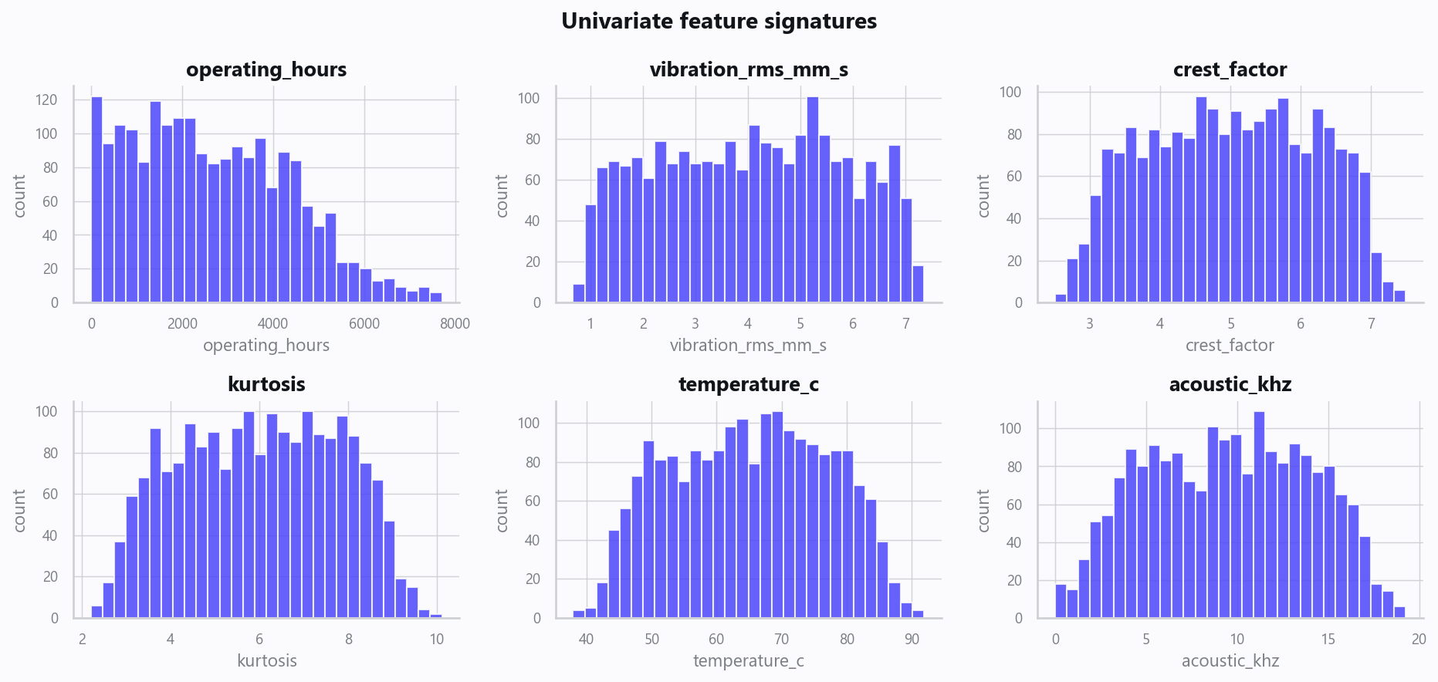
02_distributions.png
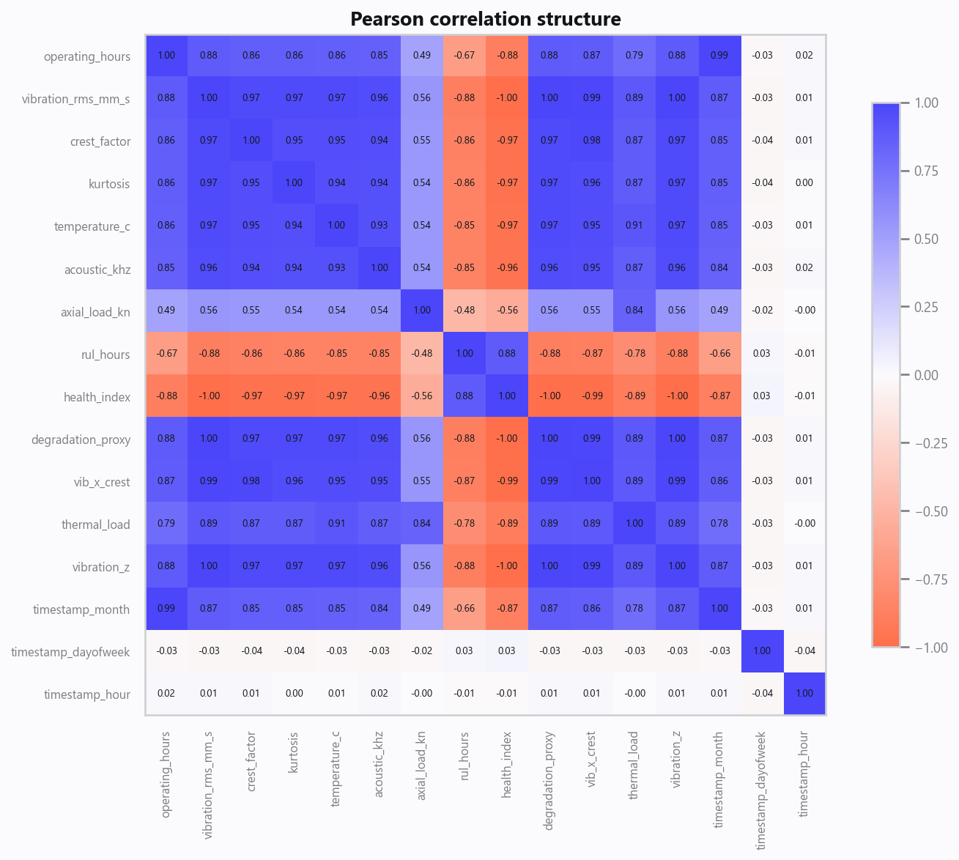
03_correlation.png
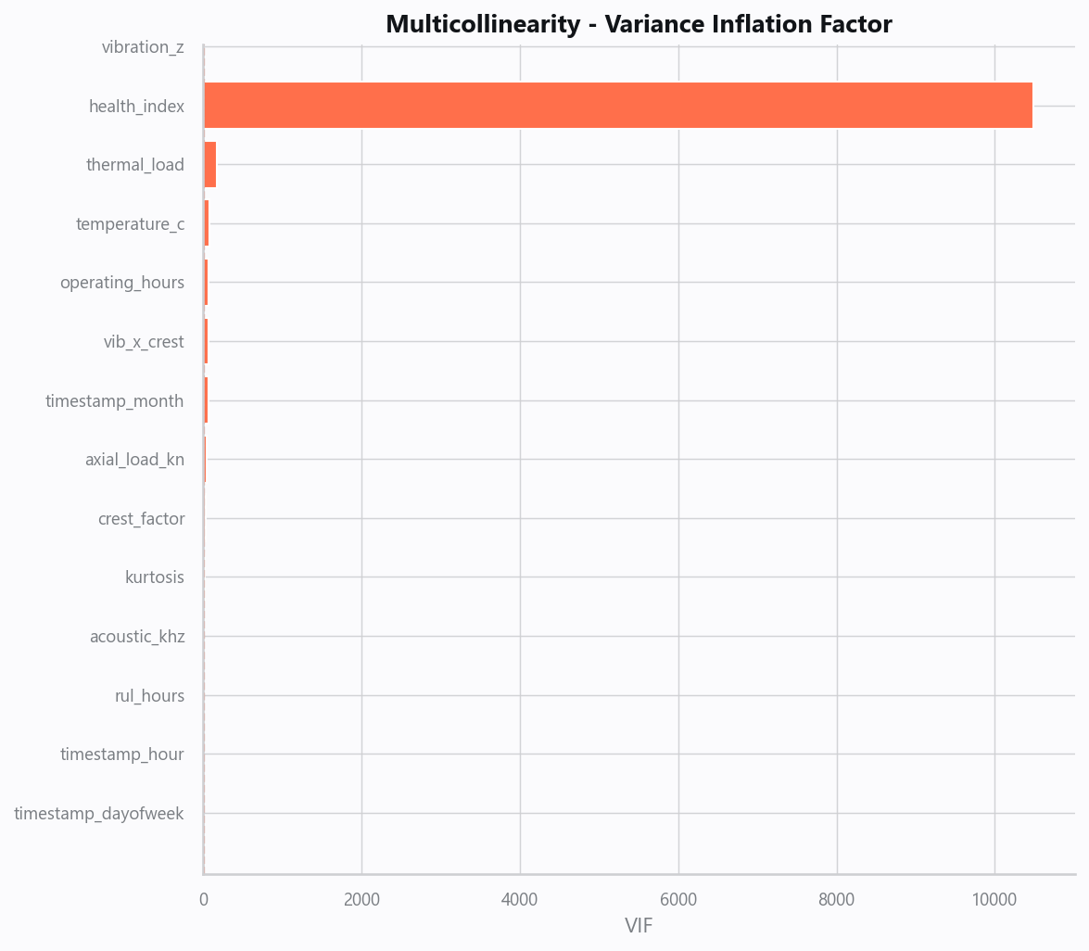
04_vif.png
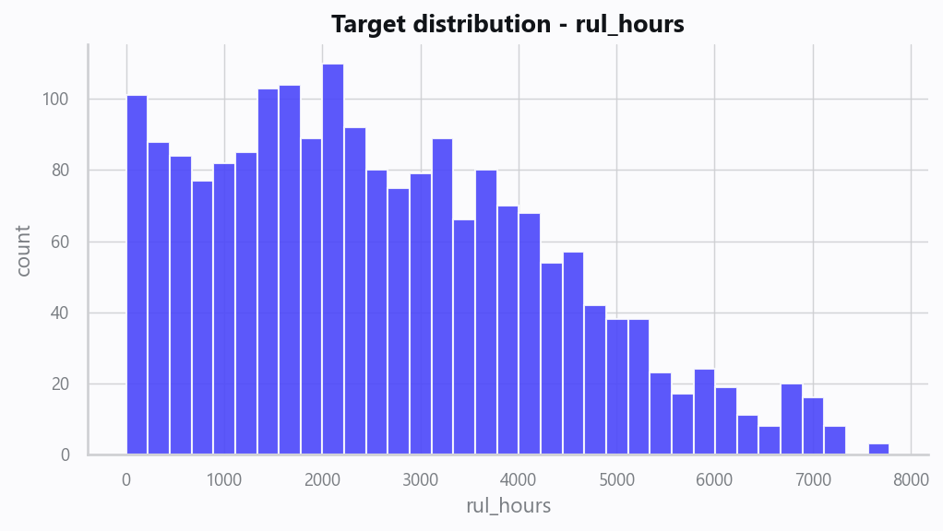
05_target.png
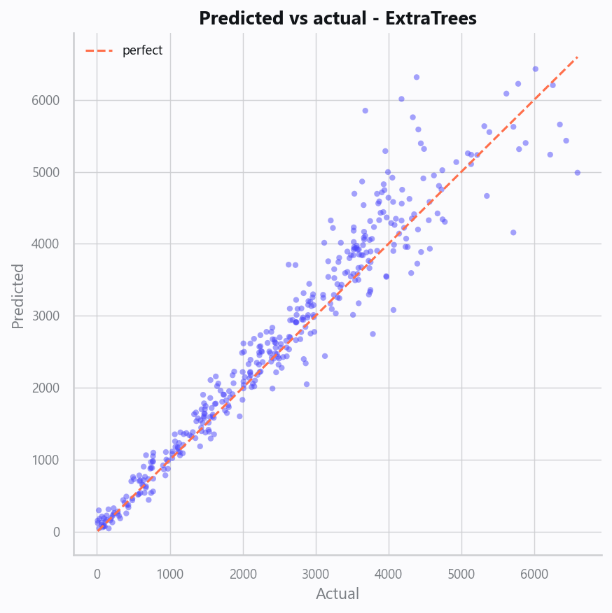
10_pred_vs_actual.png
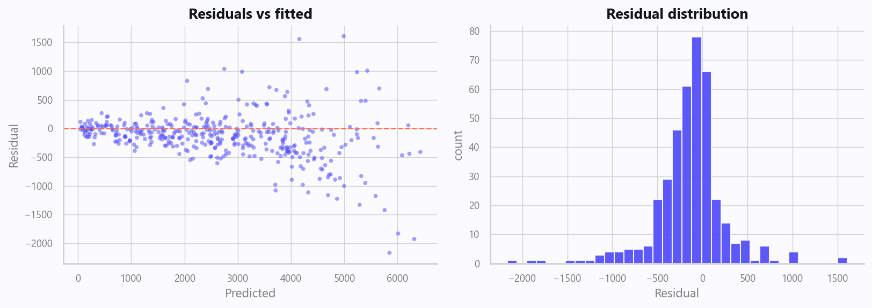
11_residuals.png
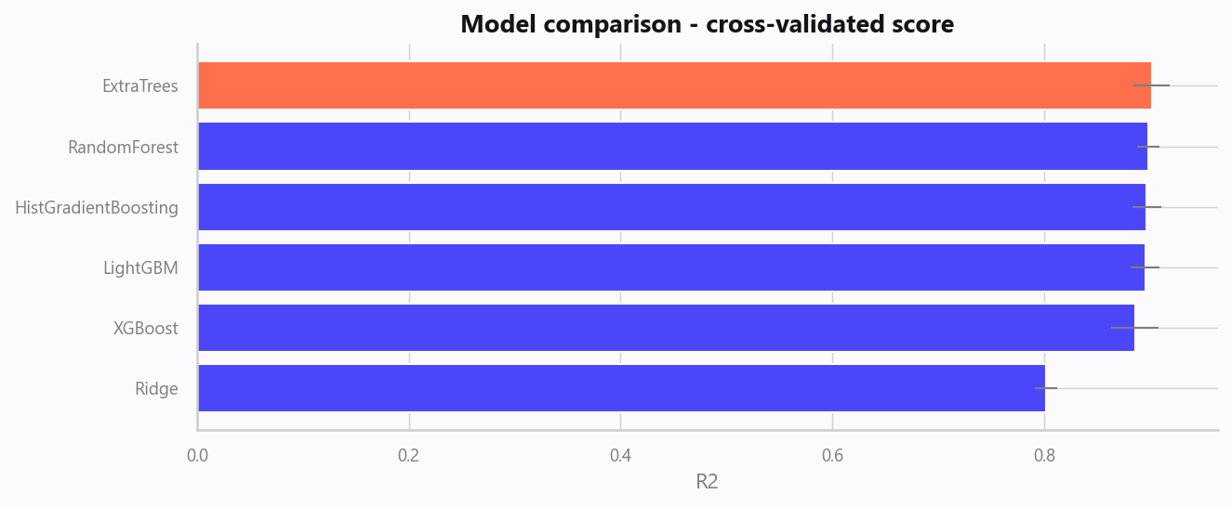
12_leaderboard.png
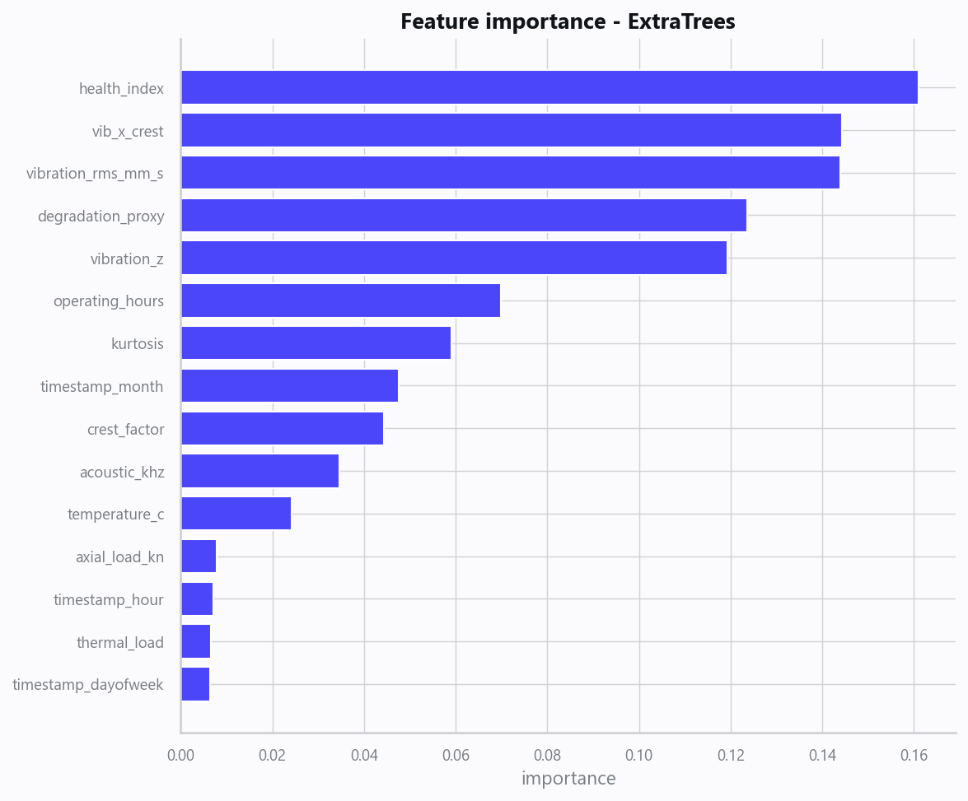
13_feature_importance.png
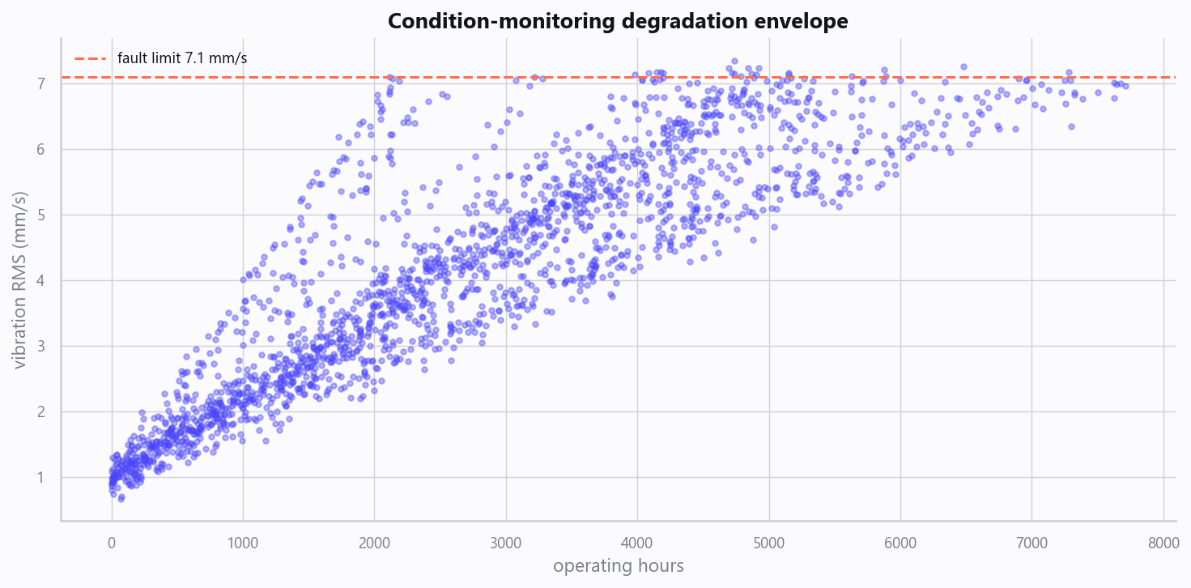
20_degradation_envelope.png
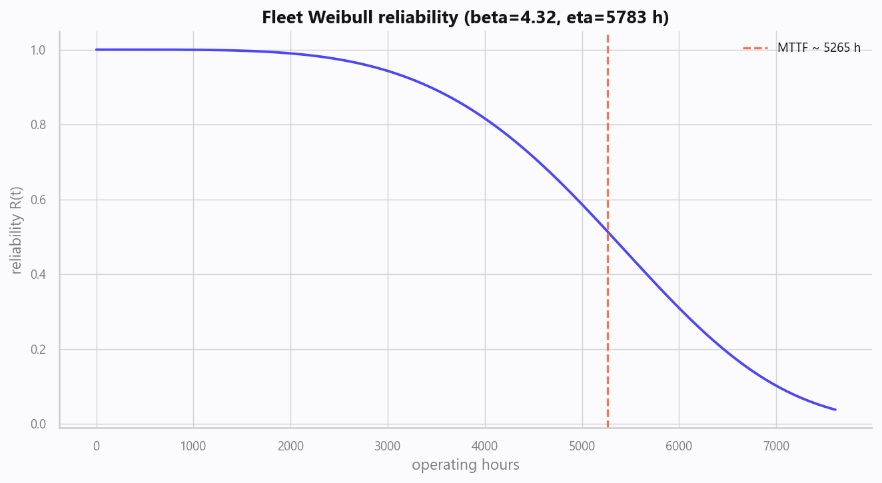
21_weibull_reliability.png
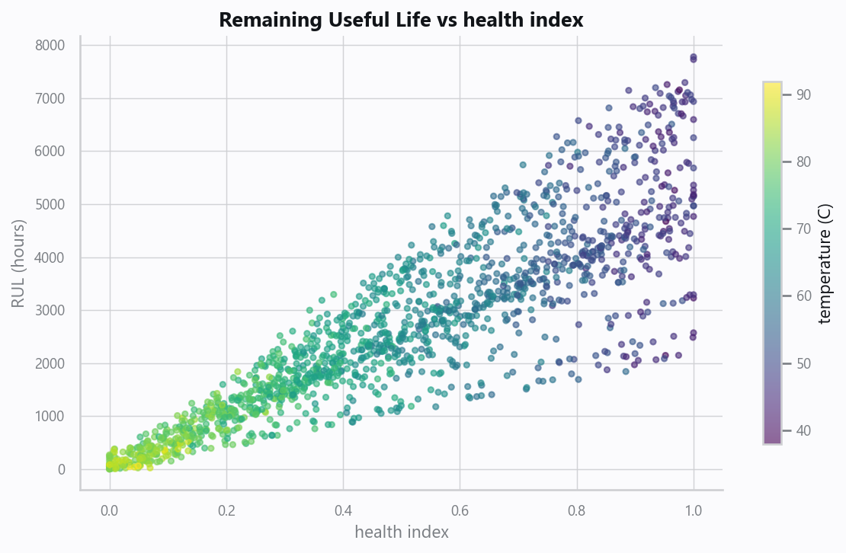
22_rul_vs_health.png

Domain Rules & Explainable Ground Truth
rule_id | field | operator | threshold | label
APM-001 | vibration_rms_mm_s | > | 7.1 | Vibration Alert (ISO Zone C/D)
APM-002 | crest_factor | > | 6.0 | Bearing Distress
APM-003 | temperature_c | > | 85 | Thermal Alert
APM-004 | health_index | < | 0.3 | Critical Health

Limitations, Risks & Next Steps
- Results reflect the data supplied and the assumptions above; validate on a fresh sample before operational use.
- If the input was capped (see the run configuration), re-run with a larger extract to confirm stability.
- Watch for drift over time and re-train on a schedule; keep the versioned rules and audit hash with each release.

Appendix - Run Configuration
Setting | Value
domain | 8
target_column
max_rows | 0
test_size | 0.2000
cv_folds | 5
split_strategy | auto
enable_tuning | False
enable_deep_learning | False
compliance_mode | True
dataset_format | csv

