Renewable Energy: Battery Energy Storage (BESS) Health
Config-driven data science pipeline for high-fidelity industrial domains.

Field | Value
Domain | 7 - Renewable Energy: Battery Energy Storage (BESS) Health
Generated | 2026-10-08 18:23 UTC
Target | soh_percentage
Task | regression
Data source | synthetic sandbox (constrained)
Records x columns | 2000 x 28
Audit SHA-256 | cb1b8ca76598b3ebd154e5449da33c9ec701ab9e1da58e30b479b20dc18c949e

Contents
Right-click here and choose 'Update Field' to build the table of contents.

Executive Summary
Resident AI offline - a local summary follows instead.
- project: Renewable Energy: Battery Energy Storage (BESS) Health
- domain: Renewable Energy: Battery Energy Storage (BESS) Health
- task: regression
- best_model: Ridge
- rmse: 0.0039
- mae: 0.0033
- median_ae: 0.0032
- mape: 0.0034
- r2: 1.0000
- adj_r2: 1.0000
- explained_variance: 1.0000
- mean_residual: 0.0032
- leaderboard_top: [{'model': 'Ridge', 'cv_score_mean': 0.9999959403533056, 'cv_score_std': 6.074460705419131e-07, 'fit_seconds': 0.02, 'rmse': 0.003871498732868034, 'mae': 0.003326654943924808, 'median_ae': 0.003200298928554446, 'mape': 0.0034157688048159184, 'r2': 0.9999930119168928, 'adj_r2': 0.9999927654492313, 'explained_variance': 0.9999977244137489, 'mean_residual': 0.003179256936878886}, {'model': 'ExtraTrees', 'cv_score_mean': 0.9992203015955967, 'cv_score_std': 0.0010086172626388348, 'fit_seconds': 2.39, 'rmse': 0.012485356658462876, 'mae': 0.004531733333338963, 'median_ae': 0.0013700000000156365, 'mape': 0.004689020934038379, 'r2': 0.9999273222080587, 'adj_r2': 0.9999247588834467, 'explained_variance': 0.9999303068744105, 'mean_residual': 0.002530160000017048}, {'model': 'RandomForest', 'cv_score_mean': 0.9986457344571947, 'cv_score_std': 0.0018803913231992, 'fit_seconds': 4.45, 'rmse': 0.01985840350805201, 'mae': 0.0065056999999983985, 'median_ae': 0.002251666666651886, 'mape': 0.006697173630857511, 'r2': 0.9998161394815751, 'adj_r2': 0.9998096547744937, 'explained_variance': 0.9998165036491389, 'mean_residual': 0.0008837933333517185}, {'model': 'XGBoost', 'cv_score_mean': 0.9965176188580228, 'cv_score_std': 0.002541291989829856, 'fit_seconds': 0.7, 'rmse': 0.0381160665555908, 'mae': 0.02237978039550819, 'median_ae': 0.01264682006836182, 'mape': 0.02294546746607804, 'r2': 0.9993226455761065, 'adj_r2': 0.9992987554823177, 'explained_variance': 0.999326739115185, 'mean_residual': -0.0029631221923826843}, {'model': 'LightGBM', 'cv_score_mean': 0.9901102776941209, 'cv_score_std': 0.004875027237360225, 'fit_seconds': 0.67, 'rmse': 0.11524245537373422, 'mae': 0.03511691988755919, 'median_ae': 0.007080143772640213, 'mape': 0.03633189310938475, 'r2': 0.9938080873073367, 'adj_r2': 0.9935897003451474, 'explained_variance': 0.9938678202839015, 'mean_residual': 0.011318976784286549}]
Interpretation: review the strongest metric first, then check the weakest one for signs of bias, leakage or under-fitting before trusting the model.

Key Metrics at a Glance
Metric | Value
Best model | Ridge
Selection metric | r2
Cross-validated score | 1.0000
rmse | 0.0039
mae | 0.0033
median_ae | 0.0032
mape | 0.0034
r2 | 1.0000
adj_r2 | 1.0000
explained_variance | 1.0000
mean_residual | 0.0032
Deployment allowed | True

Data & Methodology
The pipeline ingested 2000 records across 28 columns from synthetic sandbox (constrained). A constrained synthetic sandbox was used when no real source was supplied.
Target: soh_percentage | Task: regression | Split strategy: group. Numeric features receive robust scaling, categoricals are encoded, and the preprocessor is fitted on the training split only.
- Best model by cross-validated r2: Ridge.

Exploratory Data Analysis

Statistical moments
feature | count | mean | std | min | 25% | 50%
cycle_count | 2000.0 | 125.5 | 72.1863 | 1.0 | 63.0 | 125.5
internal_resistance_mohm | 2000.0 | 22.2298 | 1.6136 | 16.962 | 21.1212 | 22.2
cell_voltage_delta_mv | 2000.0 | 14.8191 | 5.1066 | 2.0 | 11.3535 | 14.6695
temperature_c | 2000.0 | 30.5568 | 7.0089 | 7.47 | 25.8275 | 30.625
ambient_humidity | 2000.0 | 50.1759 | 15.2717 | 5.0 | 39.97 | 50.02
current_a | 2000.0 | 1.4974 | 0.5991 | 0.007 | 1.0782 | 1.498
thermal_runaway_indicator | 2000.0 | 0.1713 | 0.1035 | 0.0178 | 0.0952 | 0.1477
soh_percentage | 2000.0 | 96.6022 | 1.555 | 88.117 | 95.634 | 96.7575
coulomb_count_ah | 2000.0 | 184.8671 | 108.8354 | 0.912 | 90.7128 | 182.5635
reading_index | 2000.0 | 999.5 | 577.4946 | 0.0 | 499.75 | 999.5
arrhenius_factor | 2000.0 | 1.6418 | 0.815 | 0.2626 | 1.061 | 1.4865
soh_loss | 2000.0 | 3.3978 | 1.555 | 0.0 | 2.306 | 3.2425

Model Performance

Model leaderboard
model | cv_score_mean | cv_score_std | fit_seconds | rmse | mae | median_ae | mape | r2 | adj_r2 | explained_variance | mean_residual
Ridge | 1.0 | 0.0 | 0.02 | 0.0039 | 0.0033 | 0.0032 | 0.0034 | 1.0 | 1.0 | 1.0 | 0.0032
ExtraTrees | 0.9992 | 0.001 | 2.39 | 0.0125 | 0.0045 | 0.0014 | 0.0047 | 0.9999 | 0.9999 | 0.9999 | 0.0025
RandomForest | 0.9986 | 0.0019 | 4.45 | 0.0199 | 0.0065 | 0.0023 | 0.0067 | 0.9998 | 0.9998 | 0.9998 | 0.0009
XGBoost | 0.9965 | 0.0025 | 0.7 | 0.0381 | 0.0224 | 0.0126 | 0.0229 | 0.9993 | 0.9993 | 0.9993 | -0.003
LightGBM | 0.9901 | 0.0049 | 0.67 | 0.1152 | 0.0351 | 0.0071 | 0.0363 | 0.9938 | 0.9936 | 0.9939 | 0.0113
HistGradientBoosting | 0.9877 | 0.0057 | 0.77 | 0.1074 | 0.0336 | 0.0068 | 0.0347 | 0.9946 | 0.9944 | 0.9947 | 0.0108

Robustness & Compliance

Deployment gates
Check | Value
boundary_accuracy | n/a
abstention_accuracy | 1.0000
leakage_rate | 0.0000
gate:performance_pass | True
gate:recall_pass | True
gate:privacy_pass | True
gate:boundary_pass | True
gate:deployment_allowed | True
gate:note | All gates satisfied - safe to proceed with human oversight.

Figures

Charts and maps
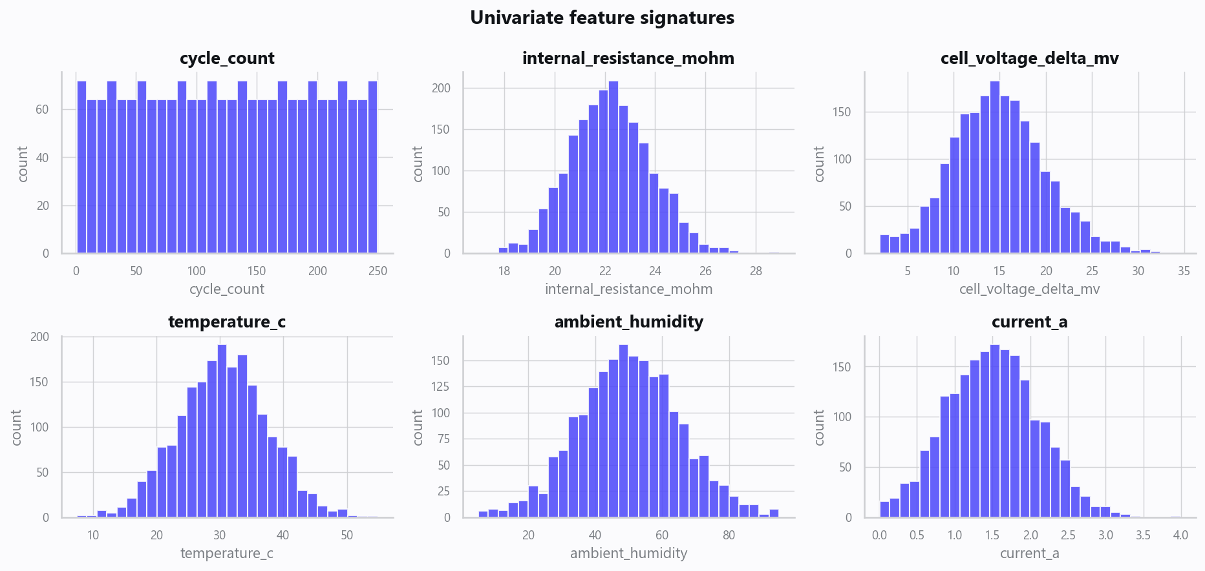
02_distributions.png
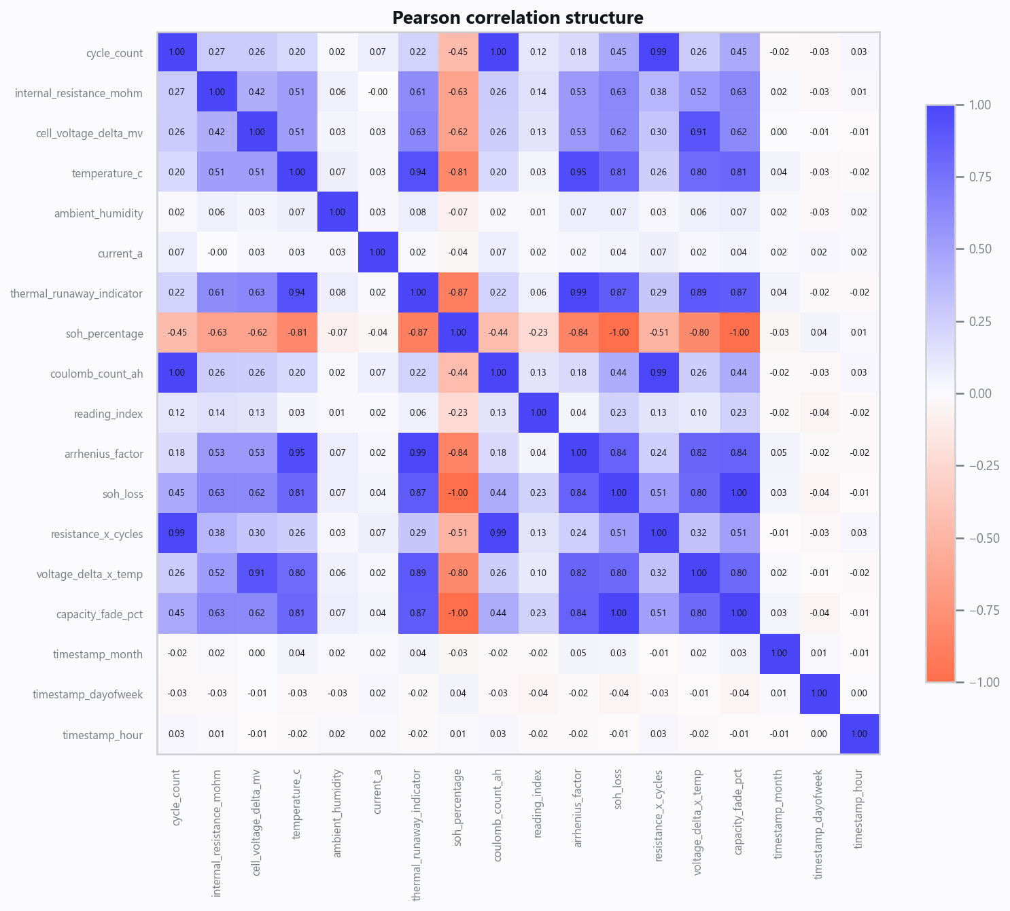
03_correlation.png
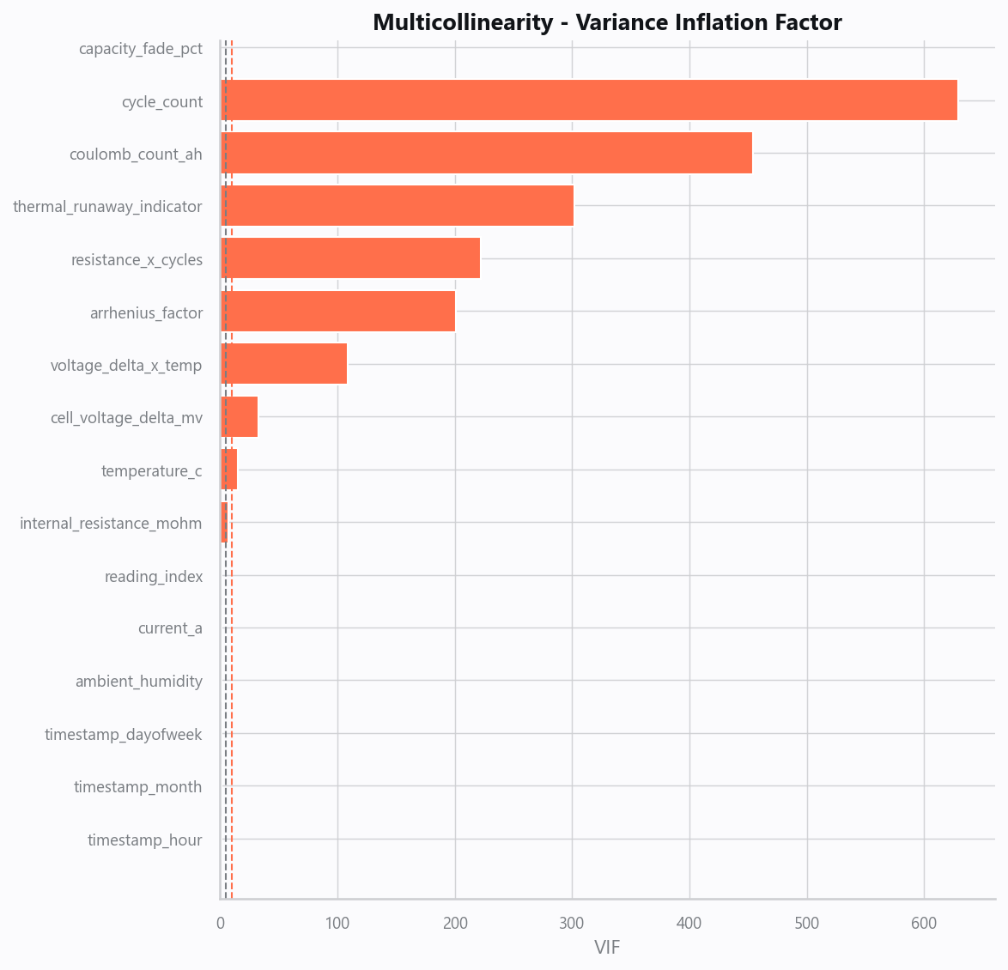
04_vif.png
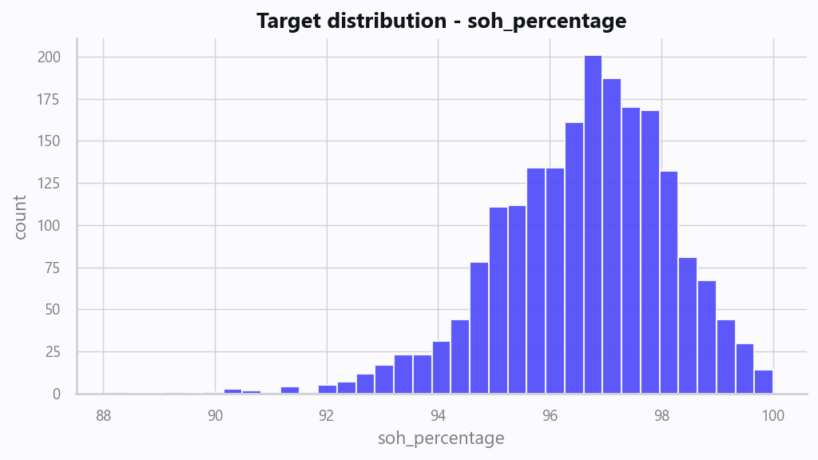
05_target.png
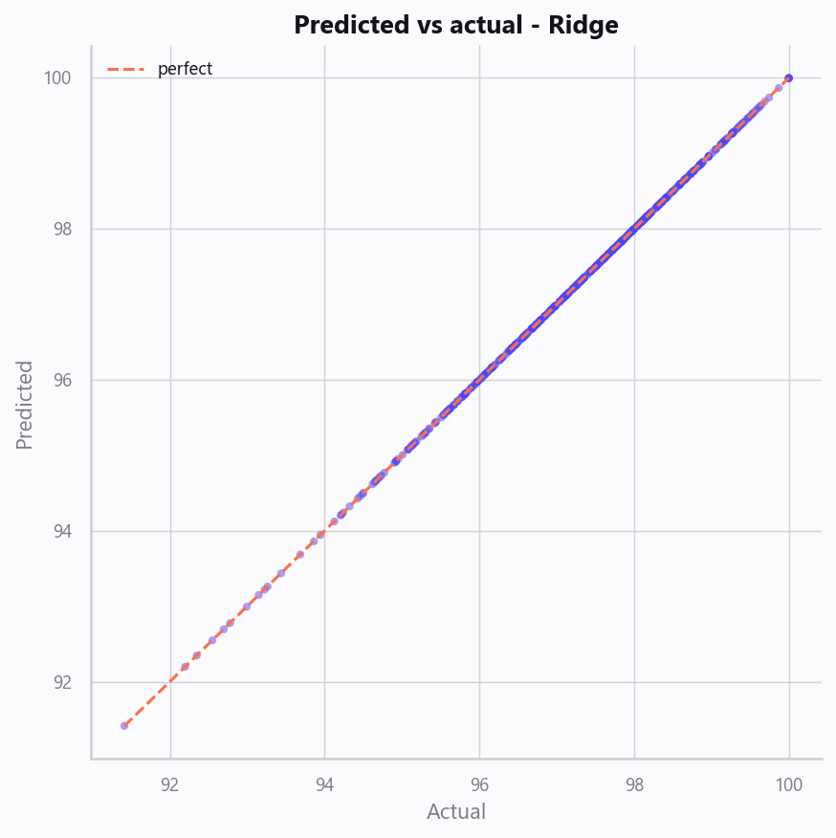
10_pred_vs_actual.png
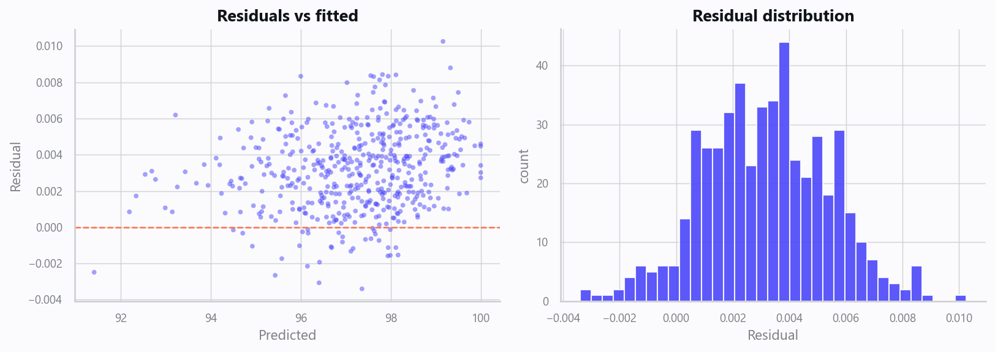
11_residuals.png
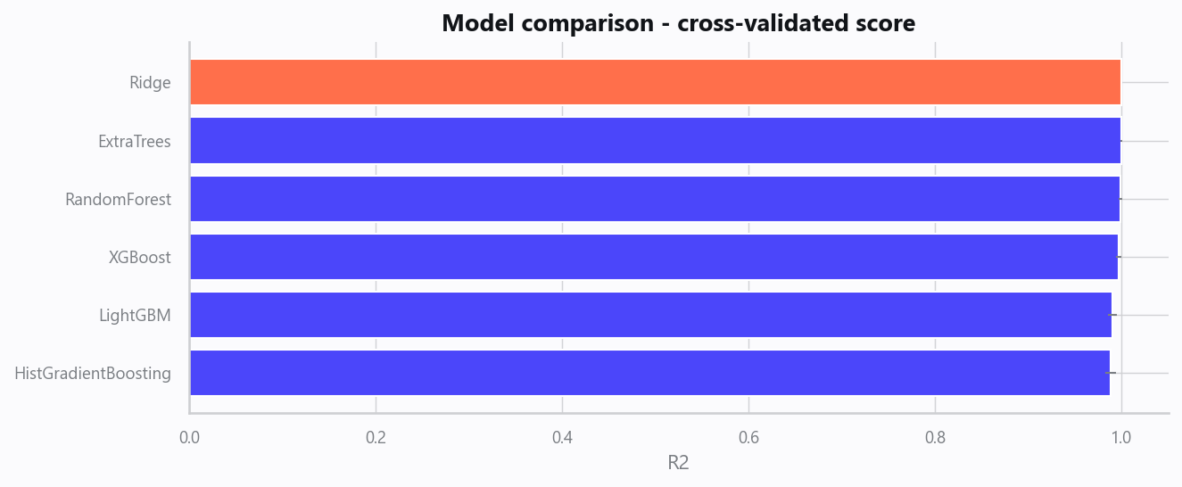
12_leaderboard.png
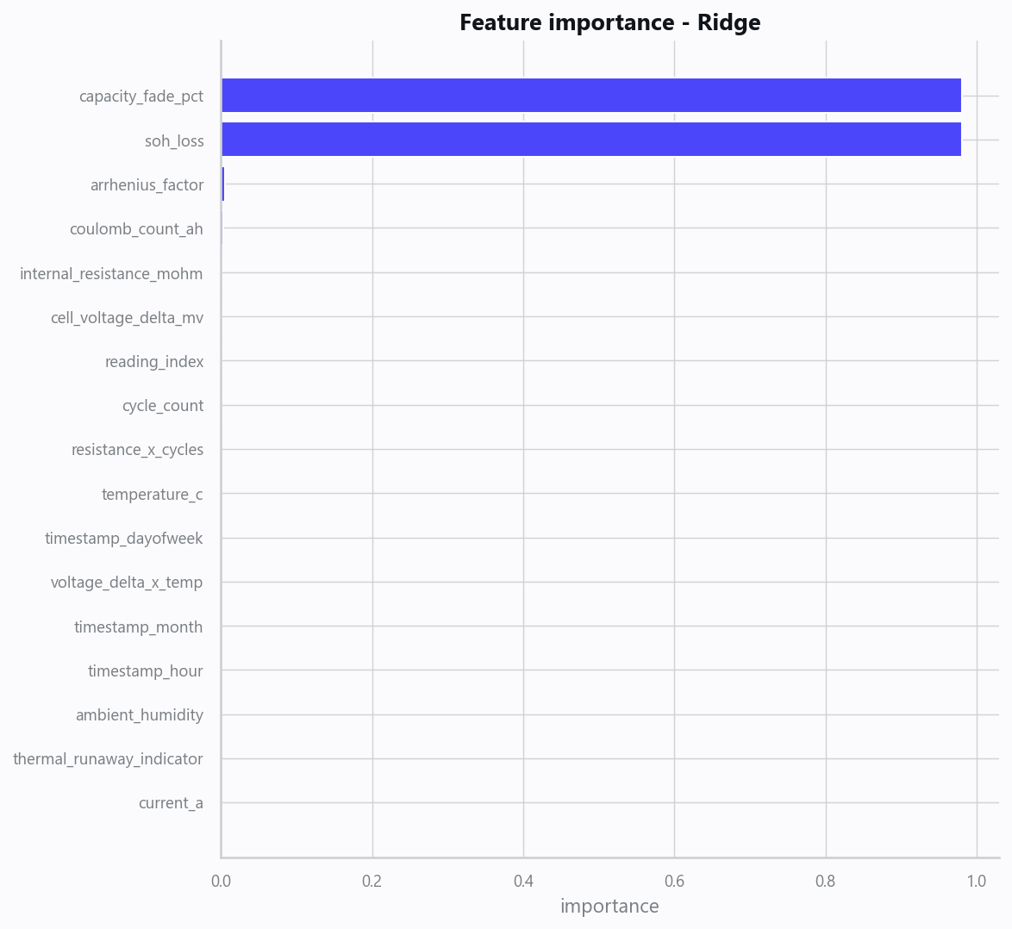
13_feature_importance.png
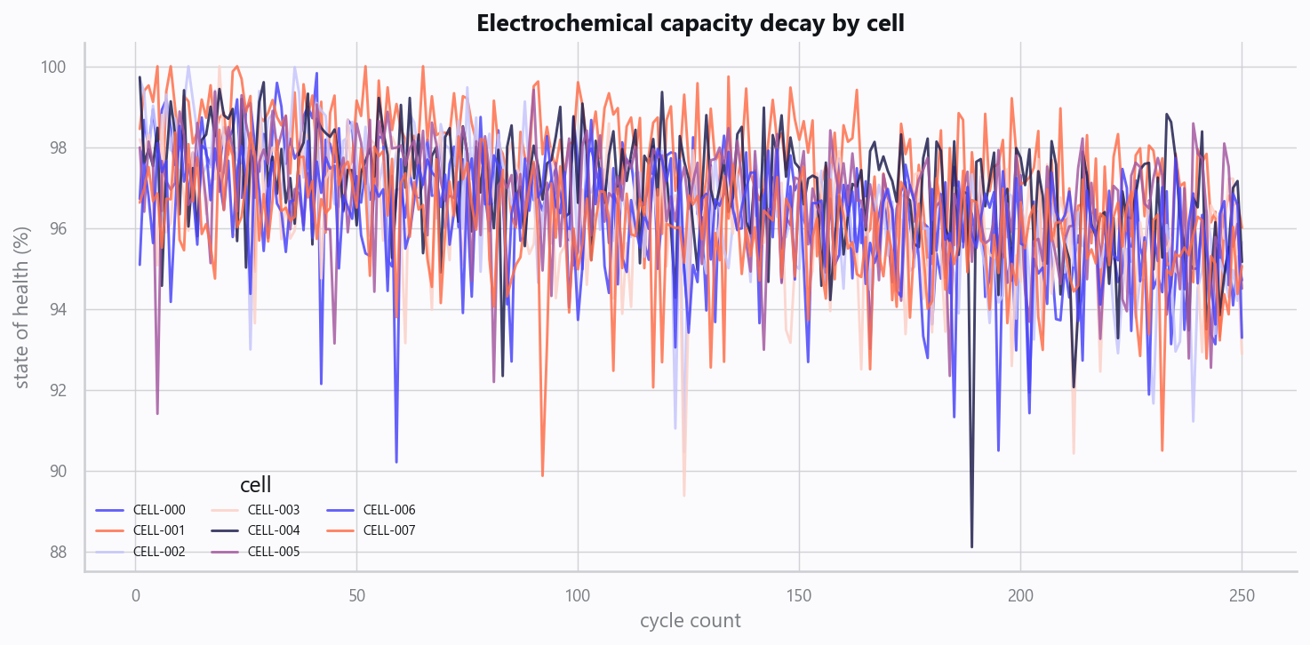
20_capacity_decay.png
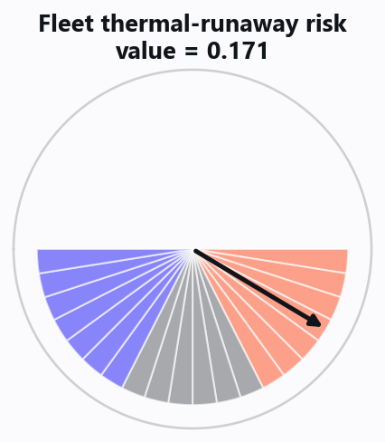
21_thermal_runaway_gauge.png

Domain Rules & Explainable Ground Truth
rule_id | field | operator | threshold | label
BESS-001 | internal_resistance_mohm | > | 45 | High Internal Resistance
BESS-002 | cell_voltage_delta_mv | > | 80 | Cell Imbalance
BESS-003 | thermal_runaway_indicator | > | 0.7 | Thermal Runaway Risk

Limitations, Risks & Next Steps
- Results reflect the data supplied and the assumptions above; validate on a fresh sample before operational use.
- If the input was capped (see the run configuration), re-run with a larger extract to confirm stability.
- Watch for drift over time and re-train on a schedule; keep the versioned rules and audit hash with each release.

Appendix - Run Configuration
Setting | Value
domain | 7
target_column
max_rows | 0
test_size | 0.2000
cv_folds | 5
split_strategy | auto
enable_tuning | False
enable_deep_learning | False
compliance_mode | True
dataset_format | csv

