ISM + Mechatronics: Industrial Robotic Arm Kinematics
Config-driven data science pipeline for high-fidelity industrial domains.

Field | Value
Domain | 6 - ISM + Mechatronics: Industrial Robotic Arm Kinematics
Generated | 2026-10-08 18:22 UTC
Target | calibration_drift
Task | classification
Data source | synthetic sandbox (constrained)
Records x columns | 2000 x 51
Audit SHA-256 | 0a594b57dad180c37173e11c7dceb22259a1e2ea7d1207e5c0ffe5a9b69c2b60

Contents
Right-click here and choose 'Update Field' to build the table of contents.

Executive Summary
Resident AI offline - a local summary follows instead.
- project: ISM + Mechatronics: Industrial Robotic Arm Kinematics
- domain: ISM + Mechatronics: Industrial Robotic Arm Kinematics
- task: classification
- best_model: LogisticRegression
- accuracy: 0.8515
- balanced_accuracy: 0.7843
- precision_weighted: 0.8506
- recall_weighted: 0.8515
- f1_weighted: 0.8509
- precision_macro: 0.8101
- recall_macro: 0.7843
- f1_macro: 0.7962
- cohen_kappa: 0.7262
- matthews_corrcoef: 0.7263
Interpretation: review the strongest metric first, then check the weakest one for signs of bias, leakage or under-fitting before trusting the model.

Key Metrics at a Glance
Metric | Value
Best model | LogisticRegression
Selection metric | f1_macro
Cross-validated score | 0.7923
accuracy | 0.8515
balanced_accuracy | 0.7843
precision_weighted | 0.8506
recall_weighted | 0.8515
f1_weighted | 0.8509
precision_macro | 0.8101
recall_macro | 0.7843
f1_macro | 0.7962
cohen_kappa | 0.7262
matthews_corrcoef | 0.7263
Deployment allowed | False

Data & Methodology
The pipeline ingested 2000 records across 51 columns from synthetic sandbox (constrained). A constrained synthetic sandbox was used when no real source was supplied.
Target: calibration_drift | Task: classification | Split strategy: group. Numeric features receive robust scaling, categoricals are encoded, and the preprocessor is fitted on the training split only.
- Best model by cross-validated f1_macro: LogisticRegression.

Exploratory Data Analysis

Statistical moments
feature | count | mean | std | min | 25% | 50%
backlash_error_factor | 2000.0 | 0.0514 | 0.019 | 0.003 | 0.0374 | 0.0493
end_effector_target_delta_mm | 2000.0 | 16.2004 | 14.0439 | 0.4408 | 6.0818 | 12.1642
error_x_mm | 2000.0 | -0.6953 | 9.8361 | -85.0014 | -4.2178 | -0.3153
error_y_mm | 2000.0 | -0.0853 | 18.6102 | -102.9257 | -9.7413 | -0.0587
error_z_mm | 2000.0 | 0.0451 | 4.0291 | -18.7416 | -2.1561 | -0.0118
drift_magnitude | 2000.0 | 0.287 | 0.1538 | 0.0024 | 0.1677 | 0.2688
torque_j1 | 2000.0 | 10.8364 | 4.5052 | -4.357 | 7.3272 | 10.2275
current_j1 | 2000.0 | 2.502 | 0.6779 | 0.472 | 2.0175 | 2.446
encoder_j1 | 2000.0 | 0.0182 | 0.3513 | -1.2169 | -0.2174 | 0.0109
commanded_j1 | 2000.0 | 0.018 | 0.3509 | -1.2352 | -0.2145 | 0.011
torque_j2 | 2000.0 | 10.9354 | 4.3846 | 0.645 | 7.446 | 10.317
current_j2 | 2000.0 | 2.5131 | 0.6573 | 0.877 | 2.0398 | 2.467

Model Performance

Model leaderboard
model | cv_score_mean | cv_score_std | fit_seconds | accuracy | balanced_accuracy | precision_weighted | recall_weighted | f1_weighted | precision_macro | recall_macro | f1_macro | cohen_kappa | matthews_corrcoef | roc_auc | log_loss
LogisticRegression | 0.7923 | 0.0413 | 0.09 | 0.8515 | 0.7843 | 0.8506 | 0.8515 | 0.8509 | 0.8101 | 0.7843 | 0.7962 | 0.7262 | 0.7263 | 0.9371 | 0.3604
LightGBM | 0.7886 | 0.0527 | 3.63 | 0.833 | 0.7466 | 0.8313 | 0.833 | 0.8319 | 0.7774 | 0.7466 | 0.7603 | 0.6916 | 0.6917 | 0.9286 | 0.579
XGBoost | 0.7712 | 0.0248 | 1.8 | 0.8247 | 0.7536 | 0.8238 | 0.8247 | 0.8239 | 0.7768 | 0.7536 | 0.7641 | 0.6772 | 0.6776 | 0.9241 | 0.5881
RandomForest | 0.7667 | 0.0444 | 2.64 | 0.8289 | 0.7059 | 0.8258 | 0.8289 | 0.8262 | 0.7665 | 0.7059 | 0.7292 | 0.6814 | 0.6819 | 0.9231 | 0.4215
HistGradientBoosting | 0.7579 | 0.0701 | 2.79 | 0.8289 | 0.7687 | 0.8282 | 0.8289 | 0.8283 | 0.7845 | 0.7687 | 0.7761 | 0.6851 | 0.6853 | 0.9264 | 0.7498
ExtraTrees | 0.7196 | 0.0484 | 1.44 | 0.8206 | 0.7126 | 0.82 | 0.8206 | 0.8181 | 0.8101 | 0.7126 | 0.7469 | 0.6652 | 0.6657 | 0.9217 | 0.4458

Robustness & Compliance

Deployment gates
Check | Value
boundary_accuracy | 0.7857
abstention_accuracy | 1.0000
leakage_rate | 0.0000
gate:performance_pass | False
gate:recall_pass | False
gate:privacy_pass | True
gate:boundary_pass | False
gate:deployment_allowed | False
gate:note | One or more gates failed - hold deployment and review.

Figures

Charts and maps
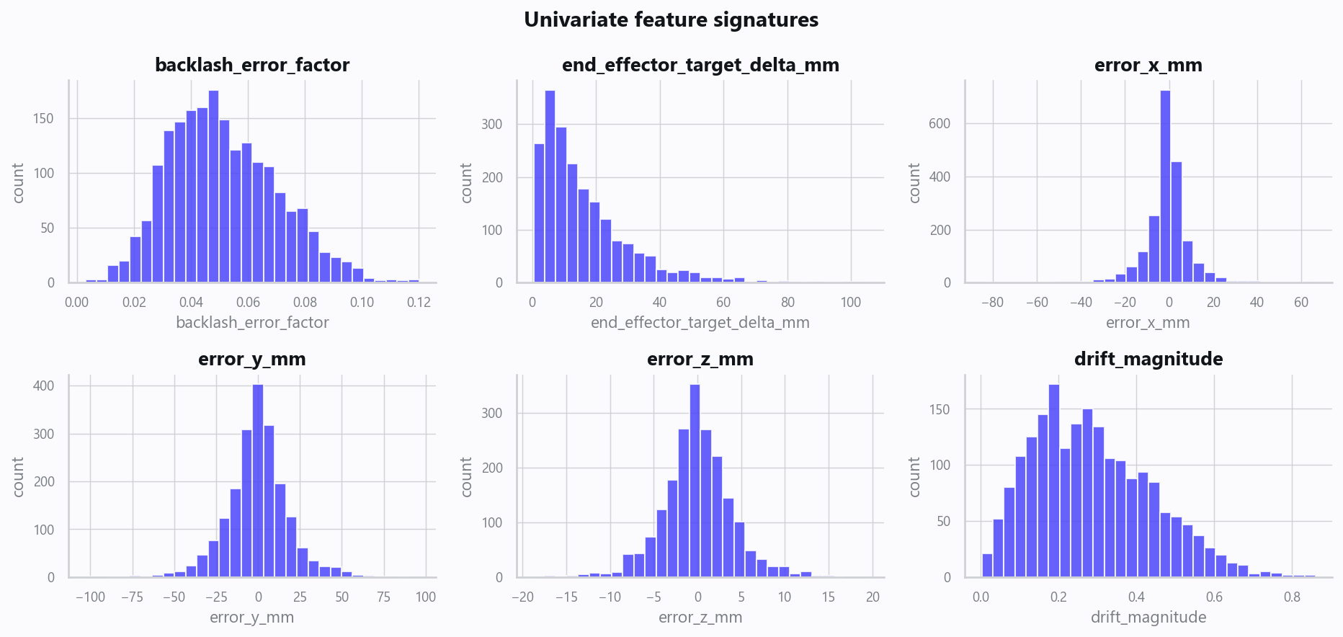
02_distributions.png
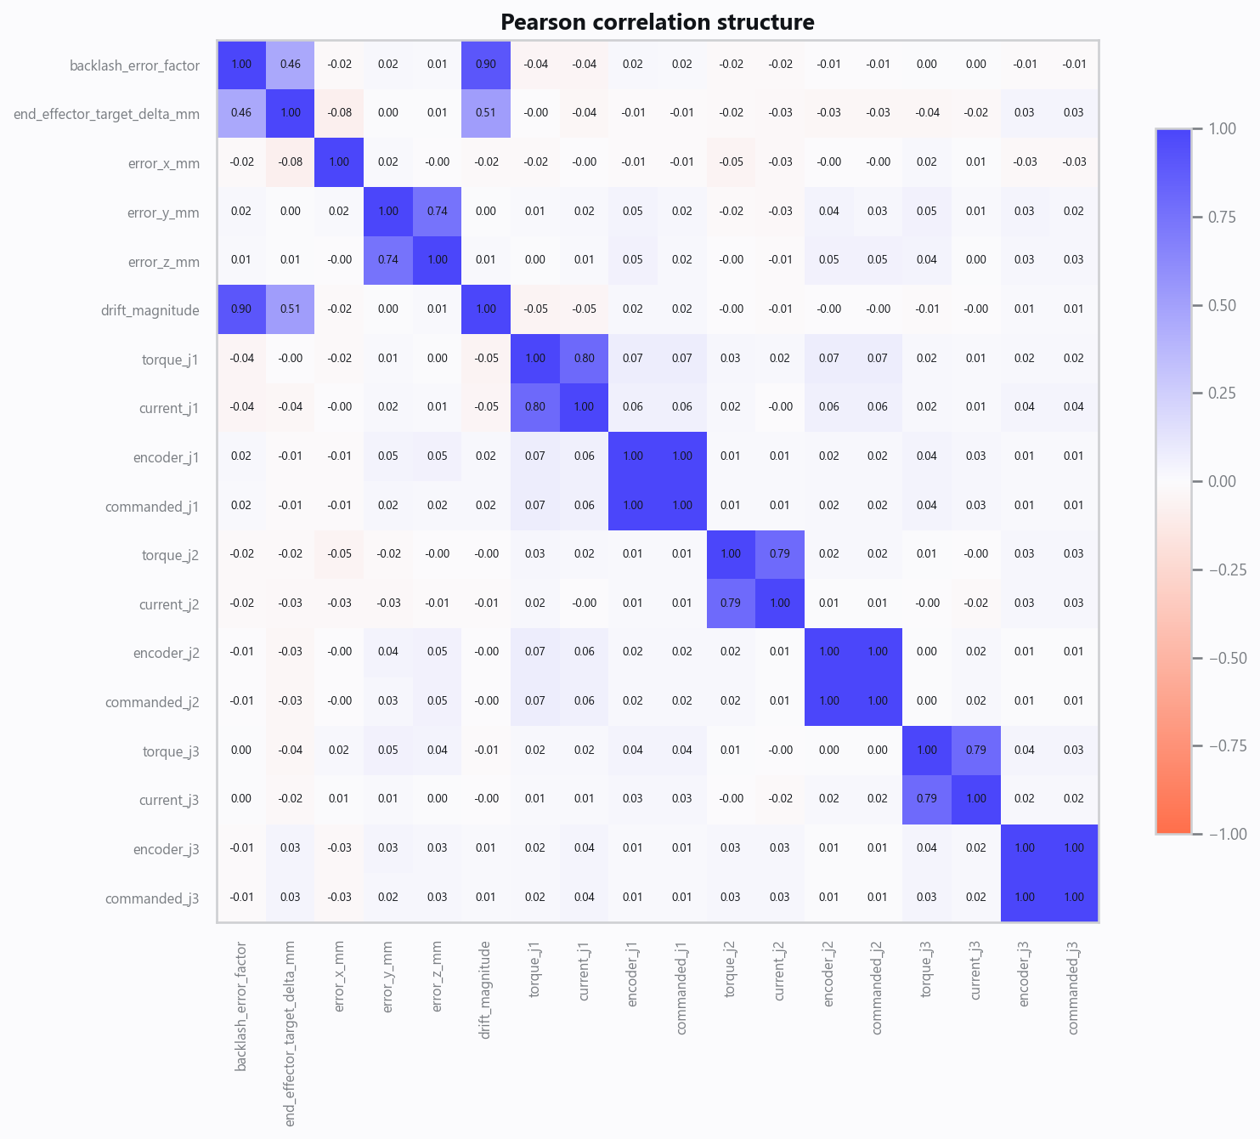
03_correlation.png
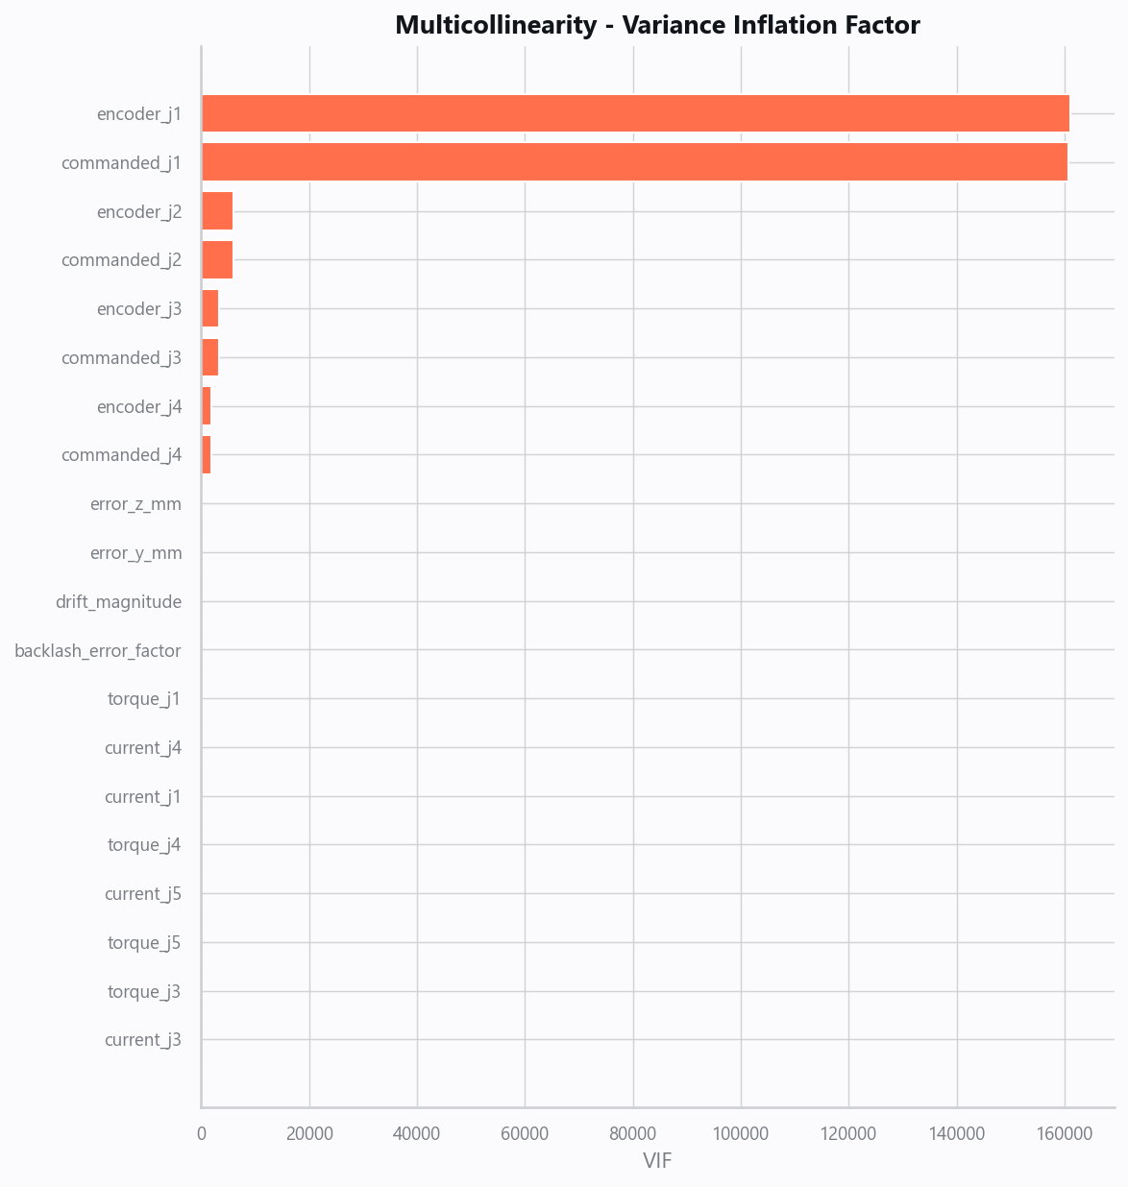
04_vif.png
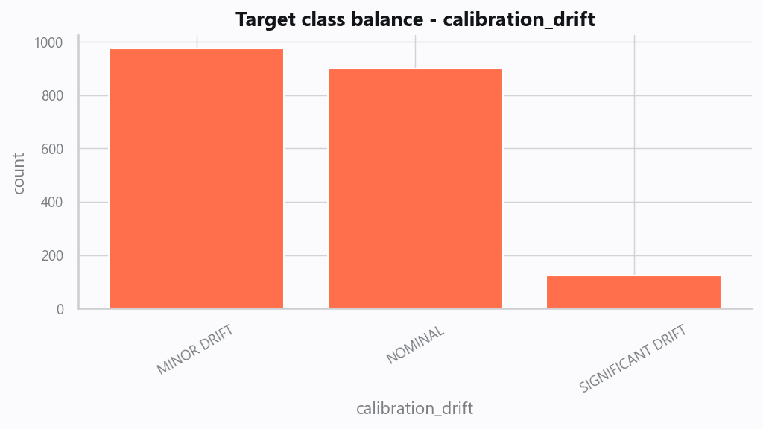
05_target.png
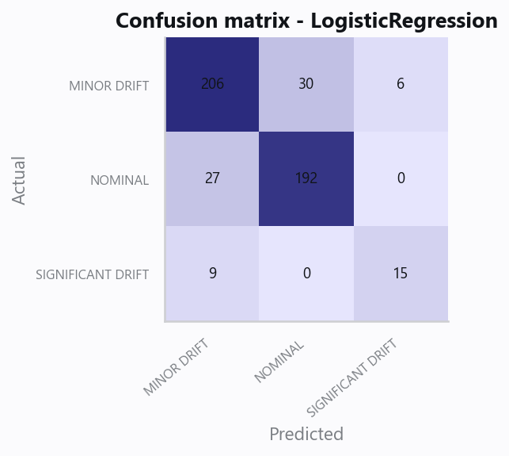
10_confusion.png
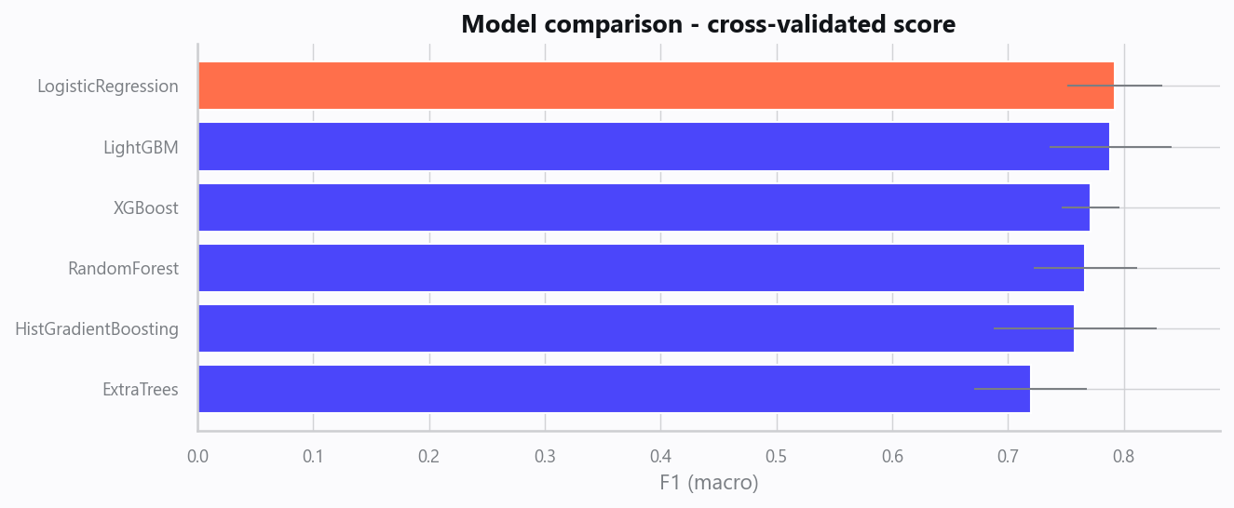
12_leaderboard.png
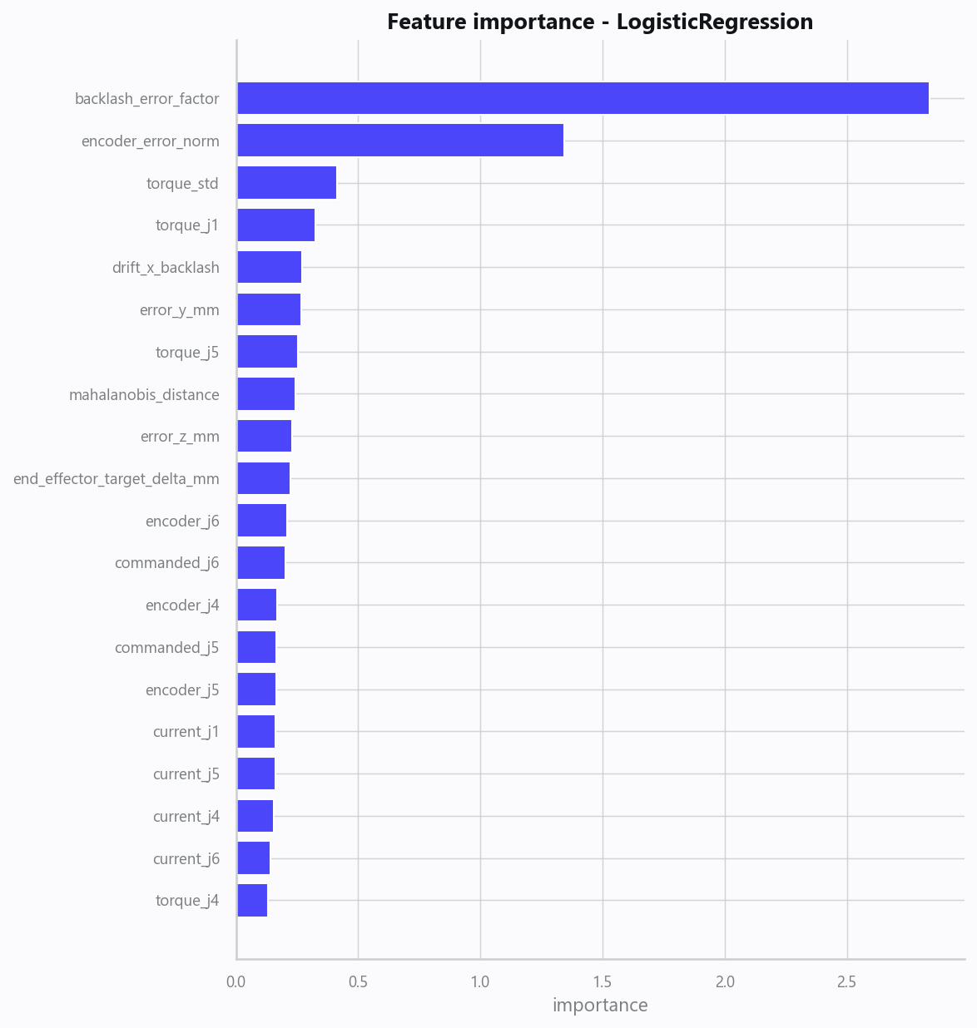
13_feature_importance.png
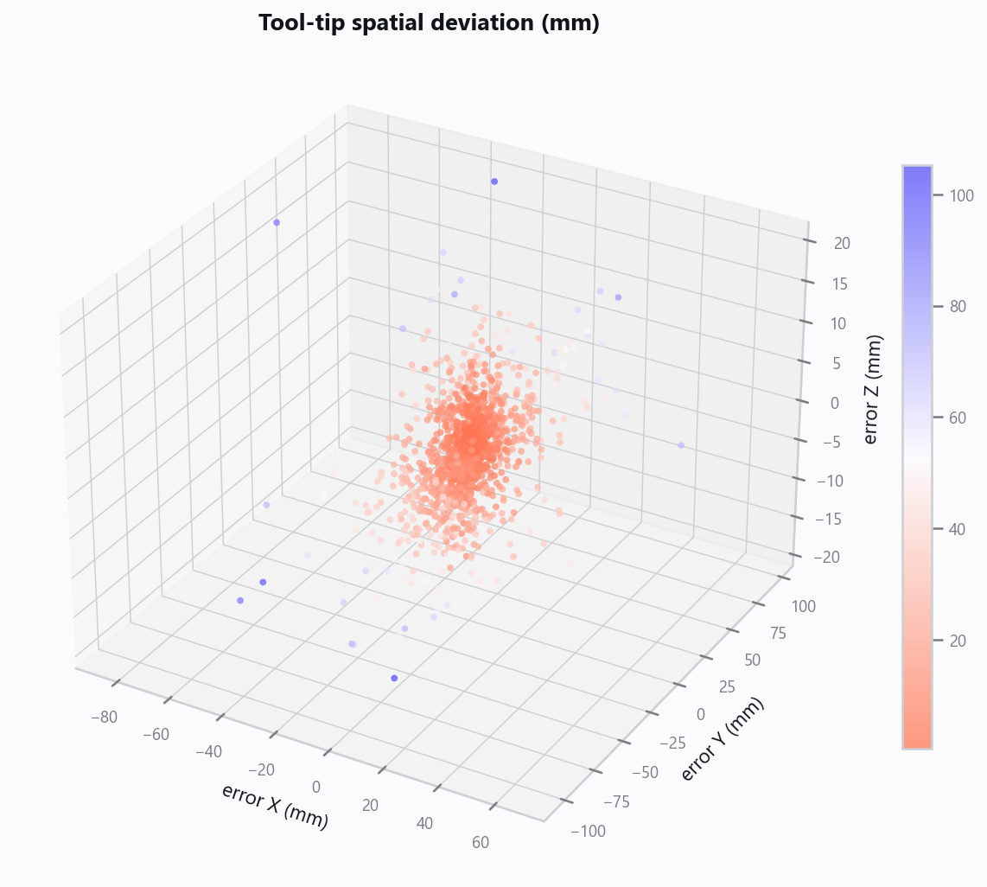
20_spatial_deviation_3d.png
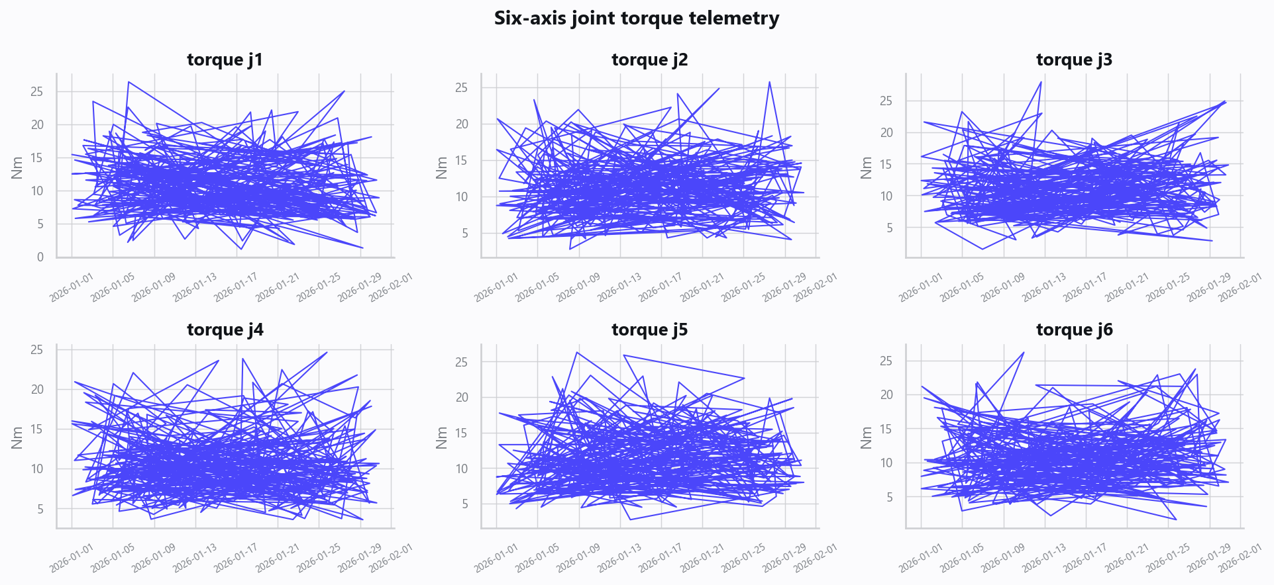
21_joint_telemetry.png

Domain Rules & Explainable Ground Truth
rule_id | field | operator | threshold | label
CAL-001 | backlash_error_factor | > | 0.08 | SIGNIFICANT DRIFT
CAL-002 | mahalanobis_distance | > | 6.0 | MINOR DRIFT
CAL-003 | end_effector_target_delta_mm | > | 12.0 | SIGNIFICANT DRIFT

Limitations, Risks & Next Steps
- Results reflect the data supplied and the assumptions above; validate on a fresh sample before operational use.
- If the input was capped (see the run configuration), re-run with a larger extract to confirm stability.
- Watch for drift over time and re-train on a schedule; keep the versioned rules and audit hash with each release.

Appendix - Run Configuration
Setting | Value
domain | 6
target_column
max_rows | 0
test_size | 0.2000
cv_folds | 5
split_strategy | auto
enable_tuning | False
enable_deep_learning | False
compliance_mode | True
dataset_format | csv

