Renewable Energy: Smart Grid Load & Solar/Wind Forecasting
Config-driven data science pipeline for high-fidelity industrial domains.

Field | Value
Domain | 5 - Renewable Energy: Smart Grid Load & Solar/Wind Forecasting
Generated | 2026-10-08 18:22 UTC
Target | curtailment_risk
Task | classification
Data source | synthetic sandbox (constrained)
Records x columns | 2000 x 35
Audit SHA-256 | 2db0f107fd9f62bce80079c4372de097ced9014f844788bebe96afc8a787df76

Contents
Right-click here and choose 'Update Field' to build the table of contents.

Executive Summary
Resident AI offline - a local summary follows instead.
- project: Renewable Energy: Smart Grid Load & Solar/Wind Forecasting
- domain: Renewable Energy: Smart Grid Load & Solar/Wind Forecasting
- task: classification
- best_model: LightGBM
- accuracy: 1.0000
- balanced_accuracy: 1.0000
- precision_weighted: 1.0000
- recall_weighted: 1.0000
- f1_weighted: 1.0000
- precision_macro: 1.0000
- recall_macro: 1.0000
- f1_macro: 1.0000
- cohen_kappa: 1.0000
- matthews_corrcoef: 1.0000
Interpretation: review the strongest metric first, then check the weakest one for signs of bias, leakage or under-fitting before trusting the model.

Key Metrics at a Glance
Metric | Value
Best model | LightGBM
Selection metric | f1_macro
Cross-validated score | 0.9958
accuracy | 1.0000
balanced_accuracy | 1.0000
precision_weighted | 1.0000
recall_weighted | 1.0000
f1_weighted | 1.0000
precision_macro | 1.0000
recall_macro | 1.0000
f1_macro | 1.0000
cohen_kappa | 1.0000
matthews_corrcoef | 1.0000
Deployment allowed | True

Data & Methodology
The pipeline ingested 2000 records across 35 columns from synthetic sandbox (constrained). A constrained synthetic sandbox was used when no real source was supplied.
Target: curtailment_risk | Task: classification | Split strategy: temporal. Numeric features receive robust scaling, categoricals are encoded, and the preprocessor is fitted on the training split only.
- Best model by cross-validated f1_macro: LightGBM.

Exploratory Data Analysis

Statistical moments
feature | count | mean | std | min | 25% | 50%
inverter_efficiency | 2000.0 | 0.9602 | 0.0148 | 0.914 | 0.9501 | 0.9602
wind_speed_ms | 2000.0 | 6.0366 | 3.2376 | 0.19 | 3.5788 | 5.6895
grid_frequency_hz | 2000.0 | 50.0497 | 0.0494 | 49.8637 | 50.0223 | 50.0518
frequency_drift_hz | 2000.0 | 0.0497 | 0.0494 | -0.1363 | 0.0223 | 0.0518
irradiance_wm2 | 2000.0 | 154.026 | 194.6706 | 0.0 | 0.0 | 0.0
battery_soc | 2000.0 | 55.4327 | 1.2004 | 53.03 | 54.4 | 55.8
pv_power_kw | 2000.0 | 739.3267 | 934.4749 | 0.0 | 0.0 | 0.0
wind_power_kw | 2000.0 | 630.2602 | 1085.1548 | 0.0 | 1.0625 | 106.79
renewable_kw | 2000.0 | 1369.5869 | 1439.3101 | 0.0 | 71.7025 | 949.59
demand_kw | 2000.0 | 3174.3809 | 927.9321 | 1312.47 | 2300.615 | 3346.57
curtailment_kw | 2000.0 | 57.0667 | 255.609 | 0.0 | 0.0 | 0.0
curtailment_ratio | 2000.0 | 0.0121 | 0.0539 | 0.0 | 0.0 | 0.0

Model Performance

Model leaderboard
model | cv_score_mean | cv_score_std | fit_seconds | accuracy | balanced_accuracy | precision_weighted | recall_weighted | f1_weighted | precision_macro | recall_macro | f1_macro | cohen_kappa | matthews_corrcoef | roc_auc | log_loss
LightGBM | 0.9958 | 0.0083 | 0.41 | 1.0 | 1.0 | 1.0 | 1.0 | 1.0 | 1.0 | 1.0 | 1.0 | 1.0 | 1.0 | 1.0 | 0.0
XGBoost | 0.9837 | 0.0325 | 0.12 | 1.0 | 1.0 | 1.0 | 1.0 | 1.0 | 1.0 | 1.0 | 1.0 | 1.0 | 1.0 | 1.0 | 0.0013
HistGradientBoosting | 0.9817 | 0.0228 | 0.2 | 1.0 | 1.0 | 1.0 | 1.0 | 1.0 | 1.0 | 1.0 | 1.0 | 1.0 | 1.0 | 1.0 | 0.0
RandomForest | 0.9767 | 0.0208 | 1.34 | 0.9975 | 0.9987 | 0.9976 | 0.9975 | 0.9975 | 0.975 | 0.9987 | 0.9865 | 0.973 | 0.9734 | 1.0 | 0.0078
ExtraTrees | 0.9713 | 0.0238 | 1.01 | 0.9975 | 0.9987 | 0.9976 | 0.9975 | 0.9975 | 0.975 | 0.9987 | 0.9865 | 0.973 | 0.9734 | 1.0 | 0.0098
LogisticRegression | 0.9678 | 0.0264 | 0.14 | 0.9975 | 0.9987 | 0.9976 | 0.9975 | 0.9975 | 0.975 | 0.9987 | 0.9865 | 0.973 | 0.9734 | 0.9999 | 0.0066

Robustness & Compliance

Deployment gates
Check | Value
boundary_accuracy | 1.0000
abstention_accuracy | 1.0000
leakage_rate | 0.0000
gate:performance_pass | True
gate:recall_pass | True
gate:privacy_pass | True
gate:boundary_pass | True
gate:deployment_allowed | True
gate:note | All gates satisfied - safe to proceed with human oversight.

Figures

Charts and maps
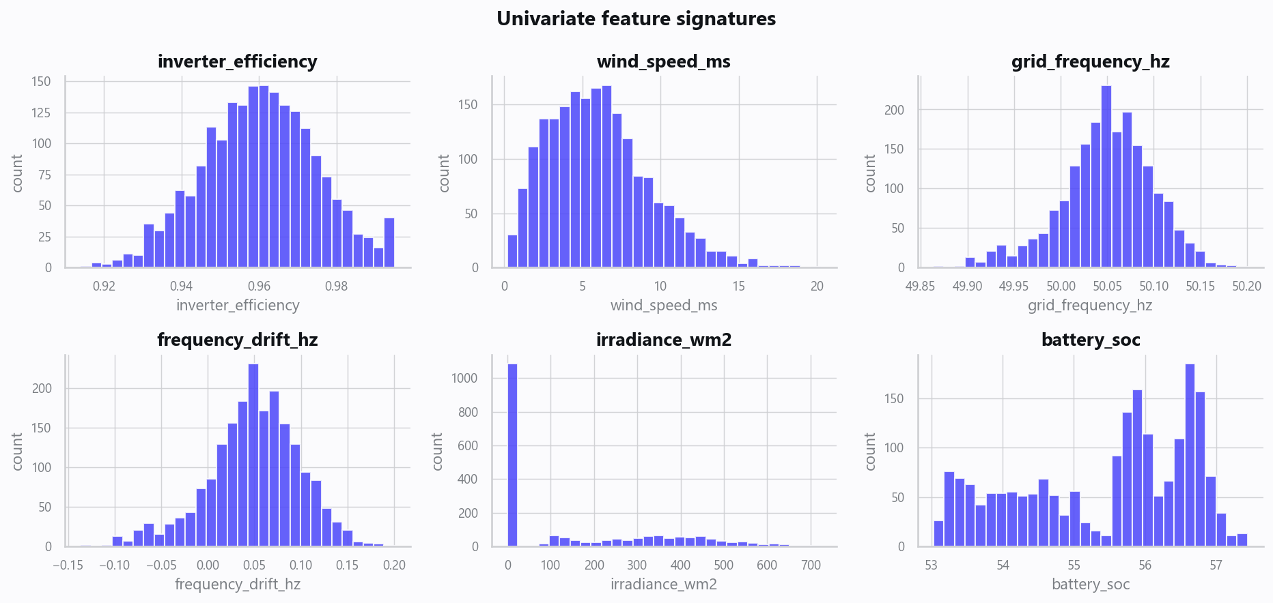
02_distributions.png
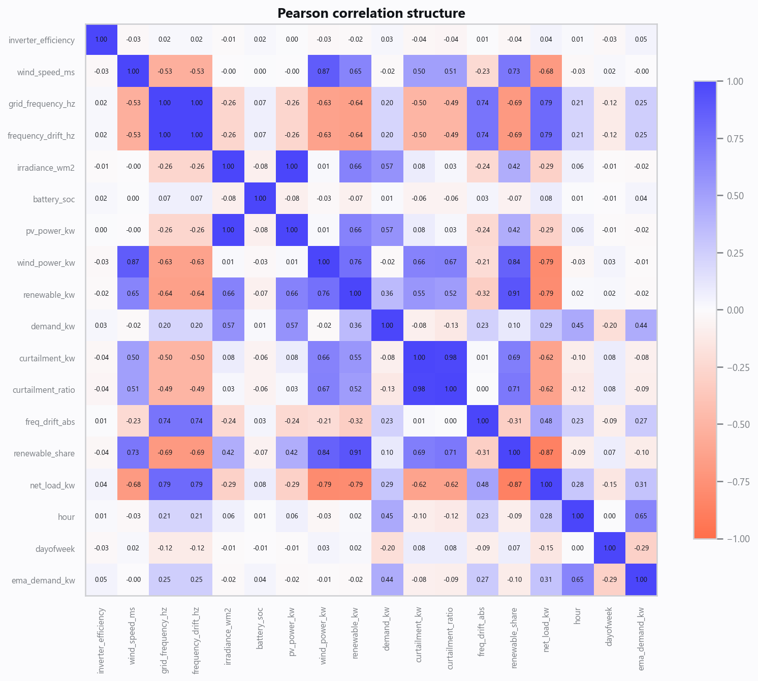
03_correlation.png
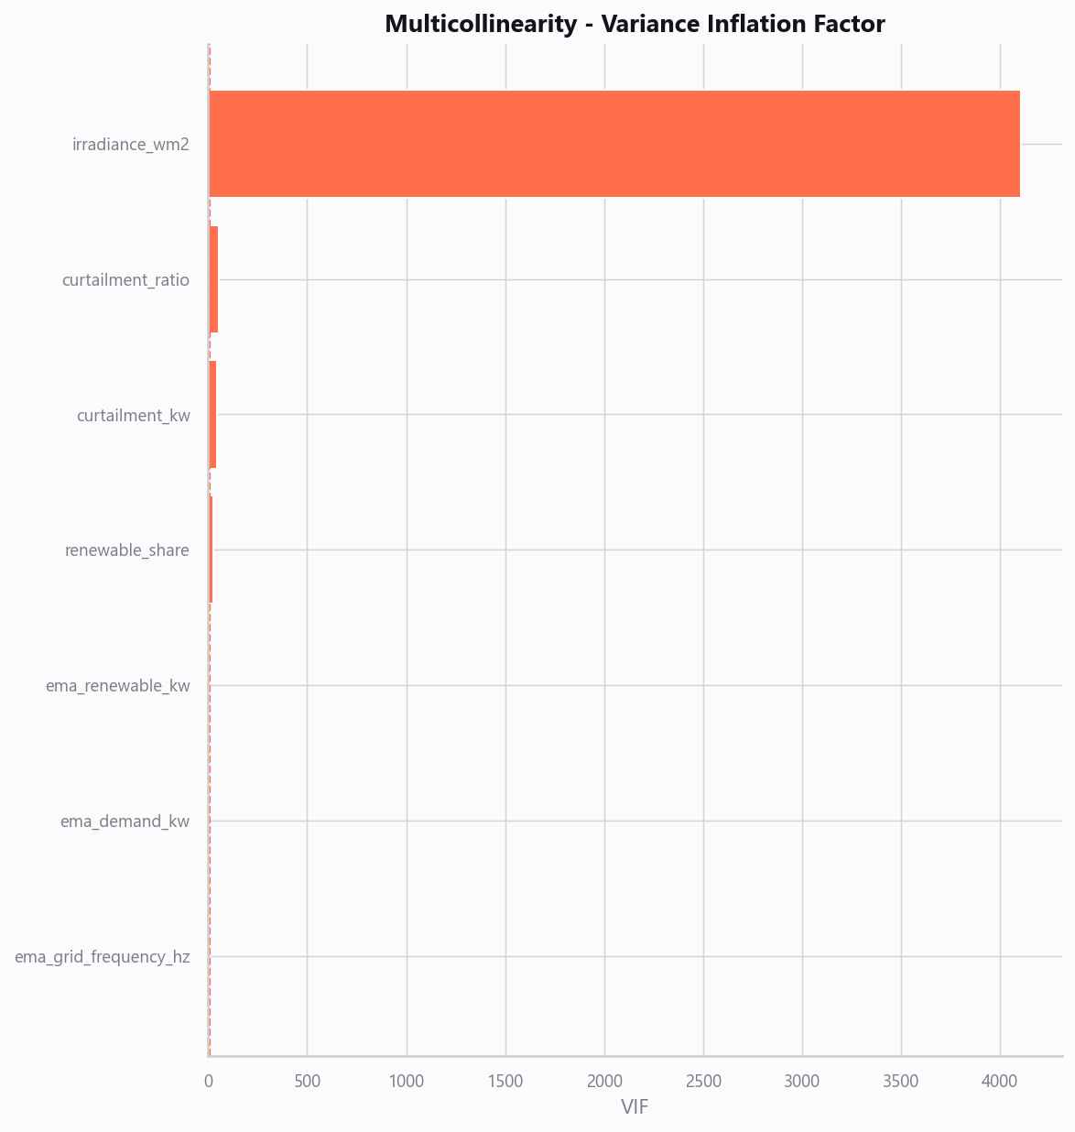
04_vif.png
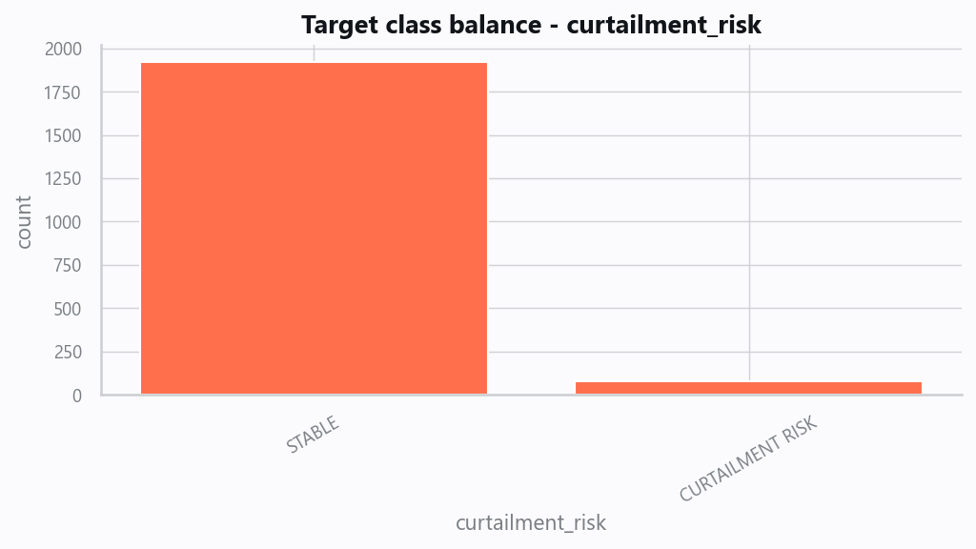
05_target.png
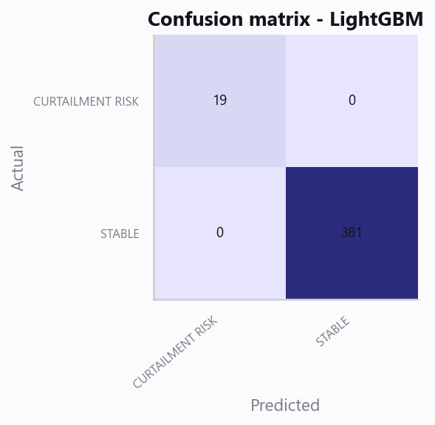
10_confusion.png
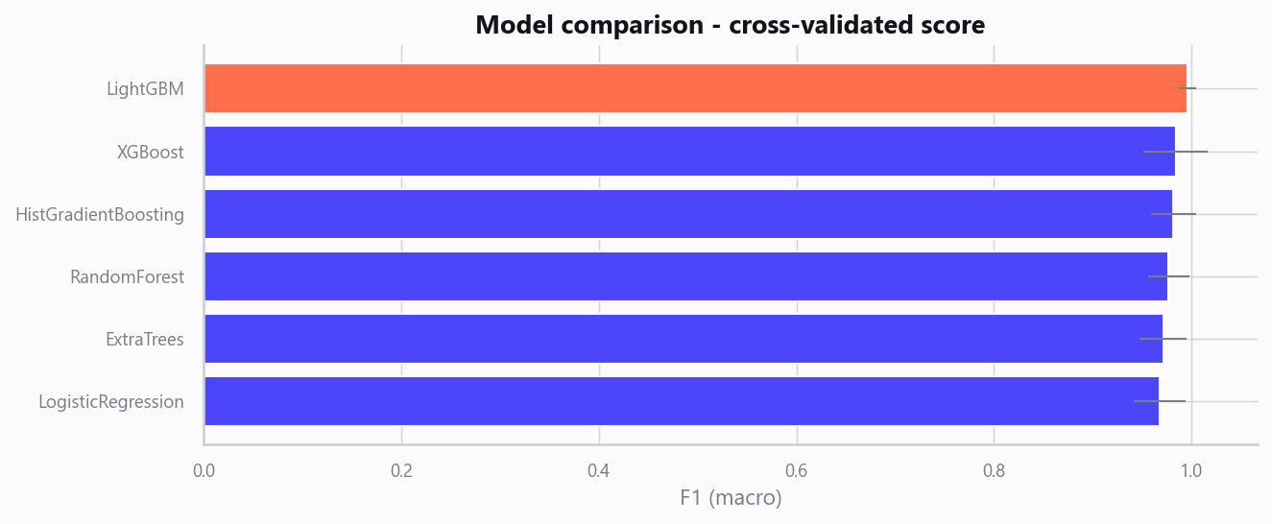
12_leaderboard.png
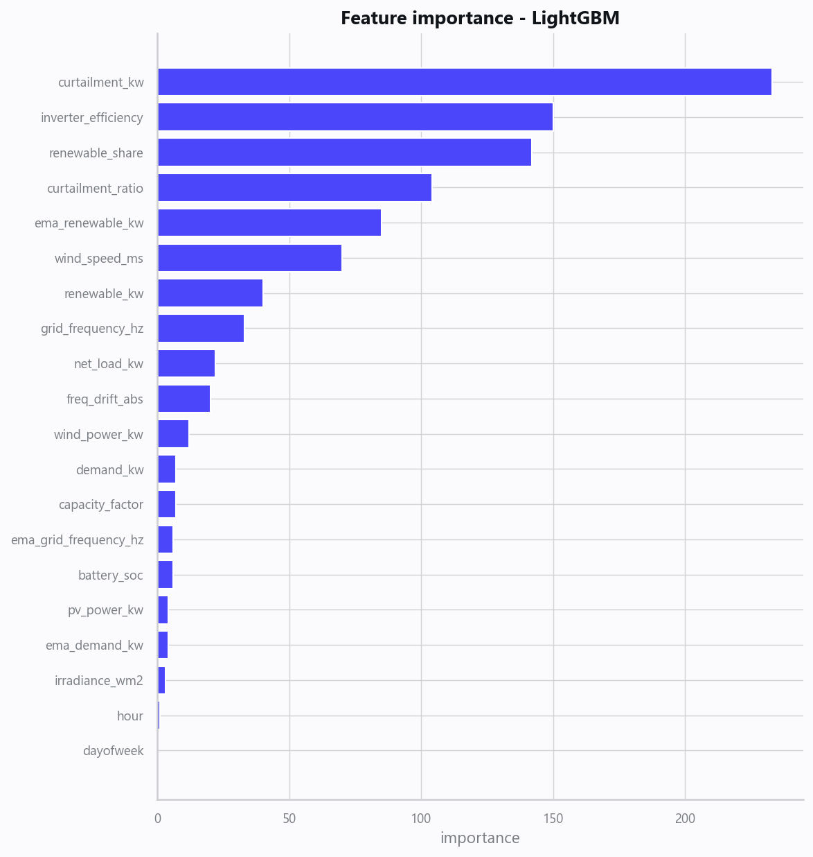
13_feature_importance.png
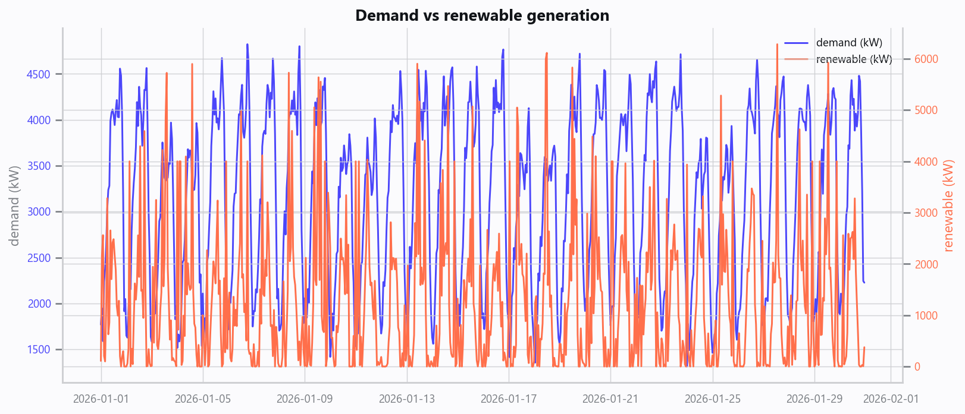
20_demand_vs_generation.png
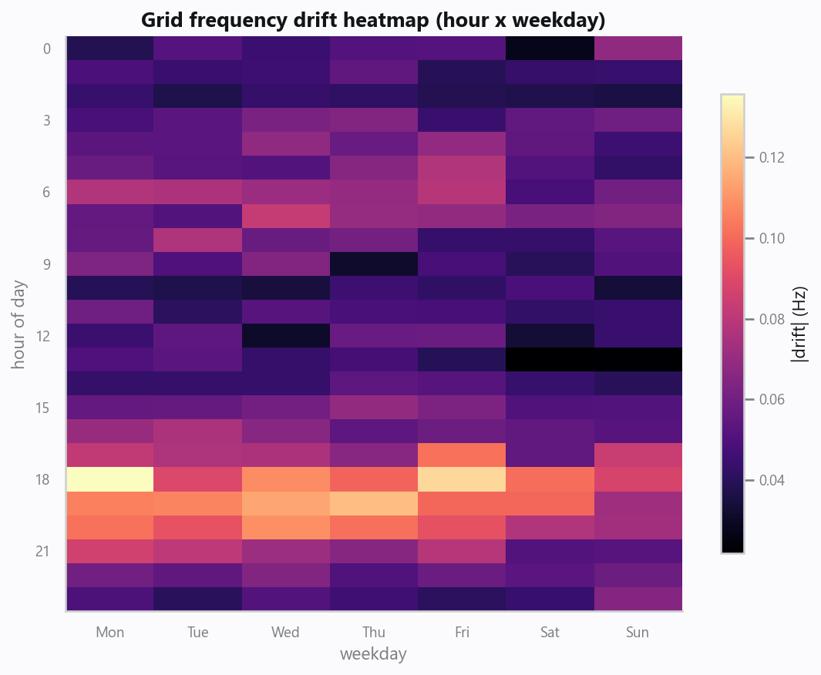
21_frequency_heatmap.png

Domain Rules & Explainable Ground Truth
rule_id | field | operator | threshold | label
GRID-001 | curtailment_ratio | > | 0.15 | CURTAILMENT RISK
GRID-002 | freq_drift_abs | > | 0.5 | FREQUENCY INSTABILITY
GRID-003 | battery_soc | < | 5 | STORAGE DEPLETED

Limitations, Risks & Next Steps
- Results reflect the data supplied and the assumptions above; validate on a fresh sample before operational use.
- If the input was capped (see the run configuration), re-run with a larger extract to confirm stability.
- Watch for drift over time and re-train on a schedule; keep the versioned rules and audit hash with each release.

Appendix - Run Configuration
Setting | Value
domain | 5
target_column
max_rows | 0
test_size | 0.2000
cv_folds | 5
split_strategy | auto
enable_tuning | False
enable_deep_learning | False
compliance_mode | True
dataset_format | csv

