Mechanical Engineering: Predictive Maintenance & Vibration
Config-driven data science pipeline for high-fidelity industrial domains.

Field | Value
Domain | 4 - Mechanical Engineering: Predictive Maintenance & Vibration
Generated | 2026-10-08 18:22 UTC
Target | failure_type
Task | classification
Data source | synthetic sandbox (constrained)
Records x columns | 2000 x 36
Audit SHA-256 | 69732d1fef320a9ba2074c9e5f475346be29aff9b644ece578df88e30a066a46

Contents
Right-click here and choose 'Update Field' to build the table of contents.

Executive Summary
Resident AI offline - a local summary follows instead.
- project: Mechanical Engineering: Predictive Maintenance & Vibration
- domain: Mechanical Engineering: Predictive Maintenance & Vibration
- task: classification
- best_model: LightGBM
- accuracy: 0.9924
- balanced_accuracy: 0.8883
- precision_weighted: 0.9926
- recall_weighted: 0.9924
- f1_weighted: 0.9912
- precision_macro: 0.9862
- recall_macro: 0.8883
- f1_macro: 0.9093
- cohen_kappa: 0.9825
- matthews_corrcoef: 0.9825
Interpretation: review the strongest metric first, then check the weakest one for signs of bias, leakage or under-fitting before trusting the model.

Key Metrics at a Glance
Metric | Value
Best model | LightGBM
Selection metric | f1_macro
Cross-validated score | 0.9487
accuracy | 0.9924
balanced_accuracy | 0.8883
precision_weighted | 0.9926
recall_weighted | 0.9924
f1_weighted | 0.9912
precision_macro | 0.9862
recall_macro | 0.8883
f1_macro | 0.9093
cohen_kappa | 0.9825
matthews_corrcoef | 0.9825
Deployment allowed | True

Data & Methodology
The pipeline ingested 2000 records across 36 columns from synthetic sandbox (constrained). A constrained synthetic sandbox was used when no real source was supplied.
Target: failure_type | Task: classification | Split strategy: group. Numeric features receive robust scaling, categoricals are encoded, and the preprocessor is fitted on the training split only.
- Best model by cross-validated f1_macro: LightGBM.

Exploratory Data Analysis

Statistical moments
feature | count | mean | std | min | 25% | 50%
runtime_hours | 2000.0 | 5926.205 | 3471.9892 | 7.7 | 2949.925 | 5946.15
rotational_speed_rpm | 2000.0 | 1487.8699 | 220.4501 | 697.3 | 1341.6 | 1495.05
axial_load_kn | 2000.0 | 3.2366 | 1.1743 | 0.02 | 2.4032 | 3.231
temperature_c | 2000.0 | 63.8897 | 13.8961 | 26.76 | 53.7975 | 62.945
acoustic_khz | 2000.0 | 9.6907 | 5.2147 | 0.0 | 5.6242 | 9.3345
vib_x_rms | 2000.0 | 3.5866 | 1.7337 | 0.0 | 2.1863 | 3.481
vib_y_rms | 2000.0 | 2.5374 | 1.1039 | 0.0 | 1.72 | 2.5
vib_z_rms | 2000.0 | 3.7482 | 1.8508 | 0.0 | 2.2838 | 3.6465
vib_rms | 2000.0 | 3.3866 | 1.4826 | 0.195 | 2.1588 | 3.2685
vib_peak | 2000.0 | 17.5678 | 11.2952 | 0.881 | 7.9755 | 15.1755
vib_crest_factor | 2000.0 | 4.7267 | 1.1975 | 1.626 | 3.7712 | 4.6735
vib_kurtosis | 2000.0 | 5.6168 | 1.7898 | 1.014 | 4.2432 | 5.467

Model Performance

Model leaderboard
model | cv_score_mean | cv_score_std | fit_seconds | accuracy | balanced_accuracy | precision_weighted | recall_weighted | f1_weighted | precision_macro | recall_macro | f1_macro | cohen_kappa | matthews_corrcoef | roc_auc | log_loss
LightGBM | 0.9487 | 0.0394 | 2.66 | 0.9924 | 0.8883 | 0.9926 | 0.9924 | 0.9912 | 0.9862 | 0.8883 | 0.9093 | 0.9825 | 0.9825 | 0.9996 | 0.0831
XGBoost | 0.9484 | 0.0409 | 0.68 | 0.9898 | 0.886 | 0.9903 | 0.9898 | 0.9887 | 0.9677 | 0.886 | 0.8984 | 0.9766 | 0.9767 | 0.9998 | 0.045
HistGradientBoosting | 0.946 | 0.0394 | 2.26 | 0.9949 | 0.8889 | 0.995 | 0.9949 | 0.9937 | 0.9955 | 0.8889 | 0.9144 | 0.9883 | 0.9883 | 0.9999 | 0.0562
RandomForest | 0.8989 | 0.0372 | 2.07 | 0.9796 | 0.8767 | 0.9847 | 0.9796 | 0.9797 | 0.9255 | 0.8767 | 0.8654 | 0.9531 | 0.9535 | 0.9996 | 0.0941
ExtraTrees | 0.7257 | 0.0778 | 1.15 | 0.9567 | 0.7165 | 0.9515 | 0.9567 | 0.9522 | 0.7441 | 0.7165 | 0.7184 | 0.8973 | 0.8986 | 0.9972 | 0.1715
LogisticRegression | 0.7226 | 0.0476 | 0.1 | 0.9517 | 0.7298 | 0.9506 | 0.9517 | 0.9492 | 0.8707 | 0.7298 | 0.7702 | 0.8859 | 0.8865 | 0.9965 | 0.1556

Robustness & Compliance

Deployment gates
Check | Value
boundary_accuracy | 0.9459
abstention_accuracy | 1.0000
leakage_rate | 0.0000
gate:performance_pass | True
gate:recall_pass | True
gate:privacy_pass | True
gate:boundary_pass | True
gate:deployment_allowed | True
gate:note | All gates satisfied - safe to proceed with human oversight.

Figures

Charts and maps
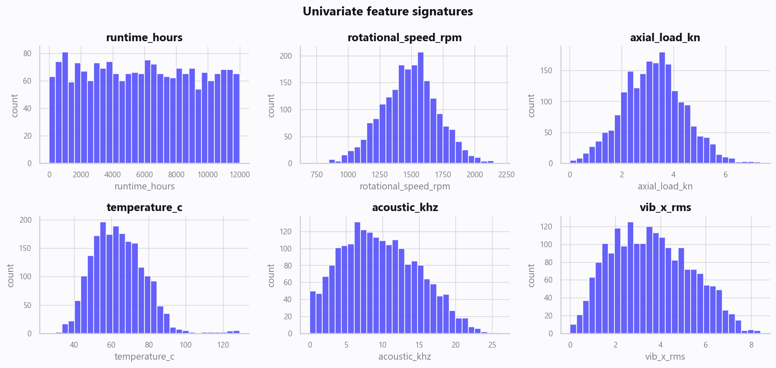
02_distributions.png
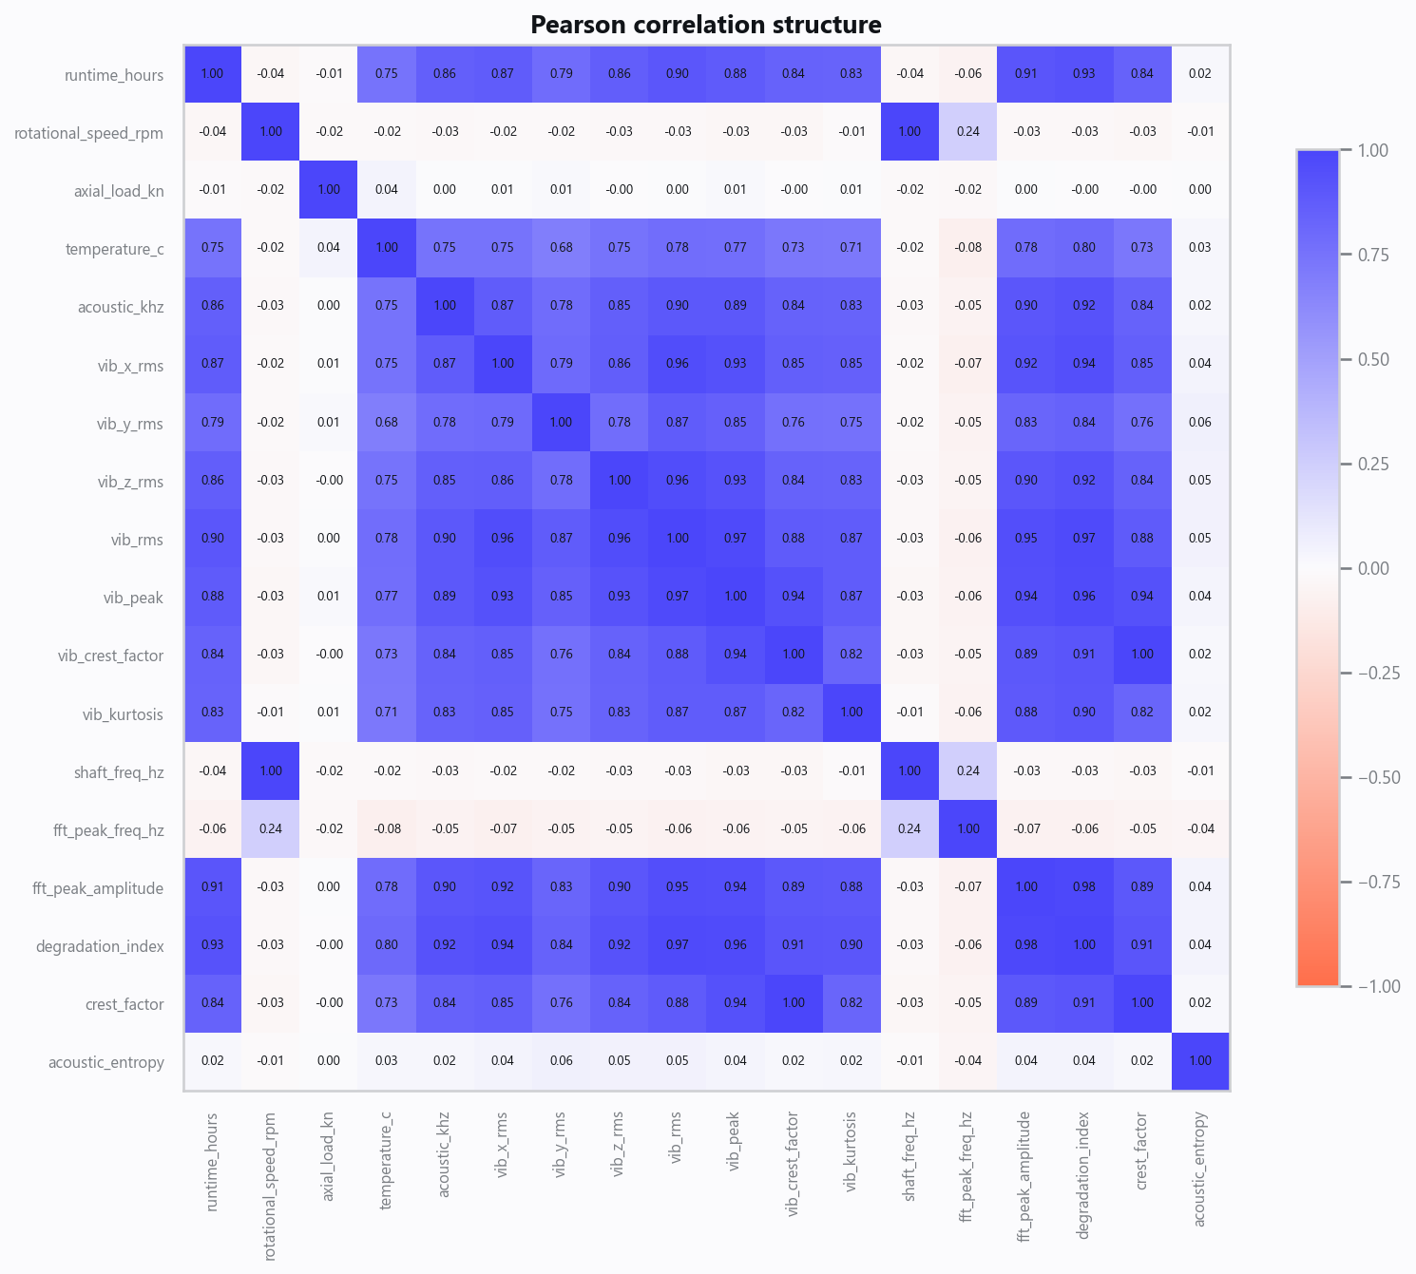
03_correlation.png
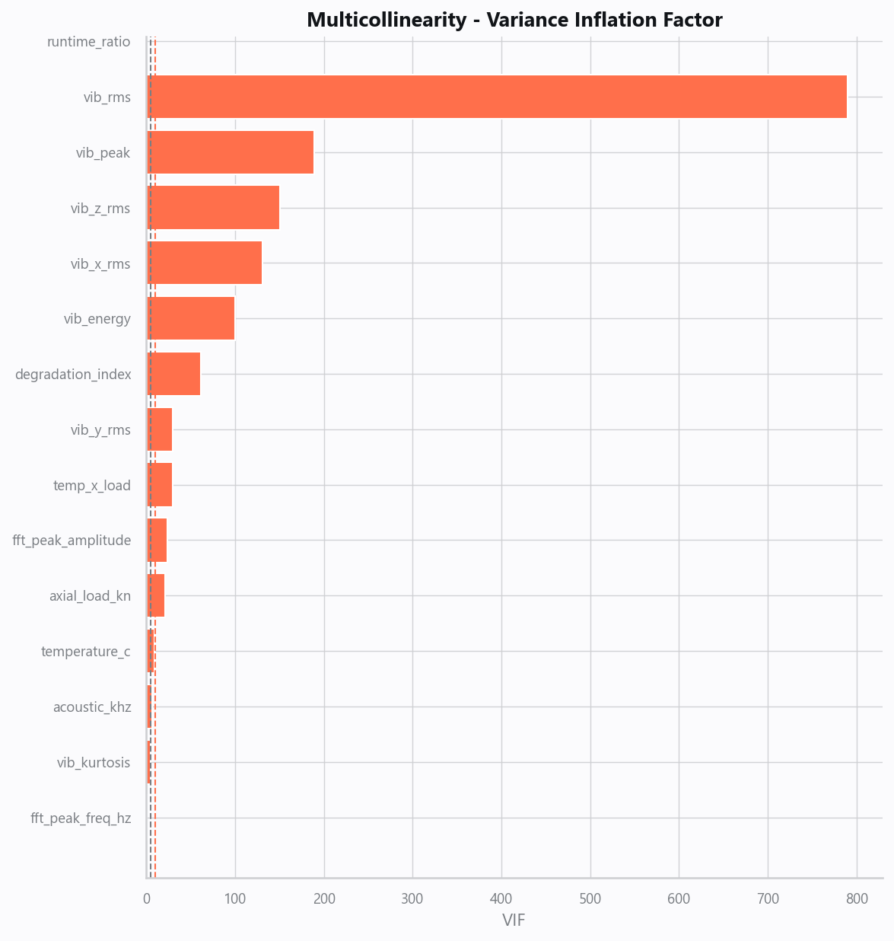
04_vif.png
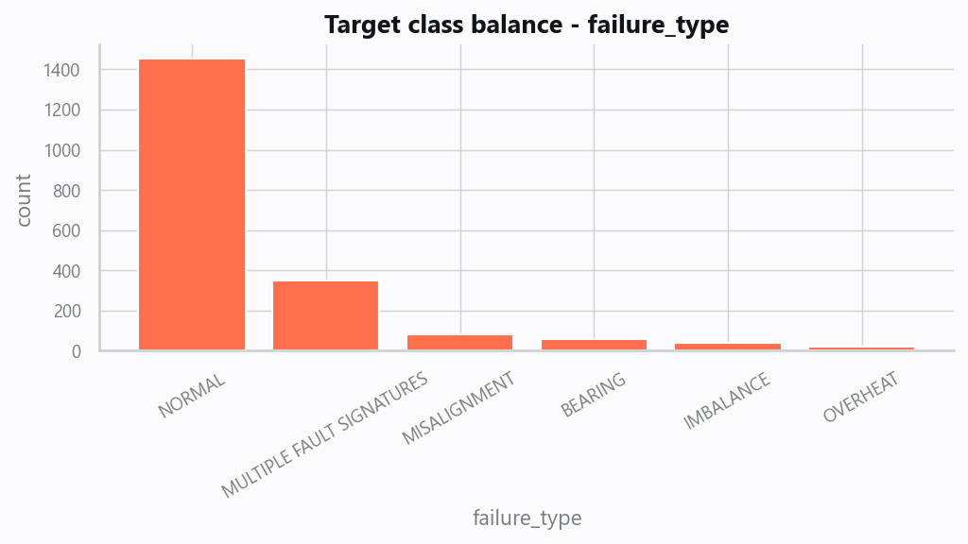
05_target.png
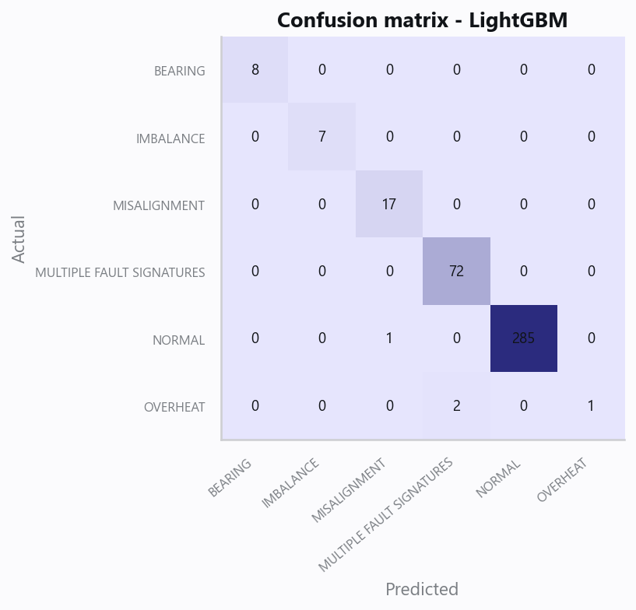
10_confusion.png
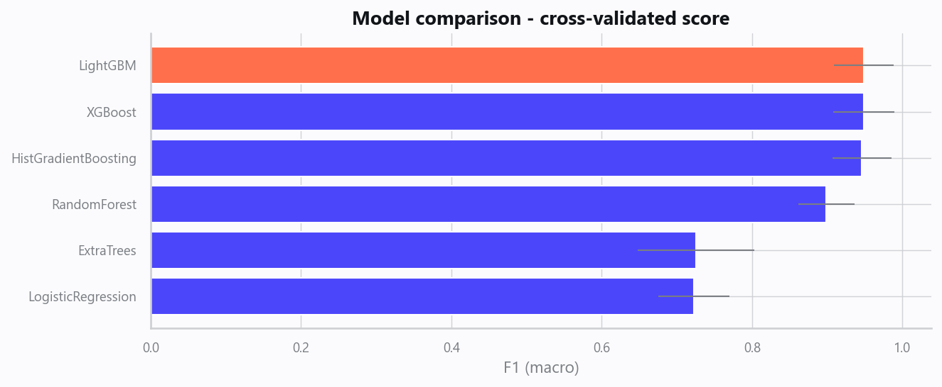
12_leaderboard.png
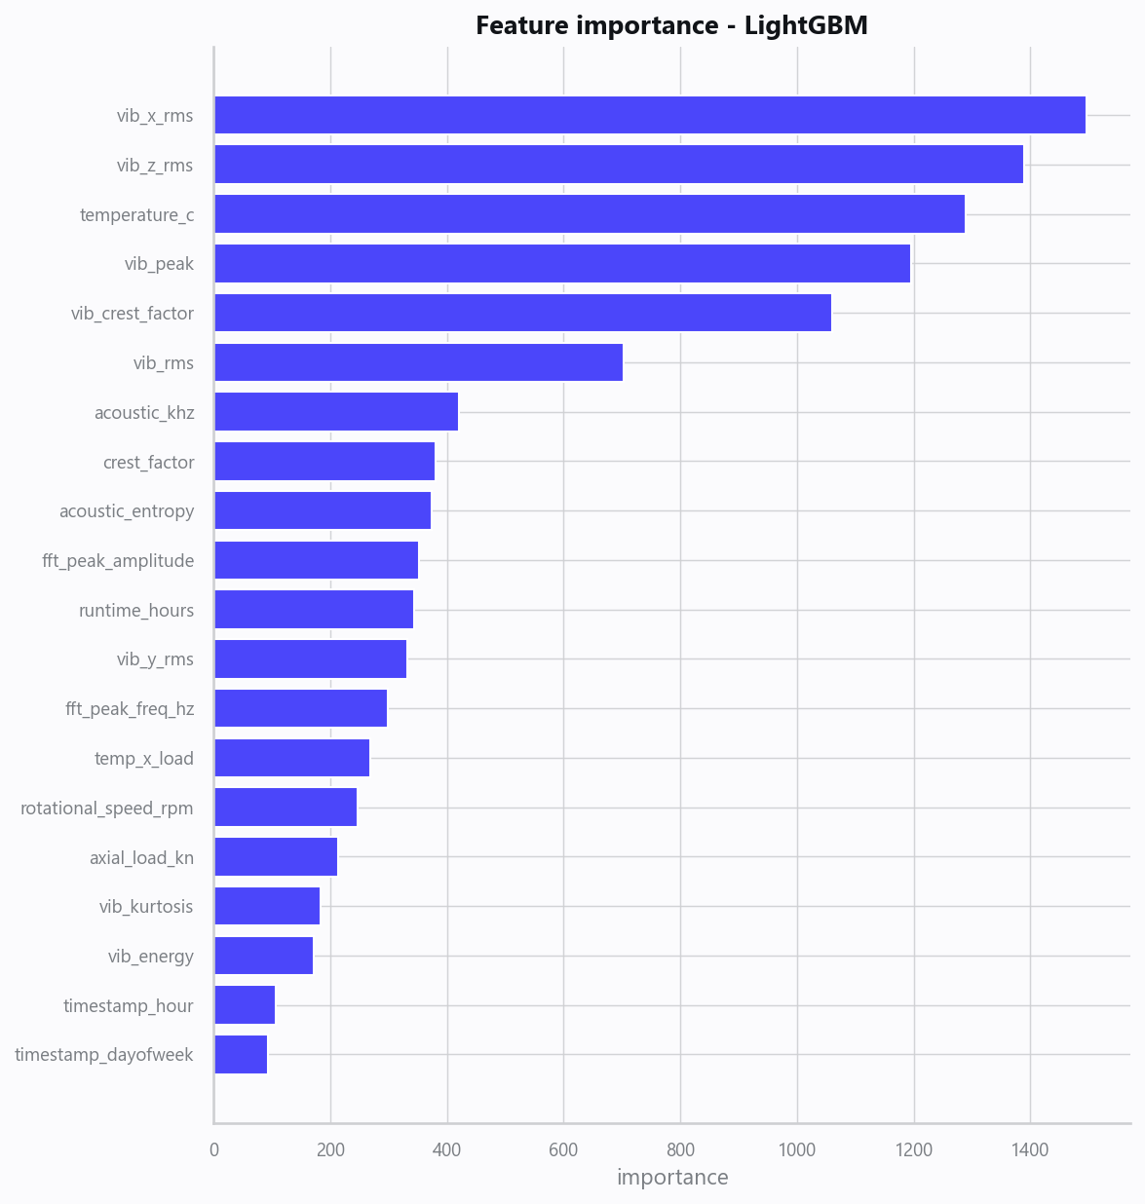
13_feature_importance.png
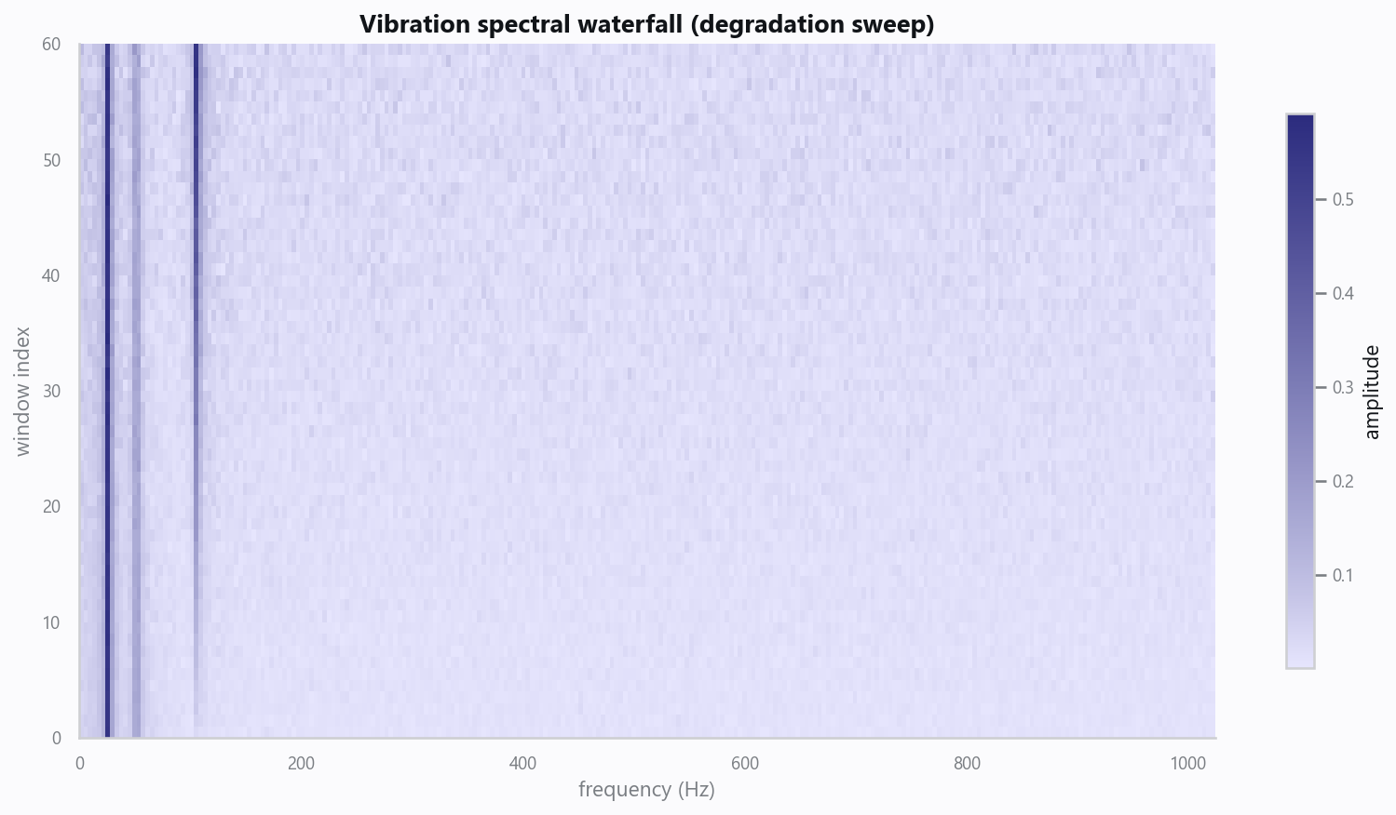
20_vibration_waterfall.png
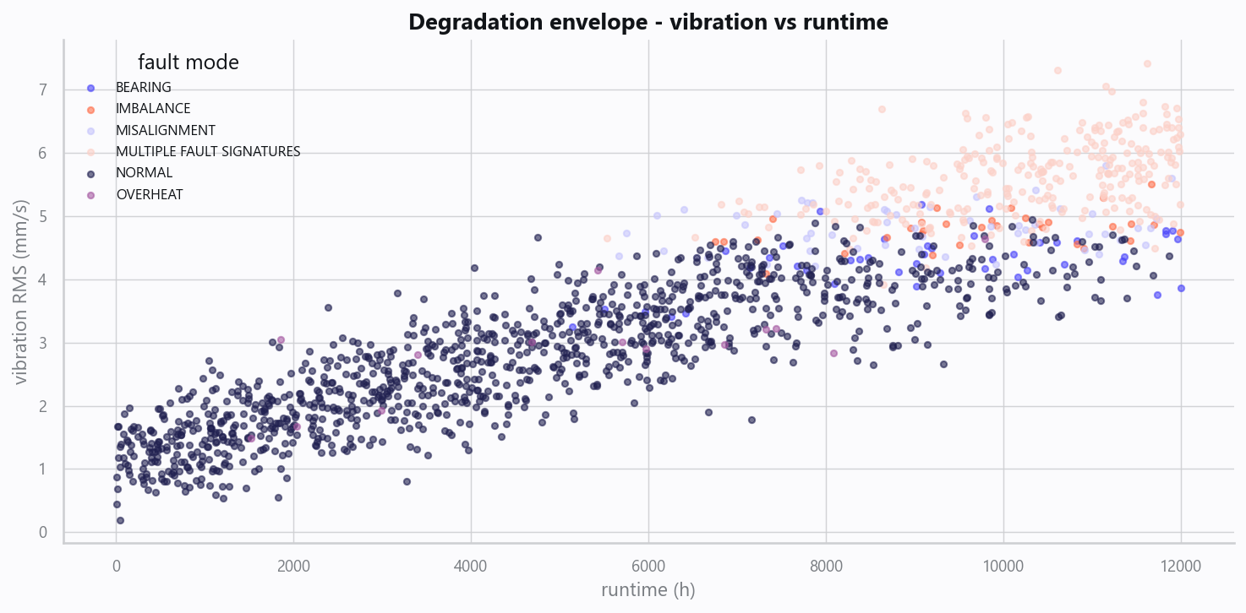
21_degradation_curves.png

Domain Rules & Explainable Ground Truth
rule_id | field | operator | threshold | label
PM-001 | temperature_c | > | 85 | OVERHEAT
PM-002 | crest_factor | > | 6.0 | BEARING
PM-003 | vib_x_rms | > | 5.5 | IMBALANCE
PM-004 | vib_z_rms | > | 5.5 | MISALIGNMENT

Limitations, Risks & Next Steps
- Results reflect the data supplied and the assumptions above; validate on a fresh sample before operational use.
- If the input was capped (see the run configuration), re-run with a larger extract to confirm stability.
- Watch for drift over time and re-train on a schedule; keep the versioned rules and audit hash with each release.

Appendix - Run Configuration
Setting | Value
domain | 4
target_column
max_rows | 0
test_size | 0.2000
cv_folds | 5
split_strategy | auto
enable_tuning | False
enable_deep_learning | False
compliance_mode | True
dataset_format | csv

