ISM + Security: AI Governance & Data Provenance
Config-driven data science pipeline for high-fidelity industrial domains.

Field | Value
Domain | 3 - ISM + Security: AI Governance & Data Provenance
Generated | 2026-10-08 18:22 UTC
Target | is_compliant
Task | classification
Data source | synthetic sandbox (constrained)
Records x columns | 2000 x 40
Audit SHA-256 | 678d40bca5df6feefb4dbb6cc4b35ef30d887b66c619f6cf9606a8265bd6f534

Contents
Right-click here and choose 'Update Field' to build the table of contents.

Executive Summary
Resident AI offline - a local summary follows instead.
- project: ISM + Security: AI Governance & Data Provenance
- domain: ISM + Security: AI Governance & Data Provenance
- task: classification
- best_model: LogisticRegression
- accuracy: 1.0000
- balanced_accuracy: 1.0000
- precision_weighted: 1.0000
- recall_weighted: 1.0000
- f1_weighted: 1.0000
- precision_macro: 1.0000
- recall_macro: 1.0000
- f1_macro: 1.0000
- cohen_kappa: 1.0000
- matthews_corrcoef: 1.0000
Interpretation: review the strongest metric first, then check the weakest one for signs of bias, leakage or under-fitting before trusting the model.

Key Metrics at a Glance
Metric | Value
Best model | LogisticRegression
Selection metric | f1_macro
Cross-validated score | 1.0000
accuracy | 1.0000
balanced_accuracy | 1.0000
precision_weighted | 1.0000
recall_weighted | 1.0000
f1_weighted | 1.0000
precision_macro | 1.0000
recall_macro | 1.0000
f1_macro | 1.0000
cohen_kappa | 1.0000
matthews_corrcoef | 1.0000
Deployment allowed | True

Data & Methodology
The pipeline ingested 2000 records across 40 columns from synthetic sandbox (constrained). A constrained synthetic sandbox was used when no real source was supplied.
Target: is_compliant | Task: classification | Split strategy: group. Numeric features receive robust scaling, categoricals are encoded, and the preprocessor is fitted on the training split only.
- Best model by cross-validated f1_macro: LogisticRegression.

Exploratory Data Analysis

Statistical moments
feature | count | mean | std | min | 25% | 50%
consensus_source_entropy | 2000.0 | 1.6905 | 0.8728 | 0.2 | 0.9097 | 1.7137
carbon_ledger_impact_factor | 2000.0 | 44.1166 | 25.5016 | 0.011 | 21.5948 | 43.7635
regulatory_drift_divergence_index | 2000.0 | 0.3324 | 0.1798 | 0.0091 | 0.19 | 0.3101
kl_divergence_purpose | 2000.0 | 0.0045 | 0.002 | 0.0019 | 0.0028 | 0.0035
gini_classification_region | 2000.0 | 0.7058 | 0.0196 | 0.6764 | 0.698 | 0.698
cross_border | 2000.0 | 0.7185 | 0.4498 | 0.0 | 0.0 | 1.0
restricted_x_crossborder | 2000.0 | 0.116 | 0.3203 | 0.0 | 0.0 | 0.0
hash_prefix_int | 2000.0 | 33922.897 | 18733.6362 | 2.0 | 18813.0 | 33416.0
export_flag | 2000.0 | 0.1415 | 0.3486 | 0.0 | 0.0 | 0.0
timestamp_month | 2000.0 | 6.4355 | 3.4699 | 1.0 | 3.0 | 6.0
timestamp_dayofweek | 2000.0 | 2.9885 | 2.0188 | 0.0 | 1.0 | 3.0
timestamp_hour | 2000.0 | 11.592 | 6.881 | 0.0 | 6.0 | 11.5

Model Performance

Model leaderboard
model | cv_score_mean | cv_score_std | fit_seconds | accuracy | balanced_accuracy | precision_weighted | recall_weighted | f1_weighted | precision_macro | recall_macro | f1_macro | cohen_kappa | matthews_corrcoef | roc_auc | log_loss
LogisticRegression | 1.0 | 0.0 | 0.12 | 1.0 | 1.0 | 1.0 | 1.0 | 1.0 | 1.0 | 1.0 | 1.0 | 1.0 | 1.0 | 1.0 | 0.005
RandomForest | 1.0 | 0.0 | 1.3 | 1.0 | 1.0 | 1.0 | 1.0 | 1.0 | 1.0 | 1.0 | 1.0 | 1.0 | 1.0 | 1.0 | 0.0049
HistGradientBoosting | 1.0 | 0.0 | 0.23 | 1.0 | 1.0 | 1.0 | 1.0 | 1.0 | 1.0 | 1.0 | 1.0 | 1.0 | 1.0 | 1.0 | 0.0
XGBoost | 1.0 | 0.0 | 0.14 | 1.0 | 1.0 | 1.0 | 1.0 | 1.0 | 1.0 | 1.0 | 1.0 | 1.0 | 1.0 | 1.0 | 0.0012
LightGBM | 1.0 | 0.0 | 0.27 | 1.0 | 1.0 | 1.0 | 1.0 | 1.0 | 1.0 | 1.0 | 1.0 | 1.0 | 1.0 | 1.0 | 0.0
ExtraTrees | 1.0 | 0.0 | 1.11 | 1.0 | 1.0 | 1.0 | 1.0 | 1.0 | 1.0 | 1.0 | 1.0 | 1.0 | 1.0 | 1.0 | 0.002

Robustness & Compliance

Deployment gates
Check | Value
boundary_accuracy | 1.0000
abstention_accuracy | 1.0000
leakage_rate | 0.0000
gate:performance_pass | True
gate:recall_pass | True
gate:privacy_pass | True
gate:boundary_pass | True
gate:deployment_allowed | True
gate:note | All gates satisfied - safe to proceed with human oversight.

Figures

Charts and maps
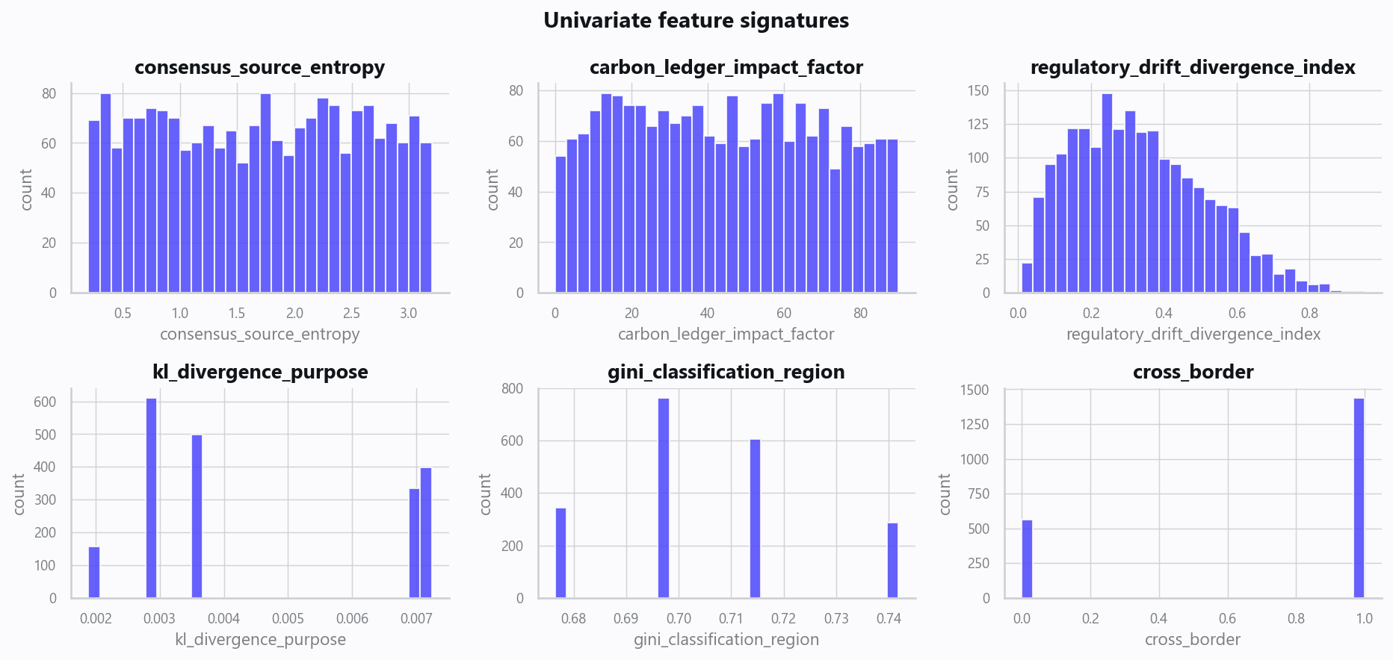
02_distributions.png
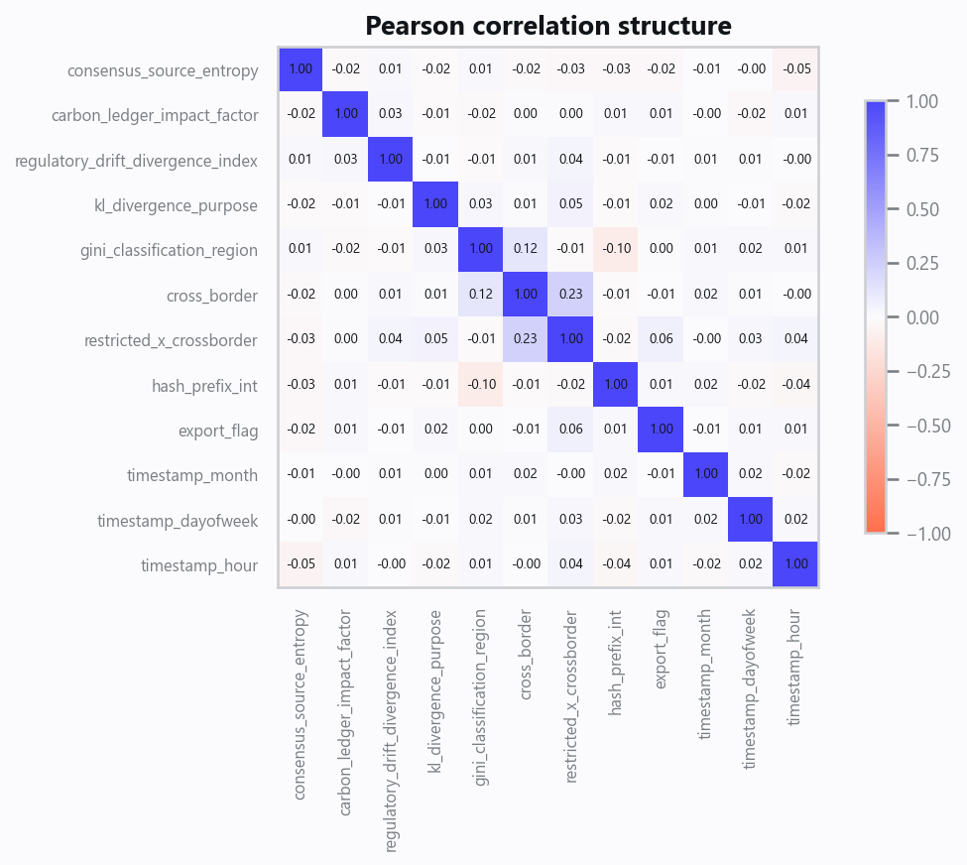
03_correlation.png
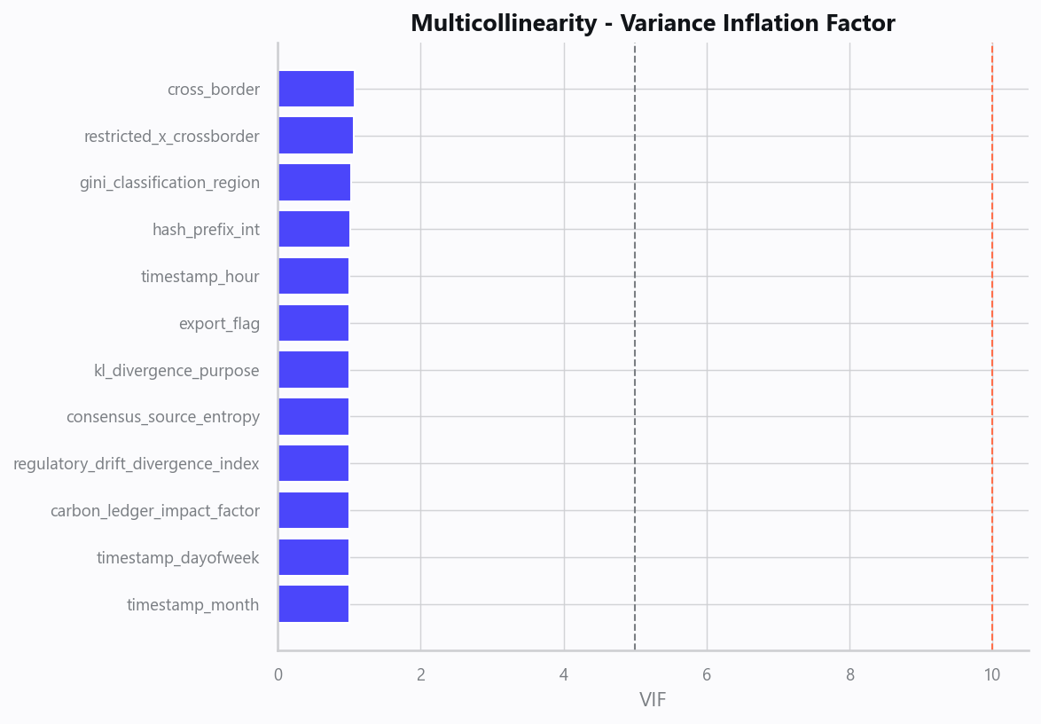
04_vif.png
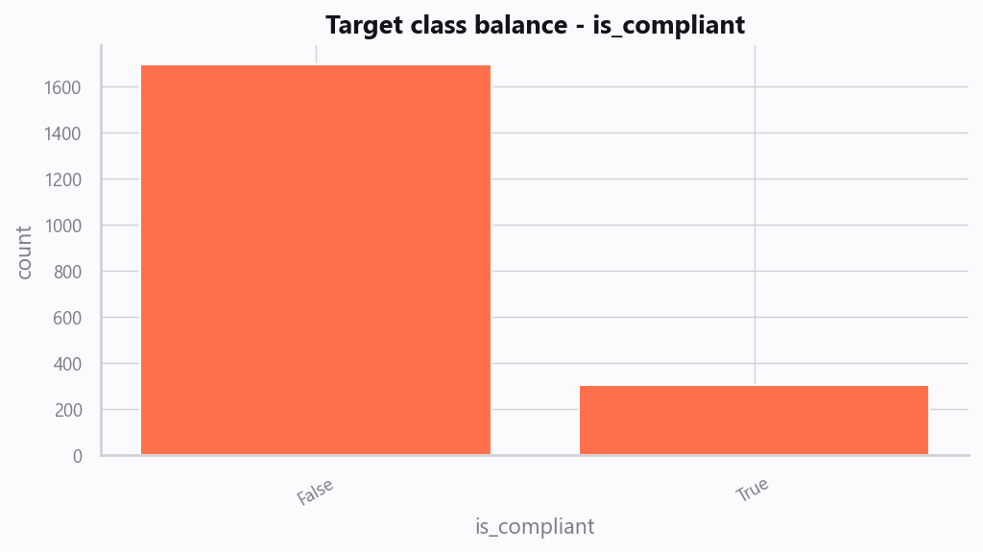
05_target.png
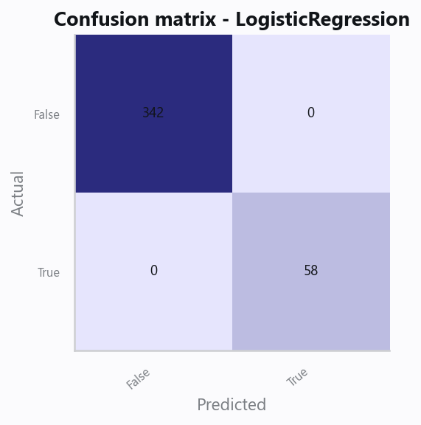
10_confusion.png
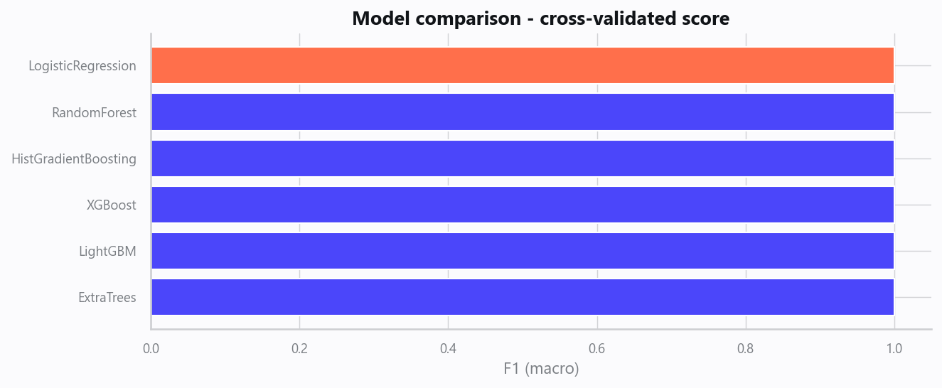
12_leaderboard.png
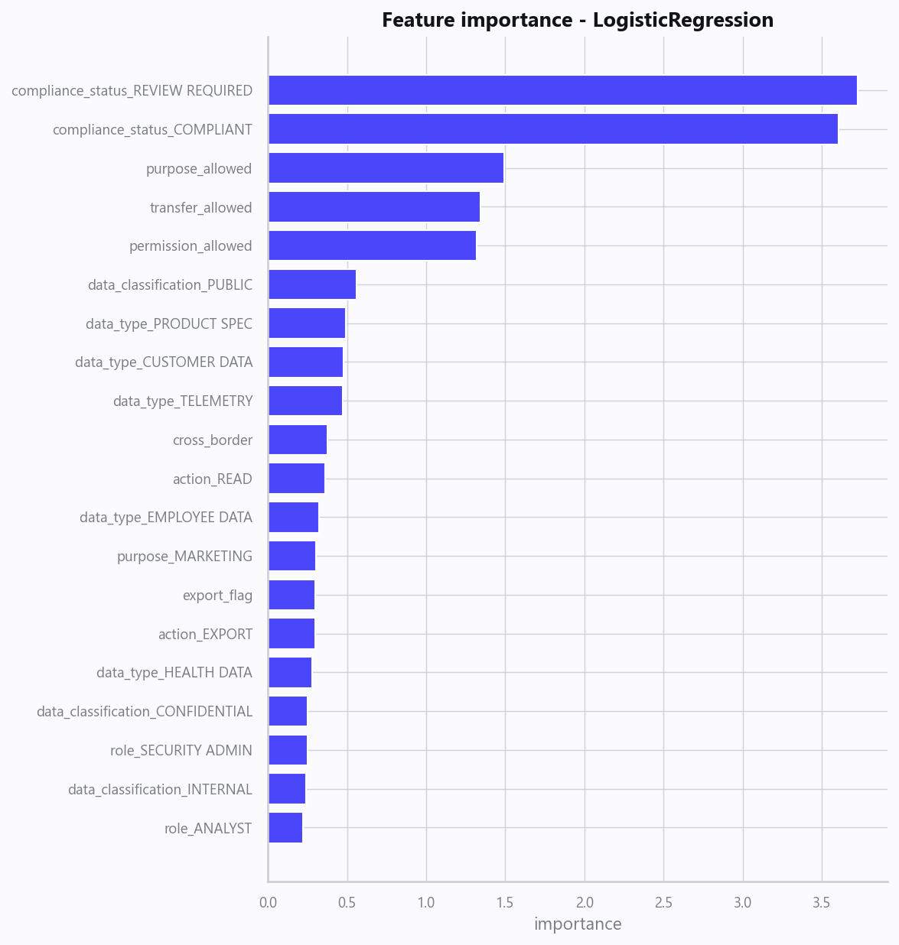
13_feature_importance.png
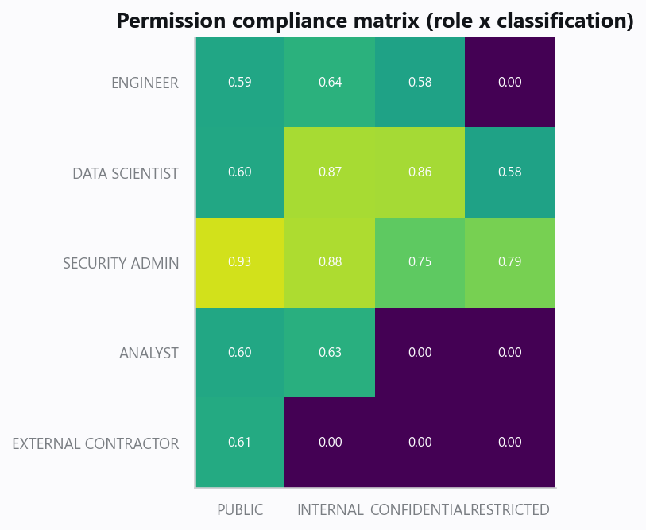
20_governance_risk_matrix.png
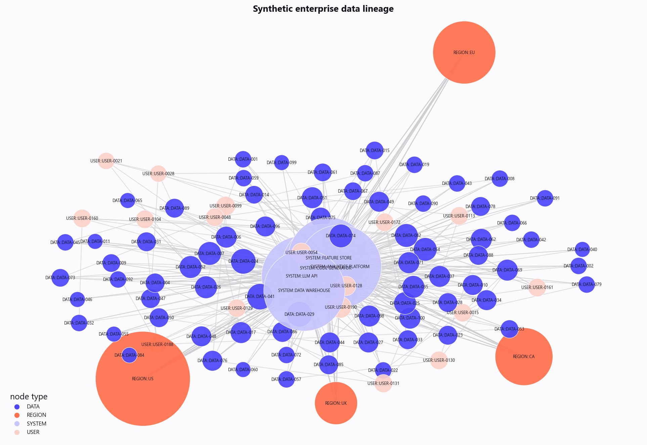
21_data_lineage_graph.png

Domain Rules & Explainable Ground Truth
rule_id | field | operator | threshold | label
GOV-001 | permission_allowed | == | False | Access Not Authorized
GOV-002 | purpose_allowed | == | False | Purpose Not Permitted
GOV-003 | transfer_allowed | == | False | Restricted Cross-Border Transfer
GOV-004 | regulatory_drift_divergence_index | > | 0.75 | Regulatory Drift Alert

Limitations, Risks & Next Steps
- Results reflect the data supplied and the assumptions above; validate on a fresh sample before operational use.
- If the input was capped (see the run configuration), re-run with a larger extract to confirm stability.
- Watch for drift over time and re-train on a schedule; keep the versioned rules and audit hash with each release.

Appendix - Run Configuration
Setting | Value
domain | 3
target_column
max_rows | 0
test_size | 0.2000
cv_folds | 5
split_strategy | auto
enable_tuning | False
enable_deep_learning | False
compliance_mode | True
dataset_format | csv

