Mechanical Engineering: Patent Novelty Graph (NLP)
Config-driven data science pipeline for high-fidelity industrial domains.

Field | Value
Domain | 2 - Mechanical Engineering: Patent Novelty Graph (NLP)
Generated | 2026-10-08 18:22 UTC
Target | novelty_index
Task | regression
Data source | synthetic sandbox (constrained)
Records x columns | 2000 x 39
Audit SHA-256 | e965c689fa884721f2a9894a8fd3c36b2e57ec03788b956f32c8801c660c90c8

Contents
Right-click here and choose 'Update Field' to build the table of contents.

Executive Summary
Resident AI offline - a local summary follows instead.
- project: Mechanical Engineering: Patent Novelty Graph (NLP)
- domain: Mechanical Engineering: Patent Novelty Graph (NLP)
- task: regression
- best_model: Ridge
- rmse: 0.0502
- mae: 0.0403
- median_ae: 0.0347
- mape: 19.5361
- r2: 0.6922
- adj_r2: 0.6429
- explained_variance: 0.6933
- mean_residual: 0.0031
- leaderboard_top: [{'model': 'Ridge', 'cv_score_mean': 0.7206149000696316, 'cv_score_std': 0.014119761413239583, 'fit_seconds': 0.17, 'rmse': 0.05022786486024287, 'mae': 0.040343615100795066, 'median_ae': 0.034701701537940555, 'mape': 19.53605932314342, 'r2': 0.6921516328362445, 'adj_r2': 0.6429316904118068, 'explained_variance': 0.6933239049003652, 'mean_residual': 0.0030994918426958183}, {'model': 'RandomForest', 'cv_score_mean': 0.6871056816955385, 'cv_score_std': 0.01786828720698103, 'fit_seconds': 6.96, 'rmse': 0.05345428586883584, 'mae': 0.04357931166666667, 'median_ae': 0.03788749999999978, 'mape': 22.071650781838716, 'r2': 0.6513316841431347, 'adj_r2': 0.5955852964334615, 'explained_variance': 0.6528072252327168, 'mean_residual': 0.0034773783333333437}, {'model': 'ExtraTrees', 'cv_score_mean': 0.6784215924780593, 'cv_score_std': 0.017723103120075356, 'fit_seconds': 6.04, 'rmse': 0.05327598947388391, 'mae': 0.0431207375, 'median_ae': 0.03655850000000034, 'mape': 21.36029940554923, 'r2': 0.6536537664647968, 'adj_r2': 0.5982786419170172, 'explained_variance': 0.6541590427781756, 'mean_residual': 0.0020348891666666976}, {'model': 'LightGBM', 'cv_score_mean': 0.6598689616862308, 'cv_score_std': 0.01264111441349817, 'fit_seconds': 0.84, 'rmse': 0.05563153875528883, 'mae': 0.04580925743115108, 'median_ae': 0.04079208273137065, 'mape': 22.66599113563662, 'r2': 0.622349933586397, 'adj_r2': 0.5619698357586407, 'explained_variance': 0.624215367486969, 'mean_residual': 0.003909905153061375}, {'model': 'HistGradientBoosting', 'cv_score_mean': 0.6598356378803825, 'cv_score_std': 0.010635820482424792, 'fit_seconds': 1.01, 'rmse': 0.055579584338924716, 'mae': 0.04543724539894143, 'median_ae': 0.041510944712043, 'mape': 22.491706714126295, 'r2': 0.6230549806648591, 'adj_r2': 0.5627876083874384, 'explained_variance': 0.6259331513772851, 'mean_residual': 0.004856624928210078}]
Interpretation: review the strongest metric first, then check the weakest one for signs of bias, leakage or under-fitting before trusting the model.

Key Metrics at a Glance
Metric | Value
Best model | Ridge
Selection metric | r2
Cross-validated score | 0.7206
rmse | 0.0502
mae | 0.0403
median_ae | 0.0347
mape | 19.5361
r2 | 0.6922
adj_r2 | 0.6429
explained_variance | 0.6933
mean_residual | 0.0031
Deployment allowed | False

Data & Methodology
The pipeline ingested 2000 records across 39 columns from synthetic sandbox (constrained). A constrained synthetic sandbox was used when no real source was supplied.
Target: novelty_index | Task: regression | Split strategy: group. Numeric features receive robust scaling, categoricals are encoded, and the preprocessor is fitted on the training split only.
- Best model by cross-validated r2: Ridge.

Exploratory Data Analysis

Statistical moments
feature | count | mean | std | min | 25% | 50%
claims_count | 2000.0 | 13.0085 | 3.4991 | 1.0 | 11.0 | 13.0
citation_count | 2000.0 | 11.7705 | 6.3952 | 0.0 | 7.0 | 11.0
filing_year | 2000.0 | 2009.26 | 8.5886 | 1995.0 | 2002.0 | 2009.0
publication_year | 2000.0 | 2010.303 | 8.6233 | 1995.0 | 2003.0 | 2010.0
max_corpus_similarity | 2000.0 | 0.7783 | 0.0735 | 0.5871 | 0.7219 | 0.7614
novelty_index | 2000.0 | 0.246 | 0.0962 | 0.02 | 0.1734 | 0.2504
abstract_len | 2000.0 | 200.901 | 7.1106 | 184.0 | 195.0 | 200.0
claims_len | 2000.0 | 156.305 | 6.6386 | 143.0 | 151.0 | 155.0
avg_word_len | 2000.0 | 6.7654 | 0.2735 | 6.1154 | 6.5385 | 6.7308
lsa_0 | 2000.0 | 0.5781 | 0.0068 | 0.5589 | 0.5732 | 0.5779
lsa_1 | 2000.0 | -0.0 | 0.2081 | -0.375 | -0.0587 | -0.0144
lsa_2 | 2000.0 | 0.0007 | 0.2053 | -0.308 | -0.1594 | 0.0

Model Performance

Model leaderboard
model | cv_score_mean | cv_score_std | fit_seconds | rmse | mae | median_ae | mape | r2 | adj_r2 | explained_variance | mean_residual
Ridge | 0.7206 | 0.0141 | 0.17 | 0.0502 | 0.0403 | 0.0347 | 19.5361 | 0.6922 | 0.6429 | 0.6933 | 0.0031
RandomForest | 0.6871 | 0.0179 | 6.96 | 0.0535 | 0.0436 | 0.0379 | 22.0717 | 0.6513 | 0.5956 | 0.6528 | 0.0035
ExtraTrees | 0.6784 | 0.0177 | 6.04 | 0.0533 | 0.0431 | 0.0366 | 21.3603 | 0.6537 | 0.5983 | 0.6542 | 0.002
LightGBM | 0.6599 | 0.0126 | 0.84 | 0.0556 | 0.0458 | 0.0408 | 22.666 | 0.6223 | 0.562 | 0.6242 | 0.0039
HistGradientBoosting | 0.6598 | 0.0106 | 1.01 | 0.0556 | 0.0454 | 0.0415 | 22.4917 | 0.6231 | 0.5628 | 0.6259 | 0.0049
XGBoost | 0.6409 | 0.0203 | 0.68 | 0.0564 | 0.0459 | 0.0411 | 22.8852 | 0.6125 | 0.5505 | 0.6133 | 0.0026

Robustness & Compliance

Deployment gates
Check | Value
boundary_accuracy | n/a
abstention_accuracy | 1.0000
leakage_rate | 0.0000
gate:performance_pass | False
gate:recall_pass | True
gate:privacy_pass | True
gate:boundary_pass | True
gate:deployment_allowed | False
gate:note | One or more gates failed - hold deployment and review.

Figures

Charts and maps
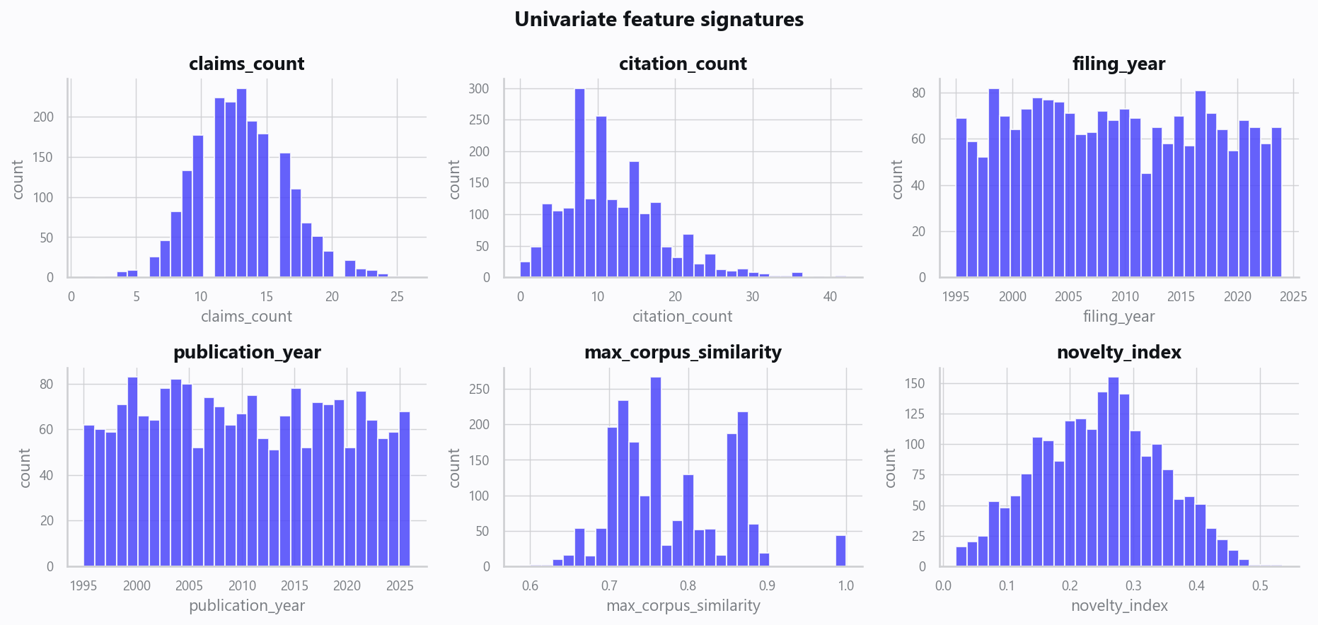
02_distributions.png
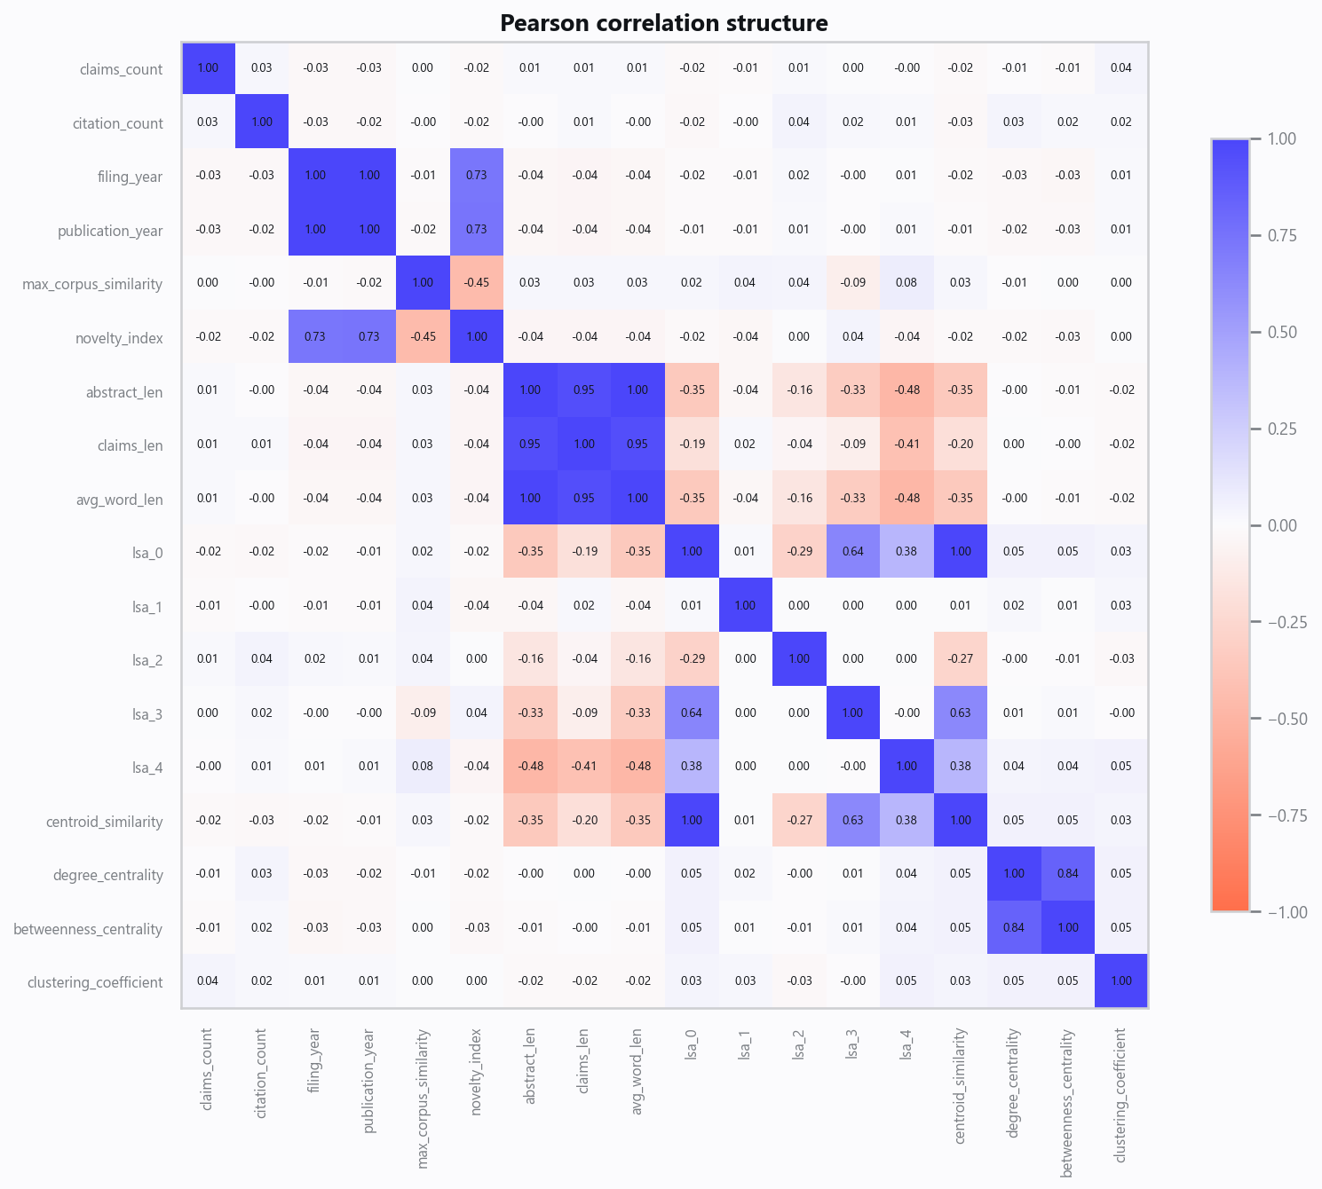
03_correlation.png
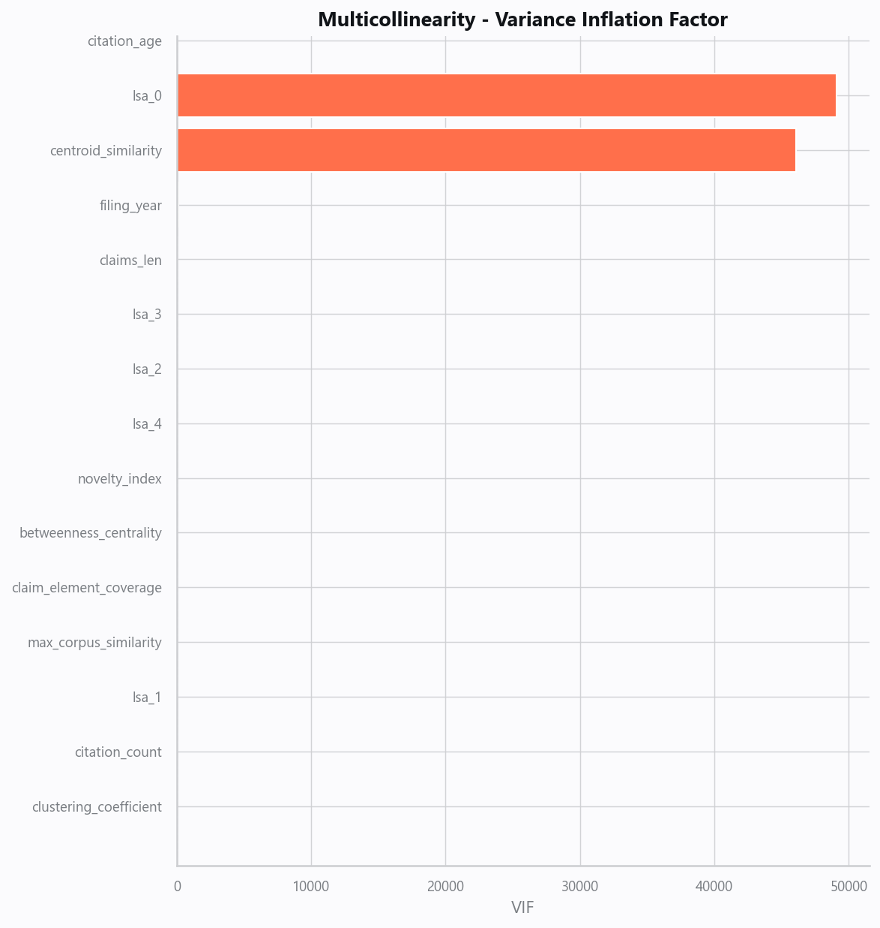
04_vif.png
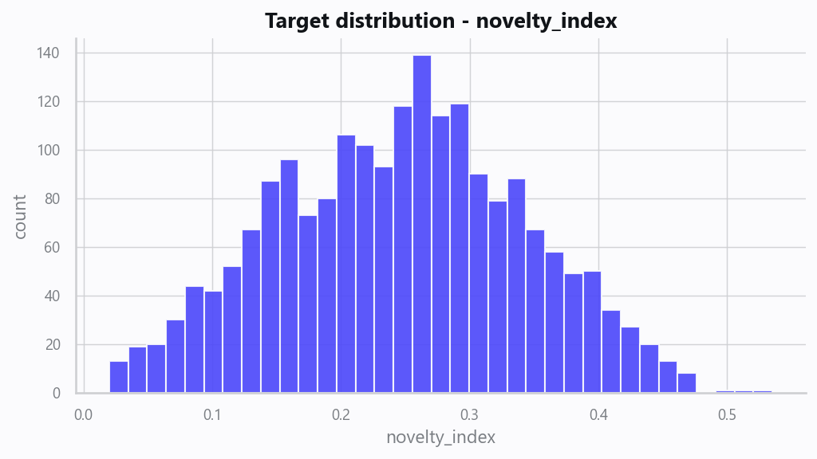
05_target.png
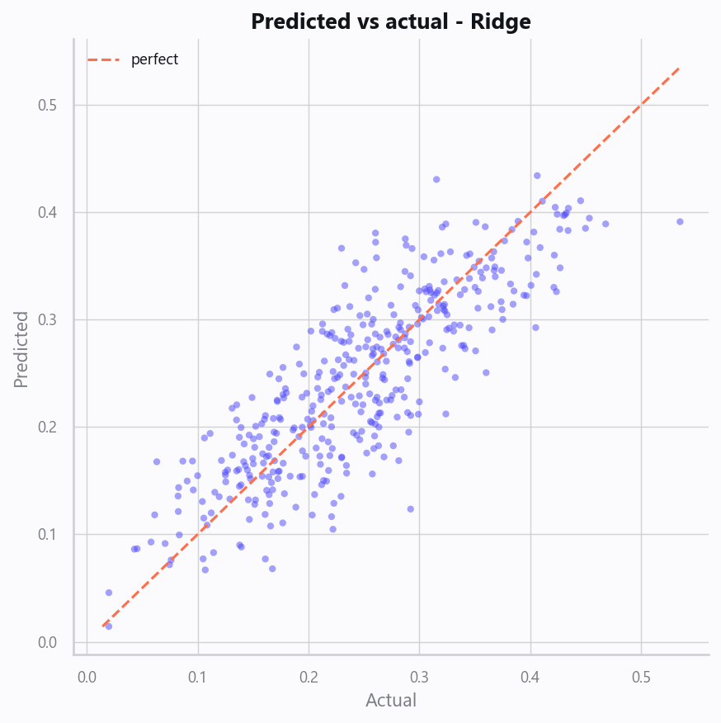
10_pred_vs_actual.png
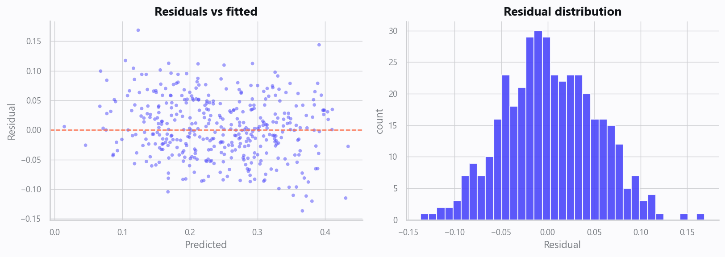
11_residuals.png
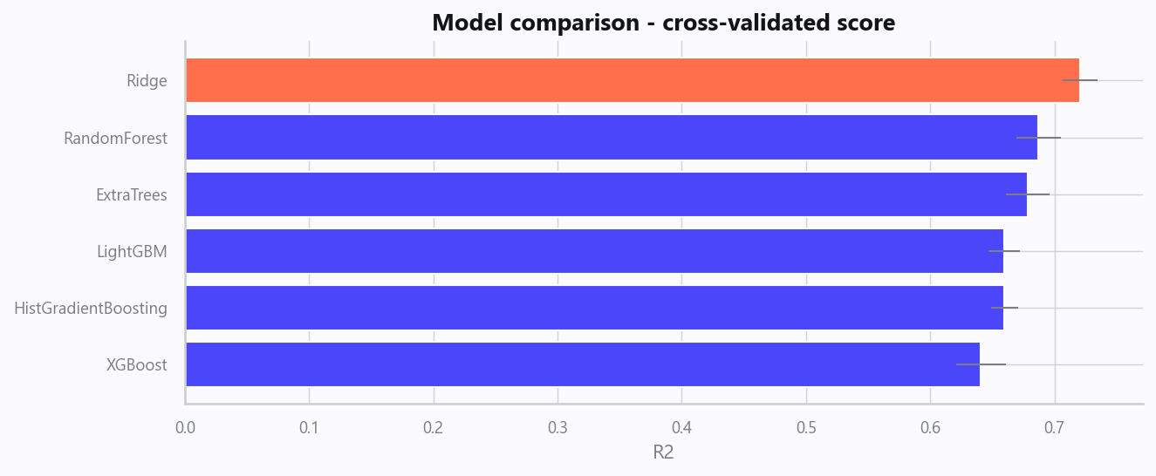
12_leaderboard.png
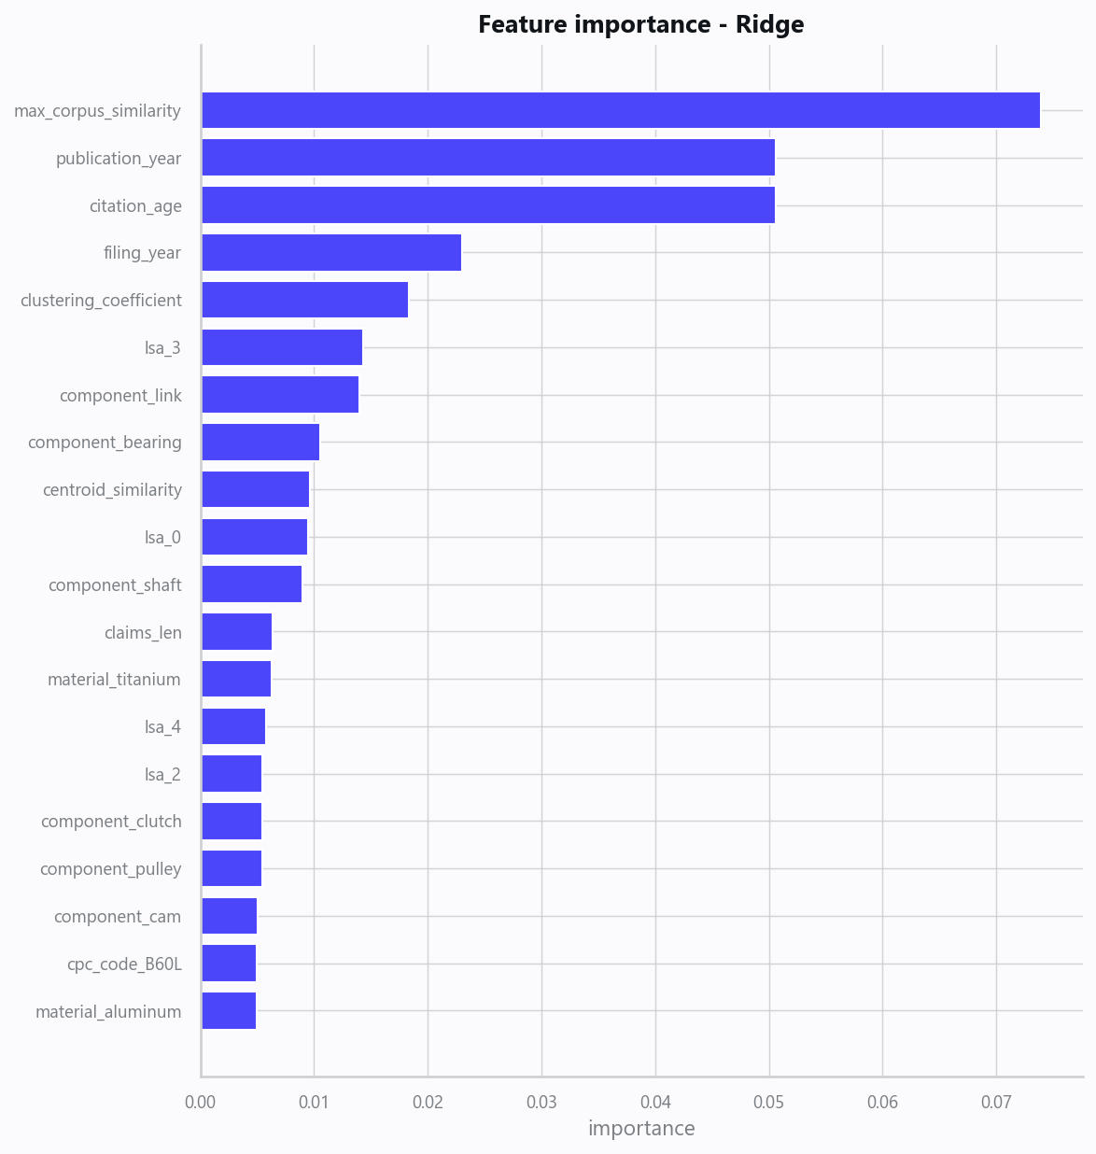
13_feature_importance.png
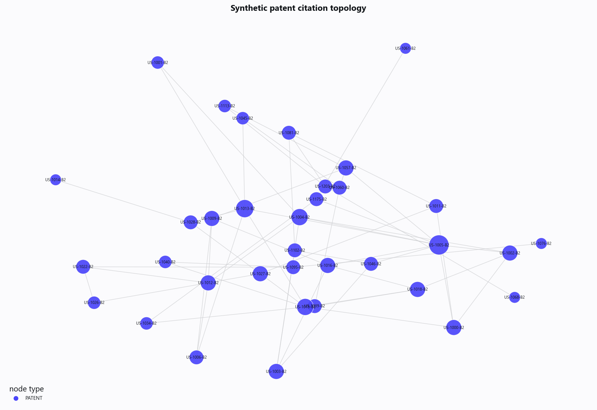
20_patent_citation_graph.png
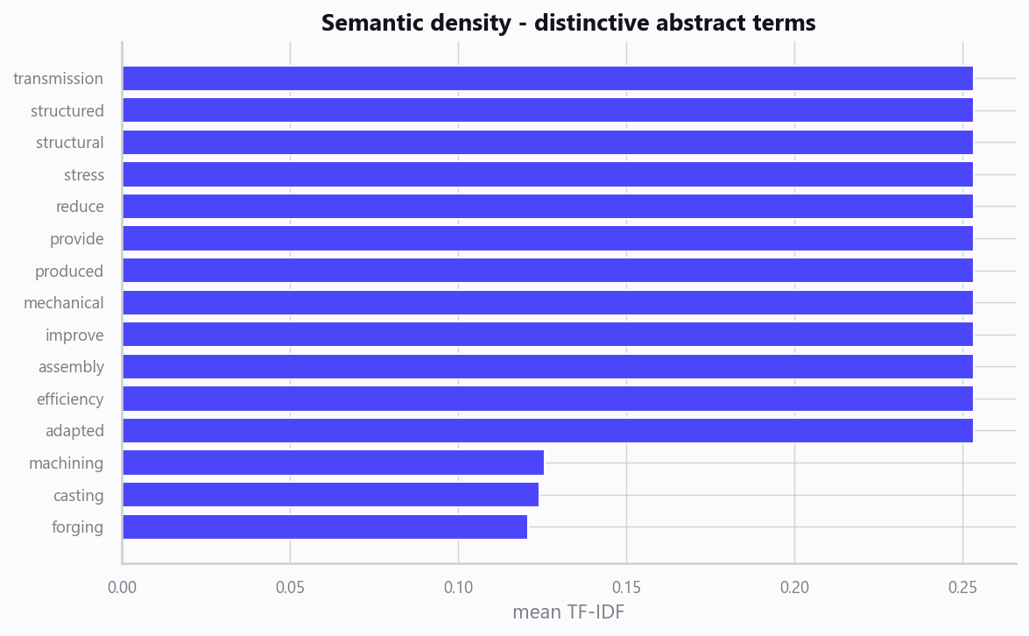
21_semantic_density.png

Domain Rules & Explainable Ground Truth
rule_id | field | operator | threshold | label
PAT-001 | max_corpus_similarity | > | 0.85 | High Semantic Overlap - Prior-Art Review
PAT-002 | claims_count | < | 3 | Sparse Claim Structure
PAT-003 | betweenness_centrality | > | 0.05 | Bridge Node in Citation Network

Limitations, Risks & Next Steps
- Results reflect the data supplied and the assumptions above; validate on a fresh sample before operational use.
- If the input was capped (see the run configuration), re-run with a larger extract to confirm stability.
- Watch for drift over time and re-train on a schedule; keep the versioned rules and audit hash with each release.

Appendix - Run Configuration
Setting | Value
domain | 2
target_column
max_rows | 0
test_size | 0.2000
cv_folds | 5
split_strategy | auto
enable_tuning | False
enable_deep_learning | False
compliance_mode | True
dataset_format | csv

