Robotics + ISM: Autonomous Vehicle Liability
Config-driven data science pipeline for high-fidelity industrial domains.

Field | Value
Domain | 1 - Robotics + ISM: Autonomous Vehicle Liability
Generated | 2026-10-08 18:21 UTC
Target | liability_class
Task | classification
Data source | synthetic sandbox (constrained)
Records x columns | 2000 x 44
Audit SHA-256 | ea61f0c3deb87b0f1760d375473b24ed23c555f2d332207d38b2940c080ed53f

Contents
Right-click here and choose 'Update Field' to build the table of contents.

Executive Summary
Resident AI offline - a local summary follows instead.
- project: Robotics + ISM: Autonomous Vehicle Liability
- domain: Robotics + ISM: Autonomous Vehicle Liability
- task: classification
- best_model: XGBoost
- accuracy: 0.9976
- balanced_accuracy: 0.9933
- precision_weighted: 0.9979
- recall_weighted: 0.9976
- f1_weighted: 0.9977
- precision_macro: 0.9750
- recall_macro: 0.9933
- f1_macro: 0.9833
- cohen_kappa: 0.9898
- matthews_corrcoef: 0.9899
Interpretation: review the strongest metric first, then check the weakest one for signs of bias, leakage or under-fitting before trusting the model.

Key Metrics at a Glance
Metric | Value
Best model | XGBoost
Selection metric | f1_macro
Cross-validated score | 0.9474
accuracy | 0.9976
balanced_accuracy | 0.9933
precision_weighted | 0.9979
recall_weighted | 0.9976
f1_weighted | 0.9977
precision_macro | 0.9750
recall_macro | 0.9933
f1_macro | 0.9833
cohen_kappa | 0.9898
matthews_corrcoef | 0.9899
Deployment allowed | True

Data & Methodology
The pipeline ingested 2000 records across 44 columns from synthetic sandbox (constrained). A constrained synthetic sandbox was used when no real source was supplied.
Target: liability_class | Task: classification | Split strategy: group. Numeric features receive robust scaling, categoricals are encoded, and the preprocessor is fitted on the training split only.
- Best model by cross-validated f1_macro: XGBoost.

Exploratory Data Analysis

Statistical moments
feature | count | mean | std | min | 25% | 50%
speed_kmh | 2000.0 | 79.3889 | 33.5334 | 0.17 | 56.33 | 79.885
acceleration_ms2 | 2000.0 | -2.2281 | 2.5964 | -10.163 | -3.8942 | -2.3315
vehicle_mass_kg | 2000.0 | 1805.3598 | 258.8794 | 1003.4 | 1626.05 | 1804.05
brake_pressure_psi | 2000.0 | 613.9512 | 295.9224 | 0.0 | 398.875 | 574.25
brake_temperature_c | 2000.0 | 71.9812 | 125.0112 | -39.66 | 29.205 | 45.87
sensor_latency_ms | 2000.0 | 110.4284 | 63.9418 | 20.0 | 65.3125 | 93.54
sensor_confidence | 2000.0 | 0.871 | 0.1209 | 0.226 | 0.8002 | 0.8929
lidar_variance | 2000.0 | 0.2265 | 0.2339 | 0.0 | 0.061 | 0.1553
radar_distance_m | 2000.0 | 47.6895 | 21.3901 | 0.5 | 33.03 | 47.315
imu_accel_x | 2000.0 | 0.0235 | 0.5895 | -2.1182 | -0.37 | 0.0221
imu_accel_y | 2000.0 | 0.0205 | 0.601 | -2.0313 | -0.3806 | 0.0287
imu_accel_z | 2000.0 | 9.8201 | 0.4112 | 8.4243 | 9.539 | 9.8162

Model Performance

Model leaderboard
model | cv_score_mean | cv_score_std | fit_seconds | accuracy | balanced_accuracy | precision_weighted | recall_weighted | f1_weighted | precision_macro | recall_macro | f1_macro | cohen_kappa | matthews_corrcoef | roc_auc
XGBoost | 0.9474 | 0.0401 | 0.95 | 0.9976 | 0.9933 | 0.9979 | 0.9976 | 0.9977 | 0.975 | 0.9933 | 0.9833 | 0.9898 | 0.9899 | nan
HistGradientBoosting | 0.9445 | 0.0325 | 3.59 | 0.9952 | 0.9867 | 0.9955 | 0.9952 | 0.9952 | 0.9745 | 0.9867 | 0.9795 | 0.9795 | 0.9796 | nan
LightGBM | 0.9428 | 0.039 | 3.48 | 0.9952 | 0.9648 | 0.9952 | 0.9952 | 0.9952 | 0.9648 | 0.9648 | 0.9648 | 0.9797 | 0.9797 | nan
RandomForest | 0.8851 | 0.0654 | 3.65 | 0.9952 | 0.9709 | 0.9955 | 0.9952 | 0.9952 | 0.9793 | 0.9709 | 0.9737 | 0.9798 | 0.9799 | nan
LogisticRegression | 0.7339 | 0.0549 | 2.51 | 0.9569 | 0.8015 | 0.9625 | 0.9569 | 0.959 | 0.7201 | 0.6679 | 0.6898 | 0.8143 | 0.8147 | nan
ExtraTrees | 0.6009 | 0.0257 | 1.25 | 0.9522 | 0.6031 | 0.9401 | 0.9522 | 0.9441 | 0.6879 | 0.6031 | 0.6338 | 0.7716 | 0.7804 | nan

Robustness & Compliance

Deployment gates
Check | Value
boundary_accuracy | 0.9737
abstention_accuracy | 1.0000
leakage_rate | 0.0000
gate:performance_pass | True
gate:recall_pass | True
gate:privacy_pass | True
gate:boundary_pass | True
gate:deployment_allowed | True
gate:note | All gates satisfied - safe to proceed with human oversight.

Figures

Charts and maps
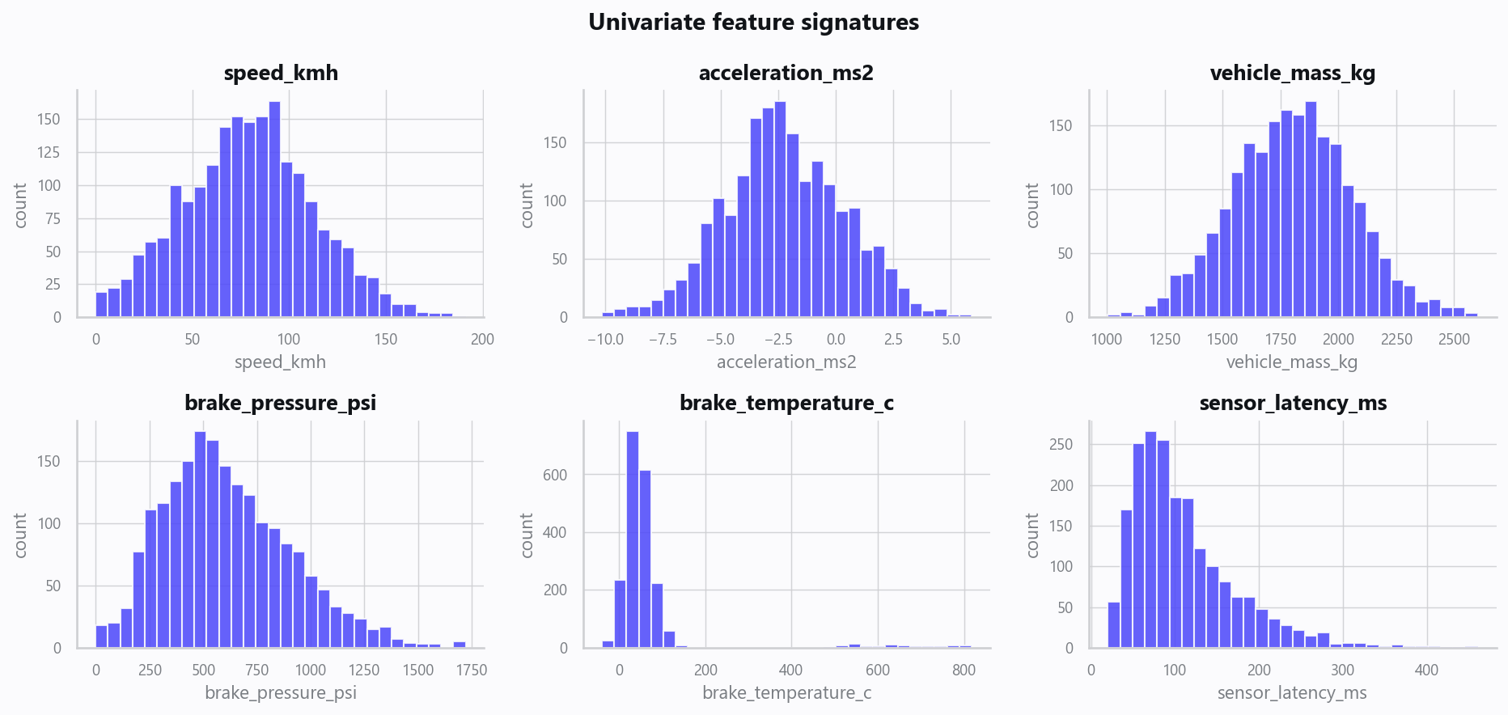
02_distributions.png
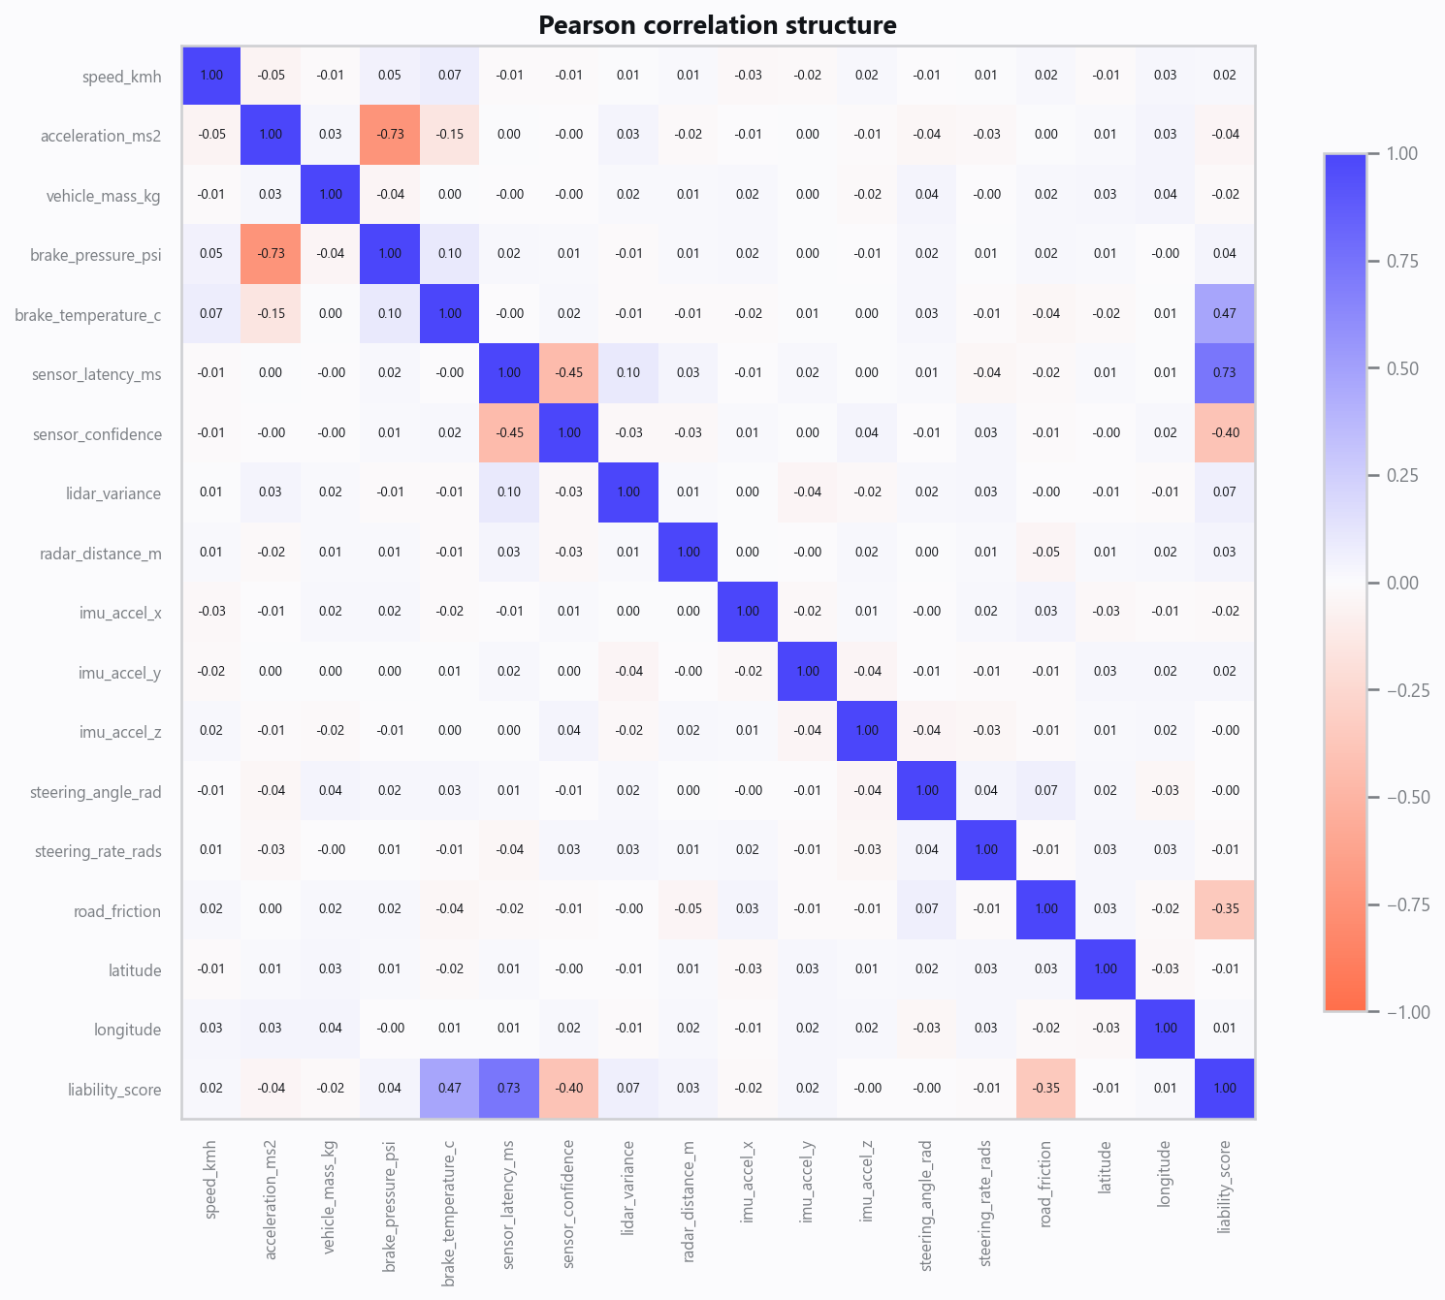
03_correlation.png
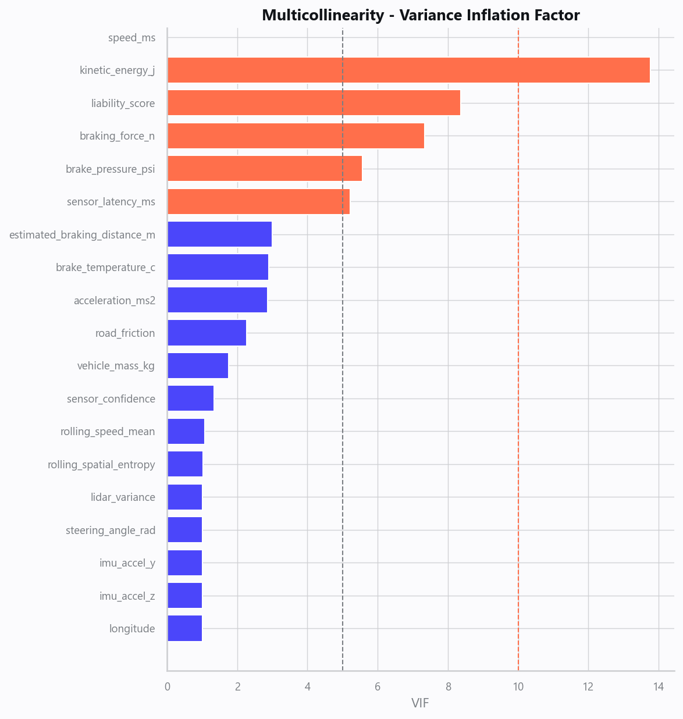
04_vif.png
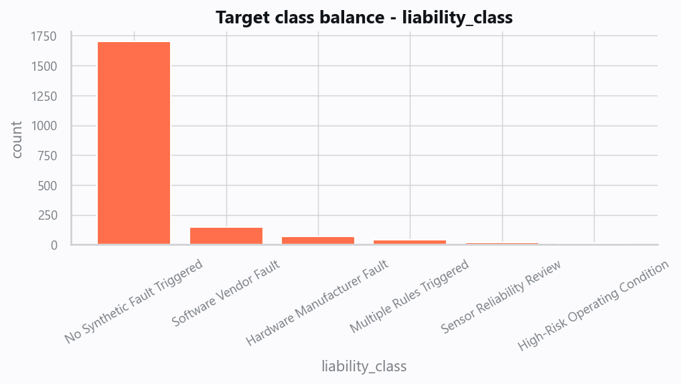
05_target.png
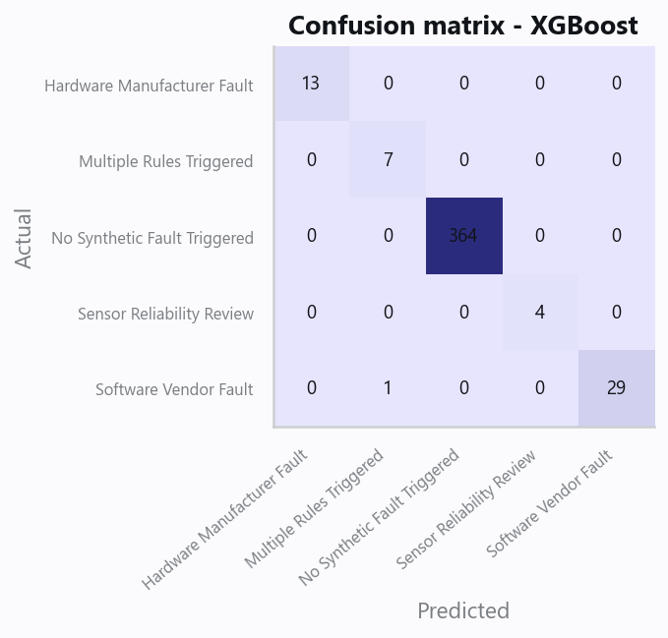
10_confusion.png
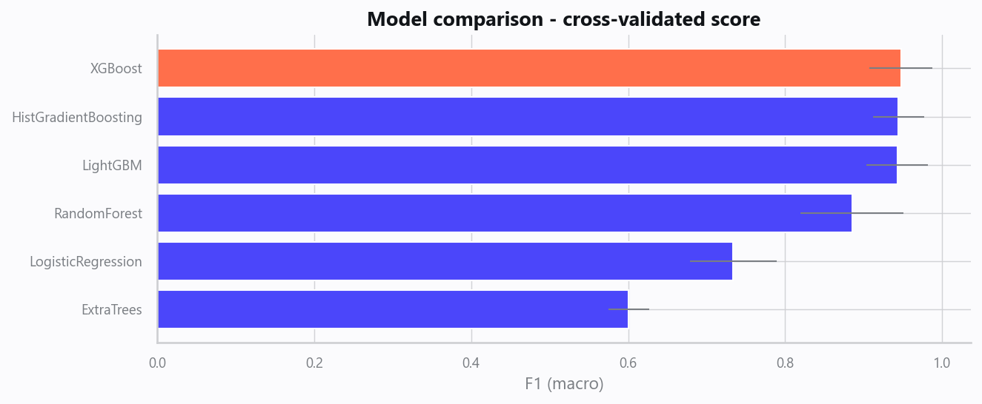
12_leaderboard.png
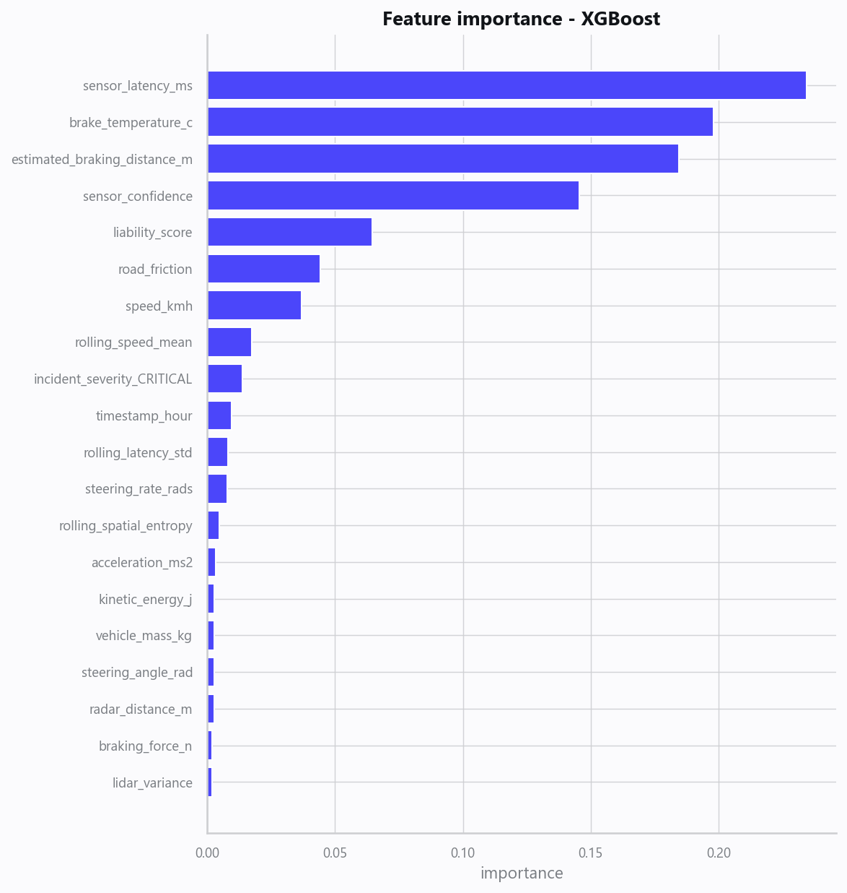
13_feature_importance.png
Interactive map (open in a browser): 20_av_trajectory.html
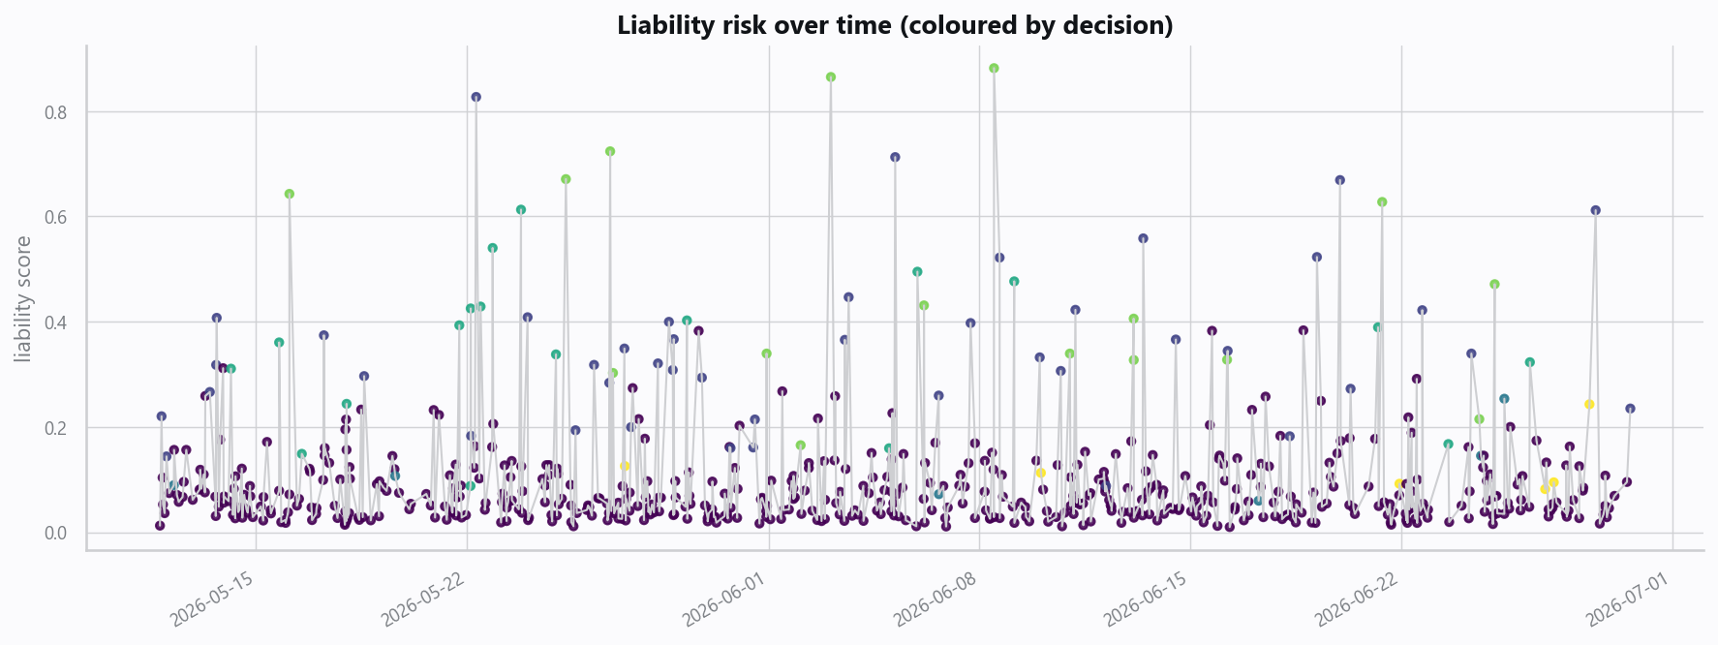
21_av_risk_timeline.png

Domain Rules & Explainable Ground Truth
rule_id | field | operator | threshold | label
AV-001 | sensor_latency_ms | > | 200 | Software Vendor Fault
AV-002 | brake_temperature_c | > | 500 | Hardware Manufacturer Fault
AV-003 | sensor_confidence | < | 0.6 | Sensor Reliability Review
AV-004 | speed_kmh | > | 120 | High-Risk Operating Condition

Limitations, Risks & Next Steps
- Results reflect the data supplied and the assumptions above; validate on a fresh sample before operational use.
- If the input was capped (see the run configuration), re-run with a larger extract to confirm stability.
- Watch for drift over time and re-train on a schedule; keep the versioned rules and audit hash with each release.

Appendix - Run Configuration
Setting | Value
domain | 1
target_column
max_rows | 0
test_size | 0.2000
cv_folds | 5
split_strategy | auto
enable_tuning | False
enable_deep_learning | False
compliance_mode | True
dataset_format | csv

