Finance, Audit & Accounting Analytics
Config-driven data science pipeline for high-fidelity industrial domains.

Field | Value
Domain | 10 - Finance, Audit & Accounting Analytics
Generated | 2026-10-09 02:38 UTC
Target | is_anomalous
Task | classification
Data source | synthetic sandbox (constrained)
Records x columns | 5000 x 34
Audit SHA-256 | 2c5102b8f3993a7534baab8c730fe8a14e7f8baa2835e354fe7d36645d2b86b5

Contents
Right-click here and choose 'Update Field' to build the table of contents.

Executive Summary
Resident AI offline - a local summary follows instead.
- project: Finance, Audit & Accounting Analytics
- domain: Finance, Audit & Accounting Analytics
- task: classification
- best_model: RandomForest
- accuracy: 0.9848
- balanced_accuracy: 0.8856
- precision_weighted: 0.9842
- recall_weighted: 0.9848
- f1_weighted: 0.9842
- precision_macro: 0.9466
- recall_macro: 0.8856
- f1_macro: 0.9136
- cohen_kappa: 0.8272
- matthews_corrcoef: 0.8299
Interpretation: review the strongest metric first, then check the weakest one for signs of bias, leakage or under-fitting before trusting the model.

Key Metrics at a Glance
Metric | Value
Best model | RandomForest
Selection metric | f1_macro
Cross-validated score | 0.9211
accuracy | 0.9848
balanced_accuracy | 0.8856
precision_weighted | 0.9842
recall_weighted | 0.9848
f1_weighted | 0.9842
precision_macro | 0.9466
recall_macro | 0.8856
f1_macro | 0.9136
cohen_kappa | 0.8272
matthews_corrcoef | 0.8299
Deployment allowed | True

Data & Methodology
The pipeline ingested 5000 records across 34 columns from synthetic sandbox (constrained). A constrained synthetic sandbox was used when no real source was supplied.
Target: is_anomalous | Task: classification | Split strategy: group. Numeric features receive robust scaling, categoricals are encoded, and the preprocessor is fitted on the training split only.
- Best model by cross-validated f1_macro: RandomForest.

Exploratory Data Analysis

Statistical moments
feature | count | mean | std | min | 25% | 50%
account_code | 5000.0 | 5465.1016 | 2610.475430888499 | 1000.0 | 3169.75 | 5451.0
amount | 5000.0 | 9593.829804532328 | 56807.50687620975 | 30.5 | 718.0 | 1481.2649999999999
days_to_period_end | 5000.0 | 14.768 | 8.900405577494139 | 0.0 | 7.0 | 15.0
is_anomalous | 5000.0 | 0.06 | 0.23751059398782887 | 0.0 | 0.0 | 0.0
amount_abs | 5000.0 | 9593.829804532328 | 56807.50687620975 | 30.5 | 718.0 | 1481.2649999999999
is_round_100 | 5000.0 | 0.0122 | 0.10978875495305898 | 0.0 | 0.0 | 0.0
is_round_1000 | 5000.0 | 0.0122 | 0.10978875495305898 | 0.0 | 0.0 | 0.0
just_below_threshold | 5000.0 | 0.0198 | 0.13932638791152843 | 0.0 | 0.0 | 0.0
is_manual | 5000.0 | 0.1826 | 0.38637688520340335 | 0.0 | 0.0 | 0.0
is_period_end | 5000.0 | 0.1074 | 0.3096520900678319 | 0.0 | 0.0 | 0.0
is_weekend | 5000.0 | 0.2914 | 0.4544527978449399 | 0.0 | 0.0 | 0.0
amount_first_digit | 5000.0 | 3.4972 | 2.551096583580432 | 1.0 | 1.0 | 3.0

Model Performance

Model leaderboard
model | cv_score_mean | cv_score_std | fit_seconds | accuracy | balanced_accuracy | precision_weighted | recall_weighted | f1_weighted | precision_macro | recall_macro | f1_macro | cohen_kappa | matthews_corrcoef | roc_auc | log_loss
RandomForest | 0.9211 | 0.0088 | 3.63 | 0.9848 | 0.8856 | 0.9842 | 0.9848 | 0.9842 | 0.9466 | 0.8856 | 0.9136 | 0.8272 | 0.8299 | 0.9938 | 0.0442
LightGBM | 0.9196 | 0.0165 | 1.23 | 0.9858 | 0.8958 | 0.9853 | 0.9858 | 0.9854 | 0.9482 | 0.8958 | 0.9202 | 0.8404 | 0.8424 | 0.9956 | 0.0479
LogisticRegression | 0.9189 | 0.0072 | 4.13 | 0.9868 | 0.8964 | 0.9864 | 0.9868 | 0.9863 | 0.959 | 0.8964 | 0.9251 | 0.8503 | 0.8531 | 0.9963 | 0.0379
HistGradientBoosting | 0.9155 | 0.0134 | 1.63 | 0.9858 | 0.9055 | 0.9854 | 0.9858 | 0.9855 | 0.9397 | 0.9055 | 0.9218 | 0.8436 | 0.8445 | 0.9944 | 0.0558
ExtraTrees | 0.9149 | 0.009 | 1.55 | 0.9868 | 0.8964 | 0.9864 | 0.9868 | 0.9863 | 0.959 | 0.8964 | 0.9251 | 0.8503 | 0.8531 | 0.9942 | 0.0414
XGBoost | 0.9144 | 0.0085 | 0.77 | 0.9838 | 0.9044 | 0.9835 | 0.9838 | 0.9836 | 0.9207 | 0.9044 | 0.9124 | 0.8248 | 0.825 | 0.9936 | 0.0558

Robustness & Compliance

Deployment gates
Check | Value
boundary_accuracy | 0.9231
abstention_accuracy | 1.0000
leakage_rate | 0.0000
gate:performance_pass | True
gate:recall_pass | True
gate:privacy_pass | True
gate:boundary_pass | True
gate:deployment_allowed | True
gate:note | All gates satisfied - safe to proceed with human oversight.

Figures

Charts and maps
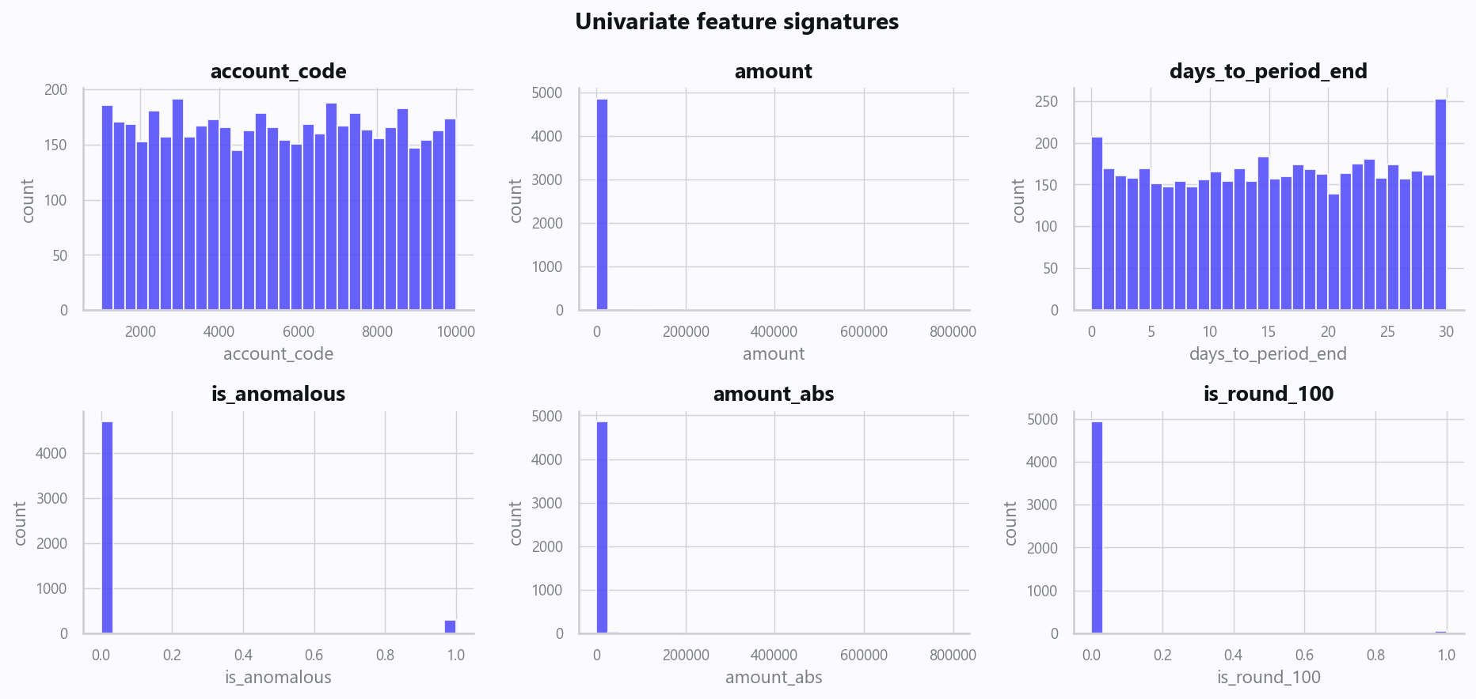
02_distributions.png
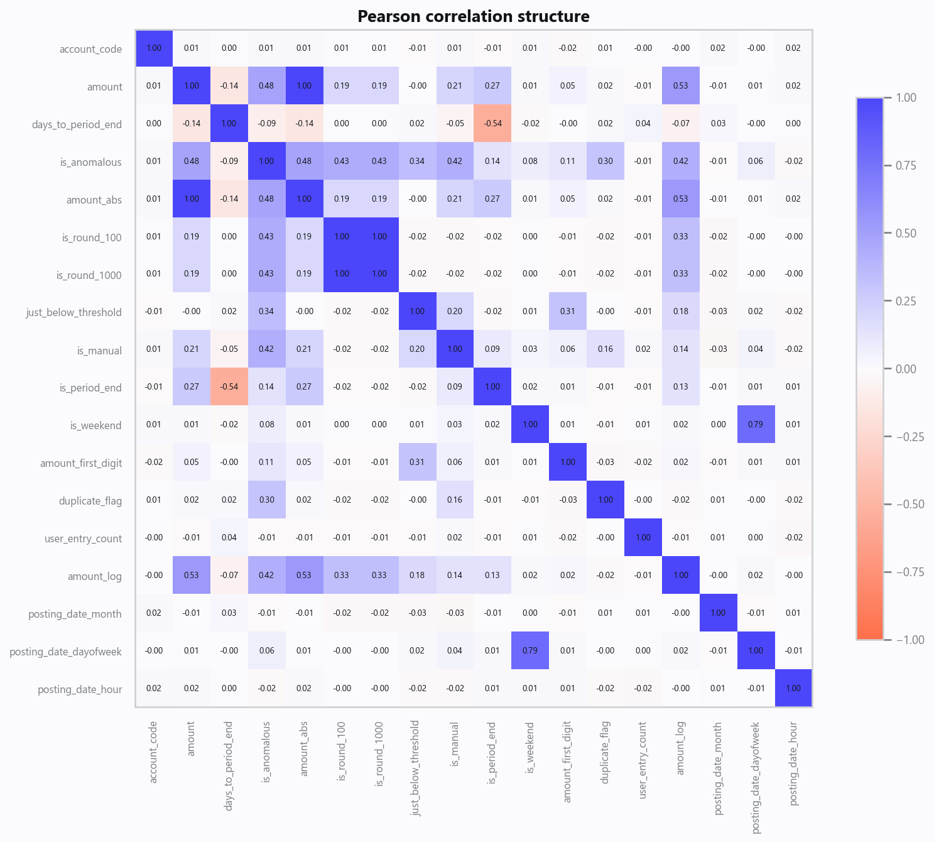
03_correlation.png
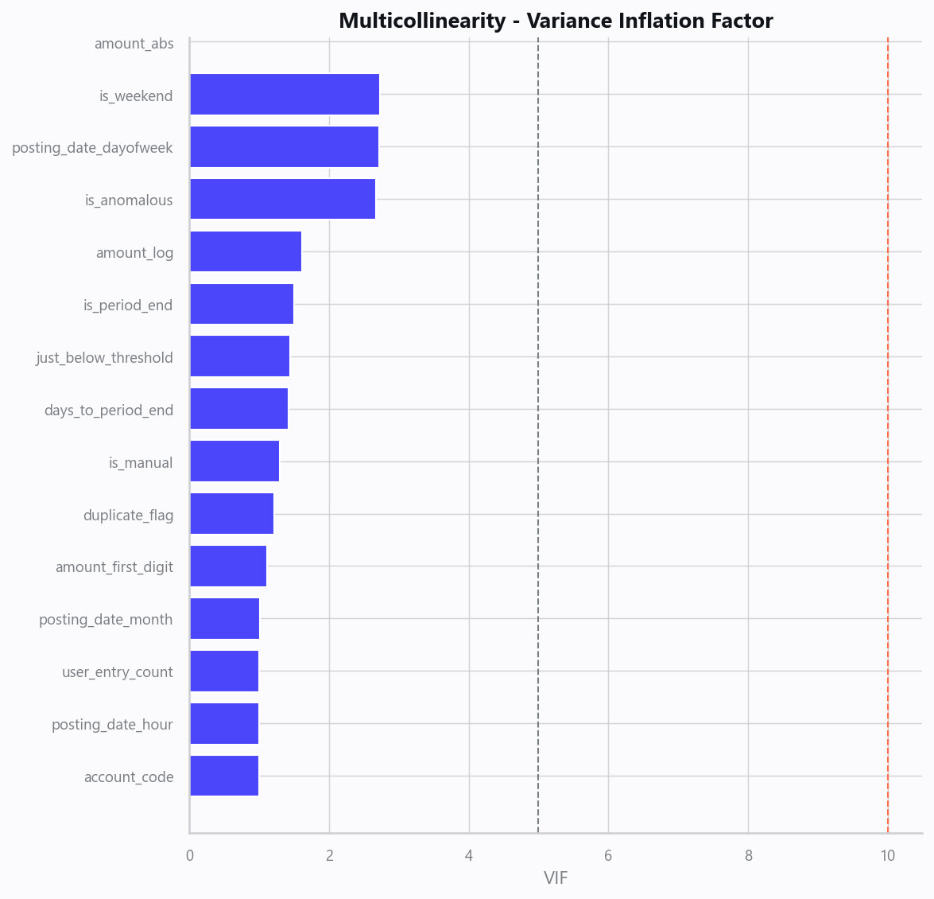
04_vif.png
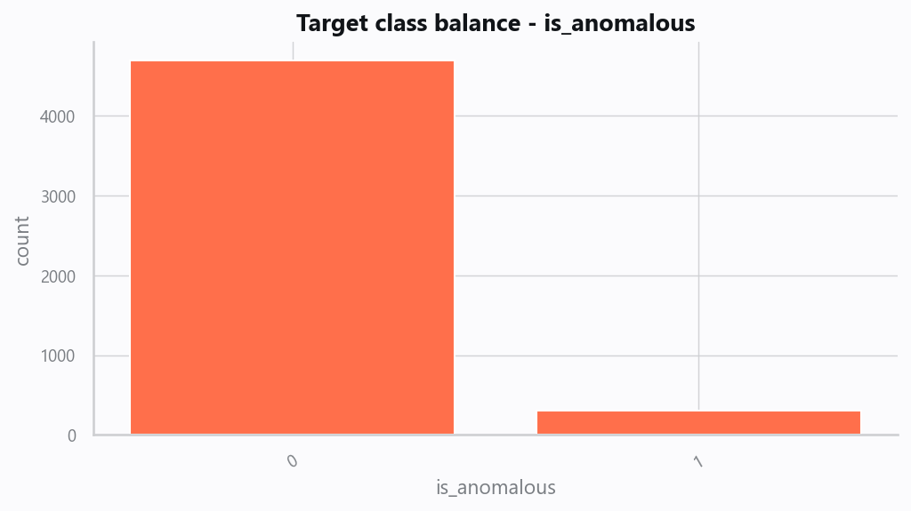
05_target.png
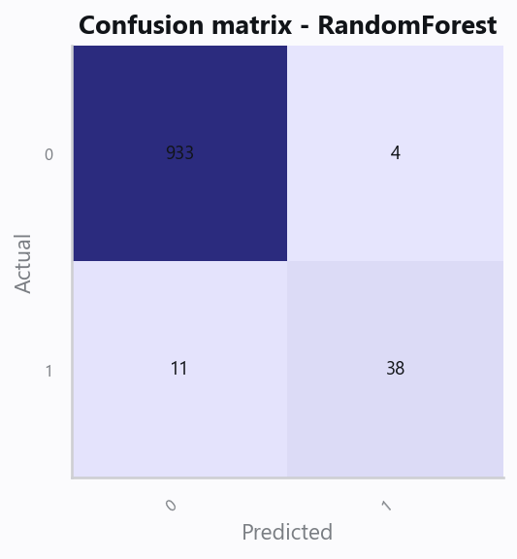
10_confusion.png
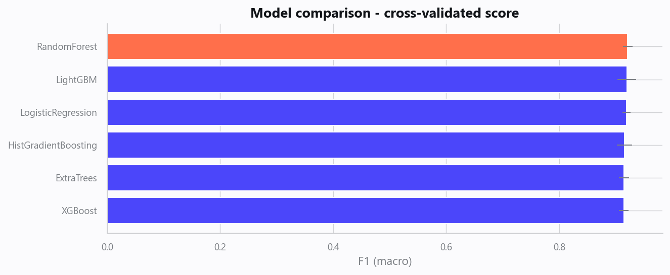
12_leaderboard.png
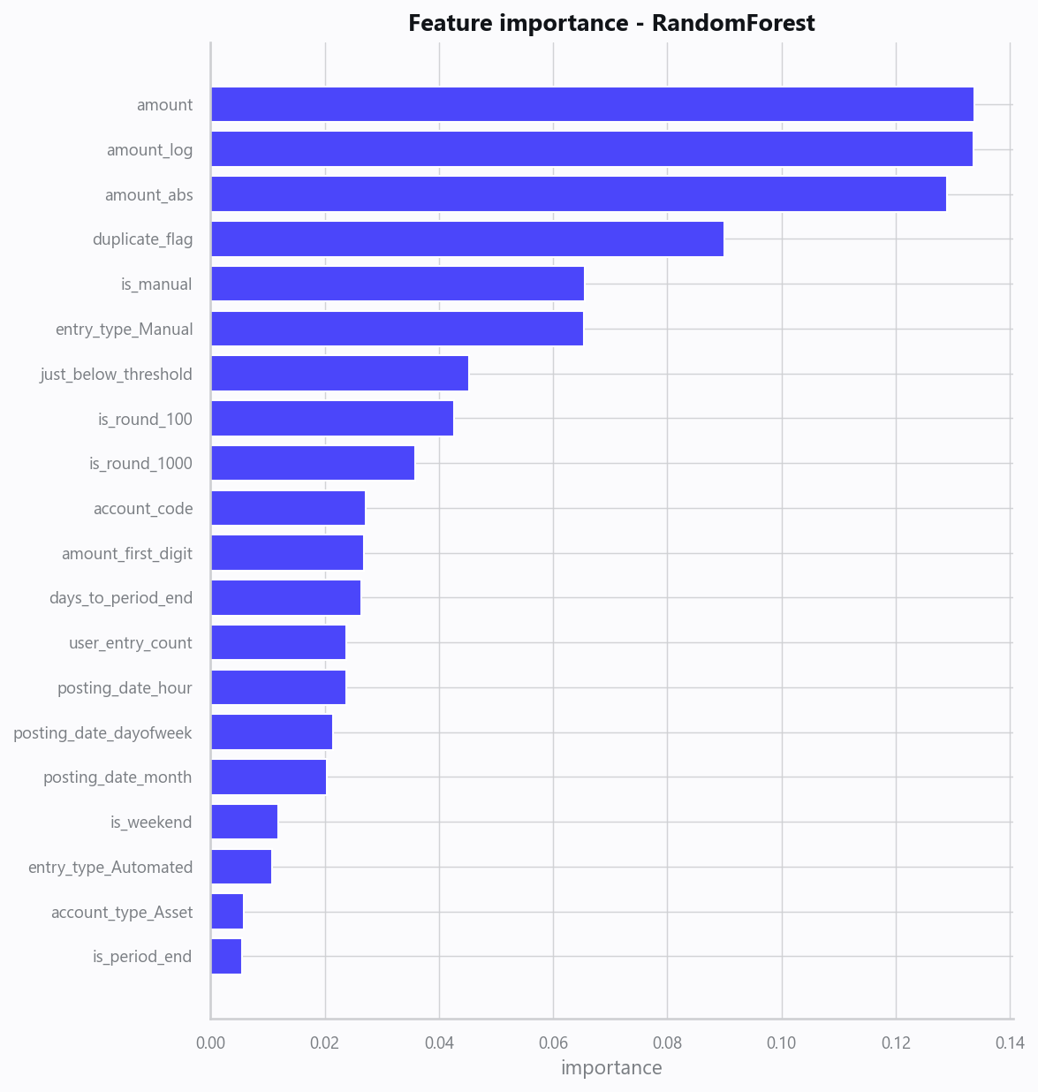
13_feature_importance.png
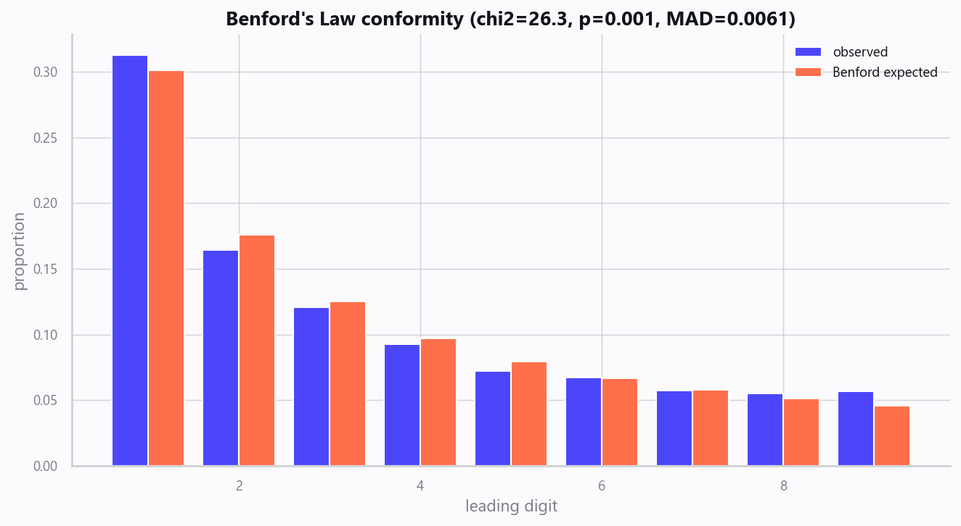
20_benford_law.png
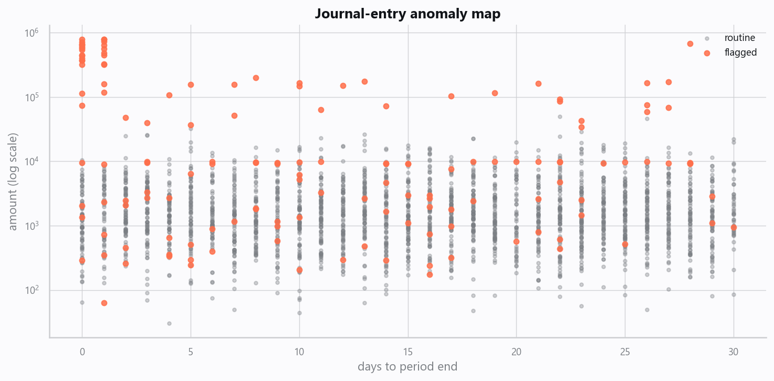
21_anomaly_map.png

Domain Rules & Explainable Ground Truth
rule_id | field | operator | threshold | label
AUD-001 | amount_abs | > | 50000 | Large Manual Period-End Entry
AUD-002 | duplicate_flag | == | 1 | Potential Duplicate Payment
AUD-003 | just_below_threshold | == | 1 | Just-Below-Approval-Threshold
AUD-004 | is_weekend | == | 1 | Weekend Manual Posting
AUD-005 | is_round_1000 | == | 1 | Large Round-Number Amount

Limitations, Risks & Next Steps
- Results reflect the data supplied and the assumptions above; validate on a fresh sample before operational use.
- If the input was capped (see the run configuration), re-run with a larger extract to confirm stability.
- Watch for drift over time and re-train on a schedule; keep the versioned rules and audit hash with each release.

Appendix - Run Configuration
Setting | Value
domain | 10
target_column
max_rows | 0
test_size | 0.2000
cv_folds | 5
split_strategy | auto
enable_tuning | True
enable_deep_learning | False
compliance_mode | True
dataset_format | csv

