Credit Card Fraud - Full Dataset
Config-driven data science pipeline for high-fidelity industrial domains.

Field | Value
Domain | auto - Generic / Auto-detect (any tabular dataset)
Generated | 2026-10-09 03:48 UTC
Target | Class
Task | classification
Data source | kaggle/archive/creditcard.csv
Records x columns | 284807 x 31
Audit SHA-256 | 22df805a5309162805d53129d433c2660f1cf39b81117c0bf51d571b915ed644

Contents
Right-click here and choose 'Update Field' to build the table of contents.

Executive Summary
Resident AI offline - a local summary follows instead.
- project: Credit Card Fraud - Full Dataset
- domain: Generic / Auto-detect (any tabular dataset)
- task: classification
- best_model: RandomForest
- accuracy: 0.9996
- balanced_accuracy: 0.9132
- precision_weighted: 0.9996
- recall_weighted: 0.9996
- f1_weighted: 0.9996
- precision_macro: 0.9708
- recall_macro: 0.9132
- f1_macro: 0.9401
- cohen_kappa: 0.8802
- matthews_corrcoef: 0.8821
Interpretation: review the strongest metric first, then check the weakest one for signs of bias, leakage or under-fitting before trusting the model.

Key Metrics at a Glance
Metric | Value
Best model | RandomForest
Selection metric | f1_macro
Cross-validated score | 0.9255
accuracy | 0.9996
balanced_accuracy | 0.9132
precision_weighted | 0.9996
recall_weighted | 0.9996
f1_weighted | 0.9996
precision_macro | 0.9708
recall_macro | 0.9132
f1_macro | 0.9401
cohen_kappa | 0.8802
matthews_corrcoef | 0.8821
Deployment allowed | True

Data & Methodology
The pipeline ingested 284807 records across 31 columns from kaggle/archive/creditcard.csv.
Target: Class | Task: classification | Split strategy: stratified. Numeric features receive robust scaling, categoricals are encoded, and the preprocessor is fitted on the training split only.
- Best model by cross-validated f1_macro: RandomForest.

Exploratory Data Analysis

Statistical moments
feature | count | mean | std | min | 25% | 50%
Time | 284807.0 | 94813.8596 | 47488.146 | 0.0 | 54201.5 | 84692.0
V1 | 284807.0 | 0.0 | 1.9587 | -56.4075 | -0.9204 | 0.0181
V2 | 284807.0 | 0.0 | 1.6513 | -72.7157 | -0.5985 | 0.0655
V3 | 284807.0 | -0.0 | 1.5163 | -48.3256 | -0.8904 | 0.1798
V4 | 284807.0 | 0.0 | 1.4159 | -5.6832 | -0.8486 | -0.0198
V5 | 284807.0 | 0.0 | 1.3802 | -113.7433 | -0.6916 | -0.0543
V6 | 284807.0 | 0.0 | 1.3323 | -26.1605 | -0.7683 | -0.2742
V7 | 284807.0 | -0.0 | 1.2371 | -43.5572 | -0.5541 | 0.0401
V8 | 284807.0 | 0.0 | 1.1944 | -73.2167 | -0.2086 | 0.0224
V9 | 284807.0 | -0.0 | 1.0986 | -13.4341 | -0.6431 | -0.0514
V10 | 284807.0 | 0.0 | 1.0888 | -24.5883 | -0.5354 | -0.0929
V11 | 284807.0 | 0.0 | 1.0207 | -4.7975 | -0.7625 | -0.0328

Model Performance

Model leaderboard
model | cv_score_mean | cv_score_std | fit_seconds | accuracy | balanced_accuracy | precision_weighted | recall_weighted | f1_weighted | precision_macro | recall_macro | f1_macro | cohen_kappa | matthews_corrcoef | roc_auc | auprc | log_loss
RandomForest | 0.9255 | 0.0044 | 776.11 | 0.9996 | 0.9132 | 0.9996 | 0.9996 | 0.9996 | 0.9708 | 0.9132 | 0.9401 | 0.8802 | 0.8821 | 0.9617 | 0.8699 | 0.0058
ExtraTrees | 0.9254 | 0.0038 | 277.26 | 0.9996 | 0.9132 | 0.9996 | 0.9996 | 0.9996 | 0.9763 | 0.9132 | 0.9425 | 0.8851 | 0.8873 | 0.9615 | 0.8759 | 0.0057
XGBoost | 0.9086 | 0.0116 | 8.91 | 0.9995 | 0.8979 | 0.9995 | 0.9995 | 0.9995 | 0.9533 | 0.8979 | 0.9238 | 0.8476 | 0.8494 | 0.9242 | 0.7925 | 0.005
LogisticRegression | 0.8664 | 0.0065 | 6.24 | 0.9992 | 0.8213 | 0.9991 | 0.9992 | 0.9991 | 0.9142 | 0.8213 | 0.8619 | 0.7237 | 0.7296 | 0.9592 | 0.7429 | 0.0045
HistGradientBoosting | 0.798 | 0.0239 | 4.09 | 0.9983 | 0.8922 | 0.9988 | 0.9983 | 0.9985 | 0.7514 | 0.8922 | 0.8063 | 0.6127 | 0.6281 | 0.835 | 0.634 | 0.0254
LightGBM | 0.6778 | 0.0178 | 8.15 | 0.9973 | 0.8 | 0.9982 | 0.9973 | 0.9977 | 0.6702 | 0.8 | 0.717 | 0.4342 | 0.4519 | 0.7546 | 0.2564 | 0.0829

Robustness & Compliance

Deployment gates
Check | Value
boundary_accuracy | n/a
abstention_accuracy | n/a
leakage_rate | 0.0000
gate:performance_pass | True
gate:recall_pass | True
gate:privacy_pass | True
gate:boundary_pass | True
gate:deployment_allowed | True
gate:note | All gates satisfied - safe to proceed with human oversight.

Figures

Charts and maps
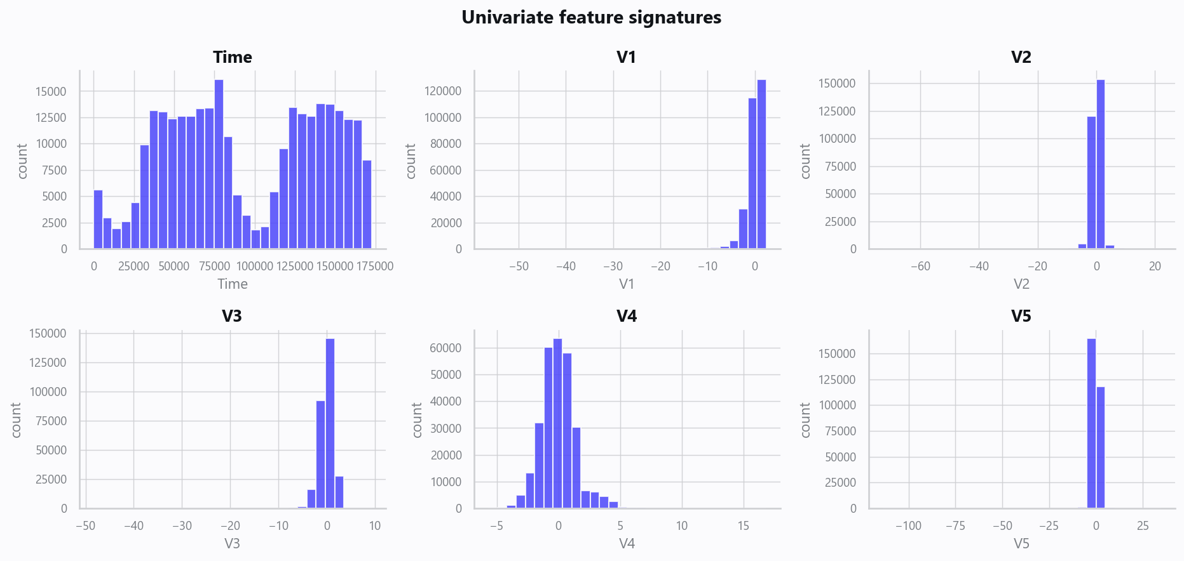
02_distributions.png
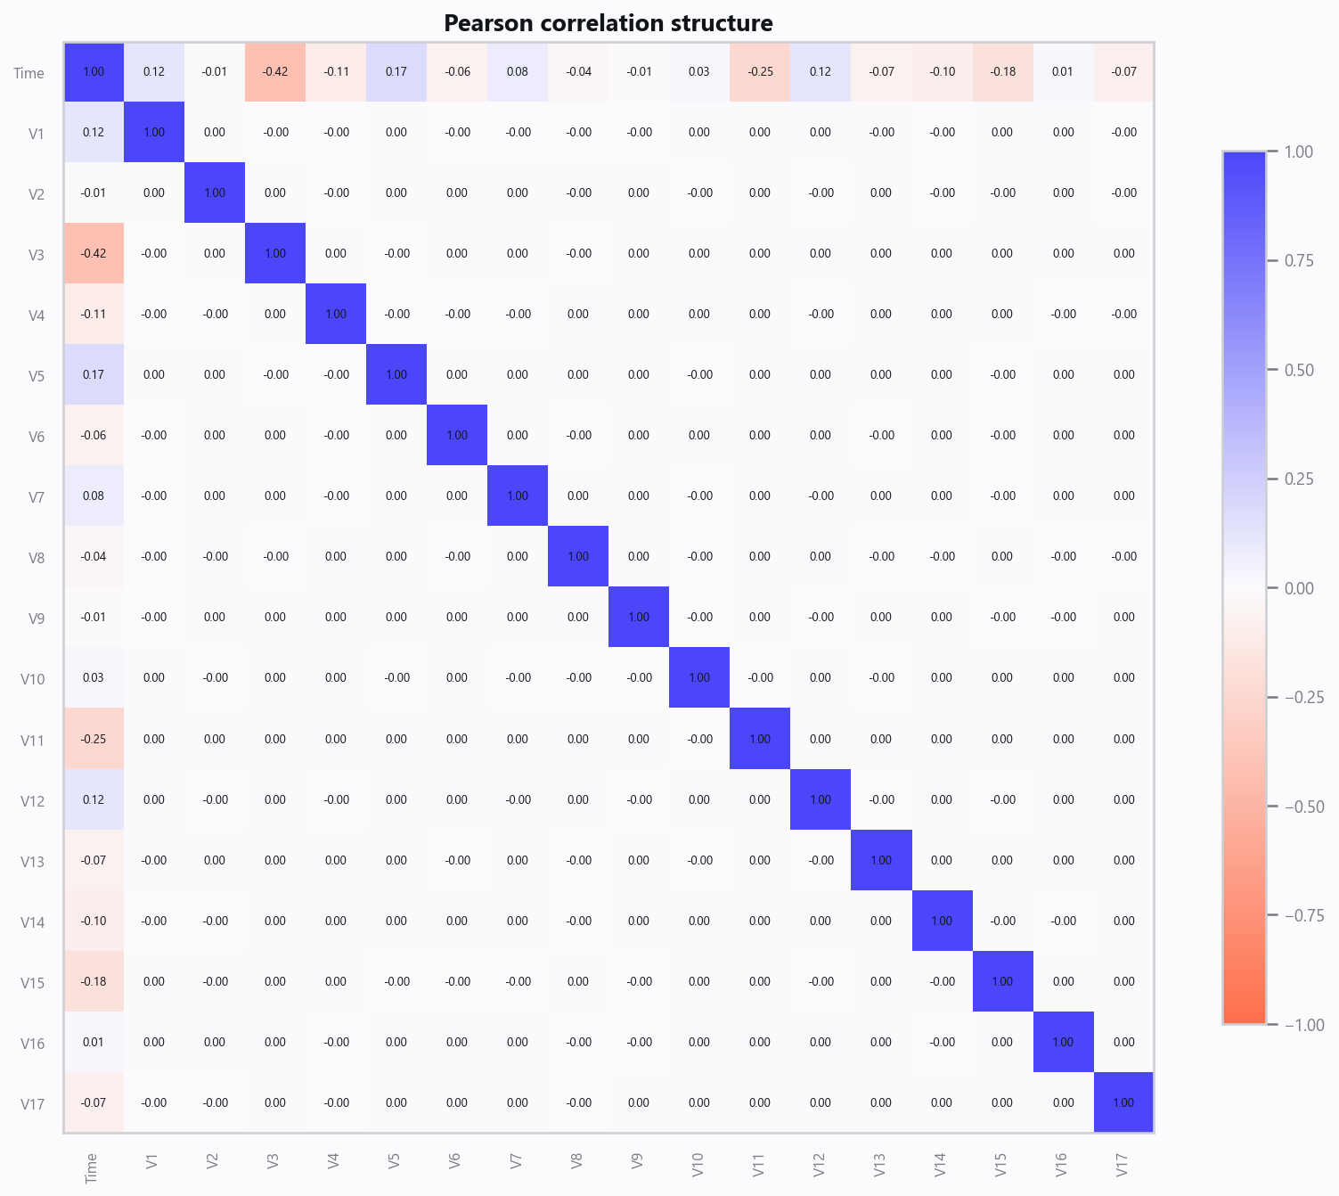
03_correlation.png
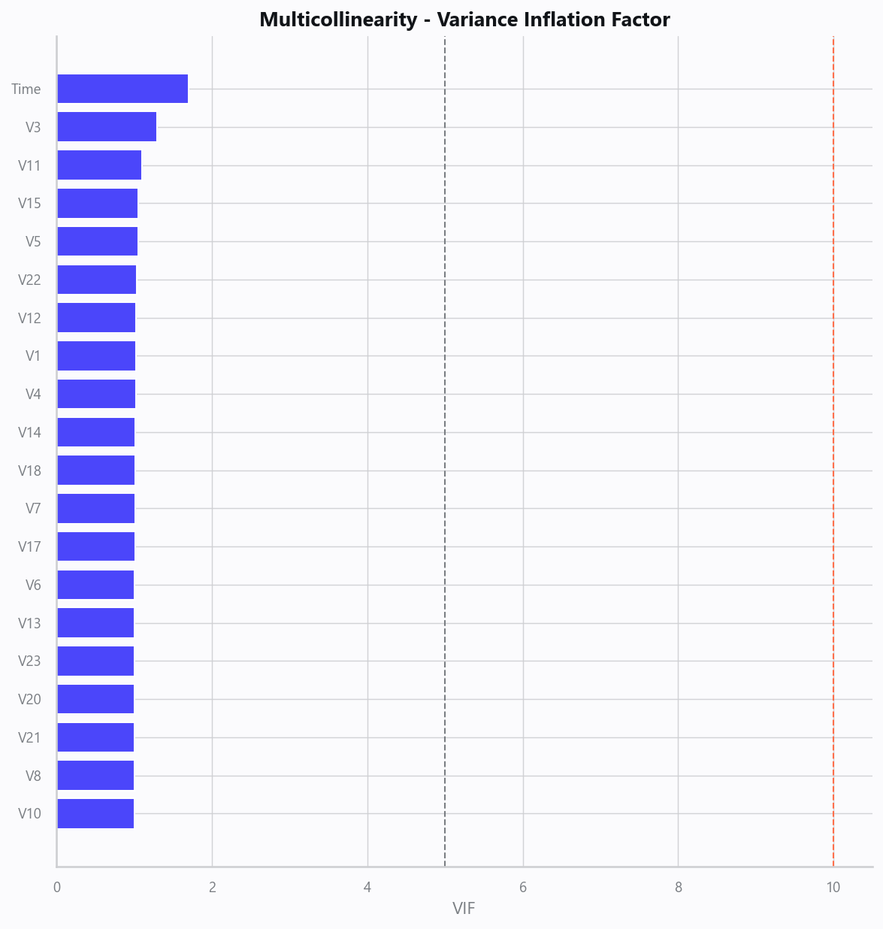
04_vif.png
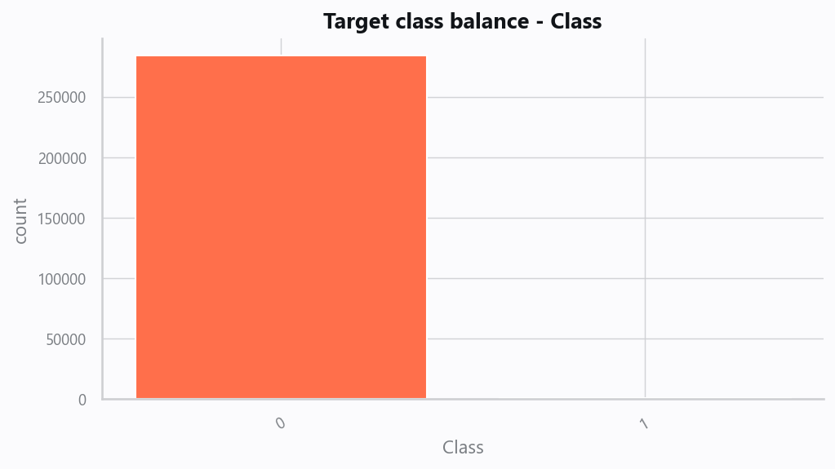
05_target.png
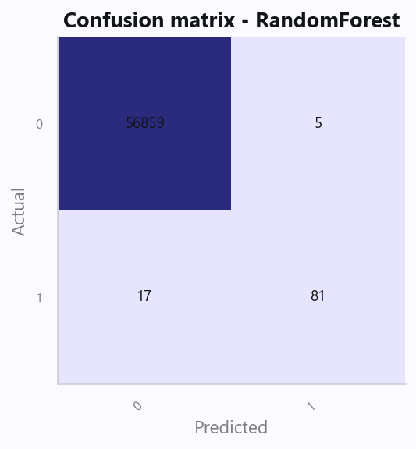
10_confusion.png
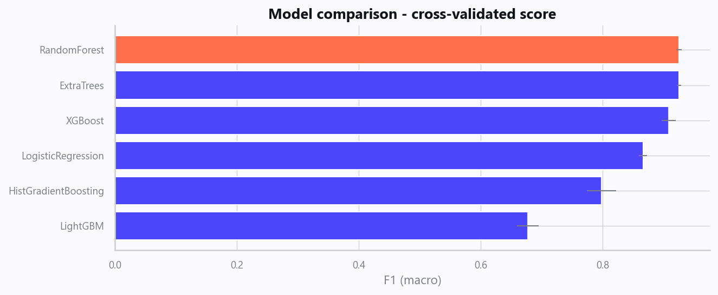
12_leaderboard.png
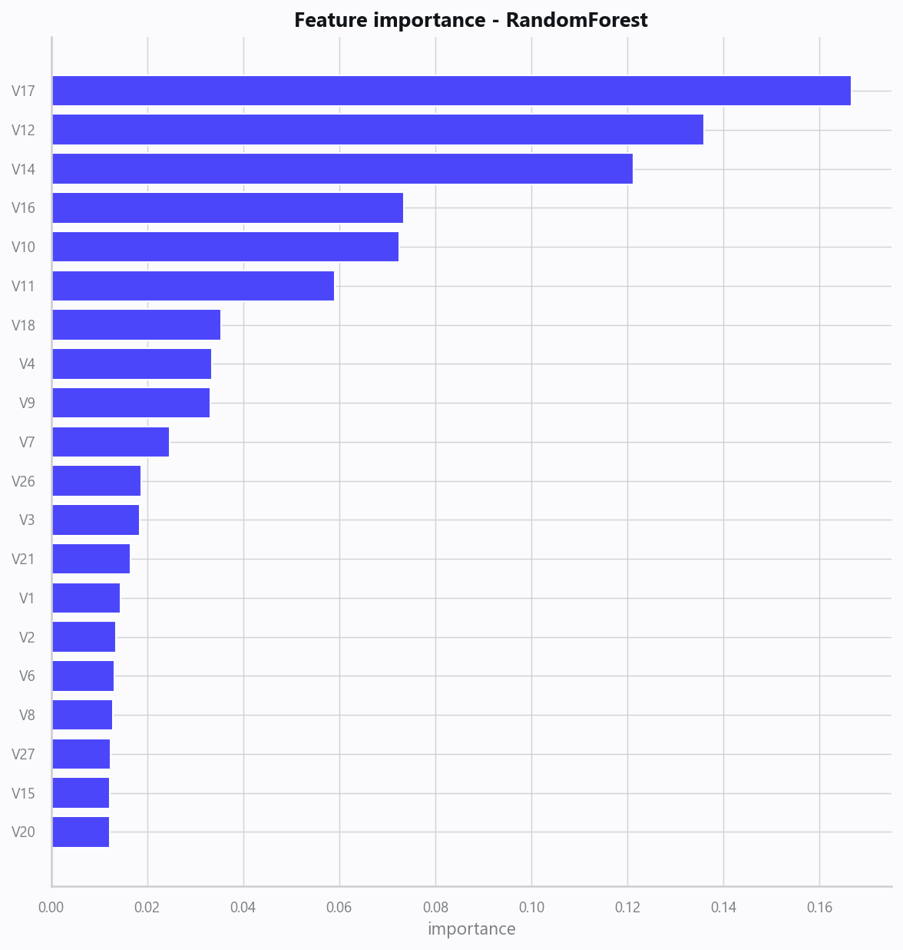
13_feature_importance.png

Limitations, Risks & Next Steps
- Results reflect the data supplied and the assumptions above; validate on a fresh sample before operational use.
- If the input was capped (see the run configuration), re-run with a larger extract to confirm stability.
- Watch for drift over time and re-train on a schedule; keep the versioned rules and audit hash with each release.

Appendix - Run Configuration
Setting | Value
domain | auto
target_column | Class
max_rows | 0
test_size | 0.2000
cv_folds | 5
split_strategy | auto
enable_tuning | False
enable_deep_learning | False
compliance_mode | True
dataset_format | csv

