AI Usage and Impact
Config-driven data science pipeline for high-fidelity industrial domains.

Field | Value
Domain | auto - Generic / Auto-detect (any tabular dataset)
Generated | 2026-10-04 03:58 UTC
Target | Would_Recommend
Task | classification
Data source | E:\Trader+\WORKING Files\Todo-PROJECTS\DATA-SCIENCE\backup\archive\AI_Usage_and_Impact_on_Students_and_Professionals.csv
Records x columns | 295 x 19
Audit SHA-256 | f44a8c14dcc8ac0db8b1712ec46e421c88edca23e3873538c22c80b0b8e317ce

Contents
Right-click here and choose 'Update Field' to build the table of contents.

Executive Summary
Resident AI offline - a local summary follows instead.
- project: AI Usage and Impact
- domain: Generic / Auto-detect (any tabular dataset)
- task: classification
- best_model: XGBoost
- accuracy: 0.6102
- balanced_accuracy: 0.5143
- precision_weighted: 0.6010
- recall_weighted: 0.6102
- f1_weighted: 0.6025
- precision_macro: 0.5417
- recall_macro: 0.5143
- f1_macro: 0.5247
- cohen_kappa: 0.2720
- matthews_corrcoef: 0.2743
Interpretation: review the strongest metric first, then check the weakest one for signs of bias, leakage or under-fitting before trusting the model.

Key Metrics at a Glance
Metric | Value
Best model | XGBoost
Selection metric | f1_macro
Cross-validated score | 0.5140
accuracy | 0.6102
balanced_accuracy | 0.5143
precision_weighted | 0.6010
recall_weighted | 0.6102
f1_weighted | 0.6025
precision_macro | 0.5417
recall_macro | 0.5143
f1_macro | 0.5247
cohen_kappa | 0.2720
matthews_corrcoef | 0.2743
Deployment allowed | False

Data & Methodology
The pipeline ingested 295 records across 19 columns from E:\Trader+\WORKING Files\Todo-PROJECTS\DATA-SCIENCE\backup\archive\AI_Usage_and_Impact_on_Students_and_Professionals.csv.
Target: Would_Recommend | Task: classification | Split strategy: stratified. Numeric features receive robust scaling, categoricals are encoded, and the preprocessor is fitted on the training split only.
- Best model by cross-validated f1_macro: XGBoost.

Exploratory Data Analysis

Statistical moments
feature | count | mean | std | min | 25% | 50%
Productivity_Score | 279.0 | 5.2254 | 1.8161 | 1.6 | 3.9 | 5.0
Accuracy_Rating | 280.0 | 3.4321 | 0.8524 | 2.0 | 3.0 | 4.0
Satisfaction_Score | 288.0 | 6.1562 | 1.5187 | 3.0 | 5.0 | 6.0

Model Performance

Model leaderboard
model | cv_score_mean | cv_score_std | fit_seconds | accuracy | balanced_accuracy | precision_weighted | recall_weighted | f1_weighted | precision_macro | recall_macro | f1_macro | cohen_kappa | matthews_corrcoef | roc_auc | log_loss
XGBoost | 0.514 | 0.0938 | 0.71 | 0.6102 | 0.5143 | 0.601 | 0.6102 | 0.6025 | 0.5417 | 0.5143 | 0.5247 | 0.272 | 0.2743 | 0.7414 | 1.3198
HistGradientBoosting | 0.5027 | 0.0618 | 1.55 | 0.5763 | 0.4698 | 0.5605 | 0.5763 | 0.5614 | 0.503 | 0.4698 | 0.4791 | 0.1913 | 0.1954 | 0.7828 | 1.2069
LightGBM | 0.4687 | 0.0729 | 0.85 | 0.6271 | 0.5238 | 0.6207 | 0.6271 | 0.6215 | 0.5424 | 0.5238 | 0.5305 | 0.3132 | 0.3149 | 0.7674 | 0.9798
LogisticRegression | 0.4593 | 0.0643 | 3.73 | 0.6102 | 0.472 | 0.5856 | 0.6102 | 0.5925 | 0.4973 | 0.472 | 0.4788 | 0.2511 | 0.256 | 0.7259 | 0.8973
RandomForest | 0.4488 | 0.0475 | 2.86 | 0.5593 | 0.3651 | 0.4714 | 0.5593 | 0.4993 | 0.3495 | 0.3651 | 0.344 | 0.0692 | 0.0781 | 0.7903 | 0.7635
ExtraTrees | 0.4436 | 0.0551 | 1.08 | 0.6949 | 0.4794 | 0.6179 | 0.6949 | 0.6238 | 0.5139 | 0.4794 | 0.4665 | 0.3261 | 0.4075 | 0.7432 | 0.8084

Robustness & Compliance

Deployment gates
Check | Value
boundary_accuracy | n/a
abstention_accuracy | n/a
leakage_rate | 0.0000
gate:performance_pass | False
gate:recall_pass | False
gate:privacy_pass | True
gate:boundary_pass | True
gate:deployment_allowed | False
gate:note | One or more gates failed - hold deployment and review.

Figures

Charts and maps
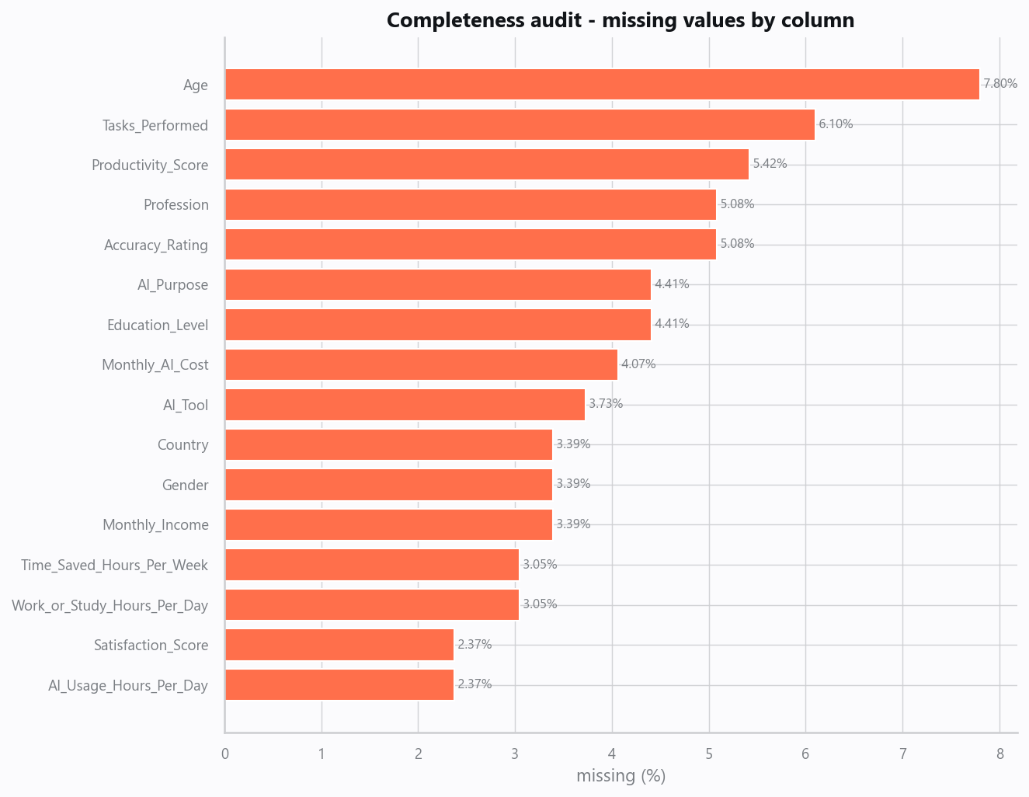
01_missingness.png
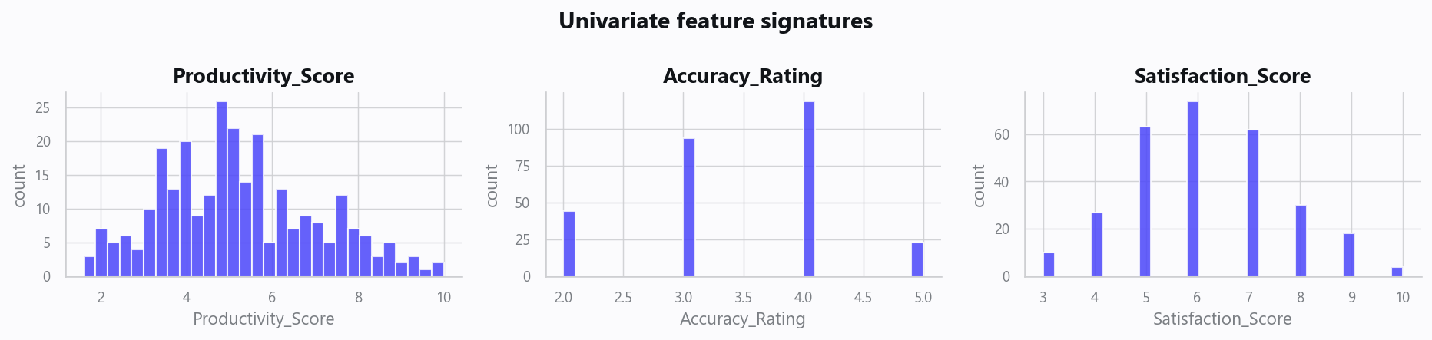
02_distributions.png
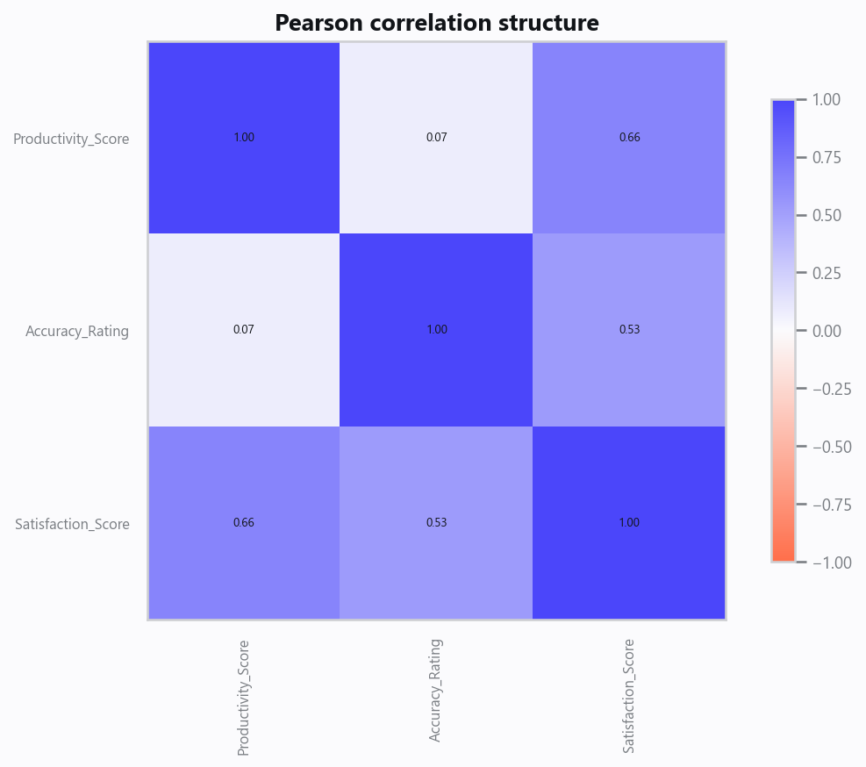
03_correlation.png
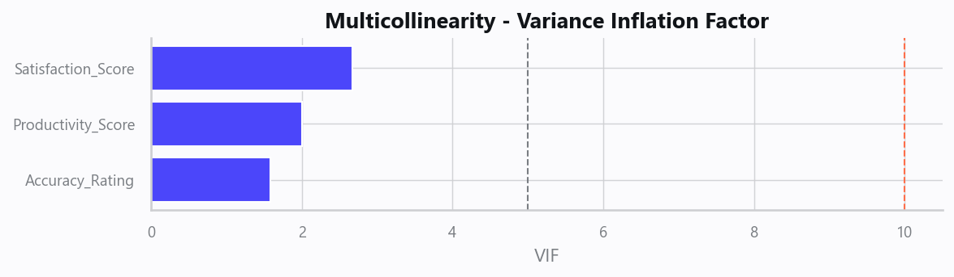
04_vif.png
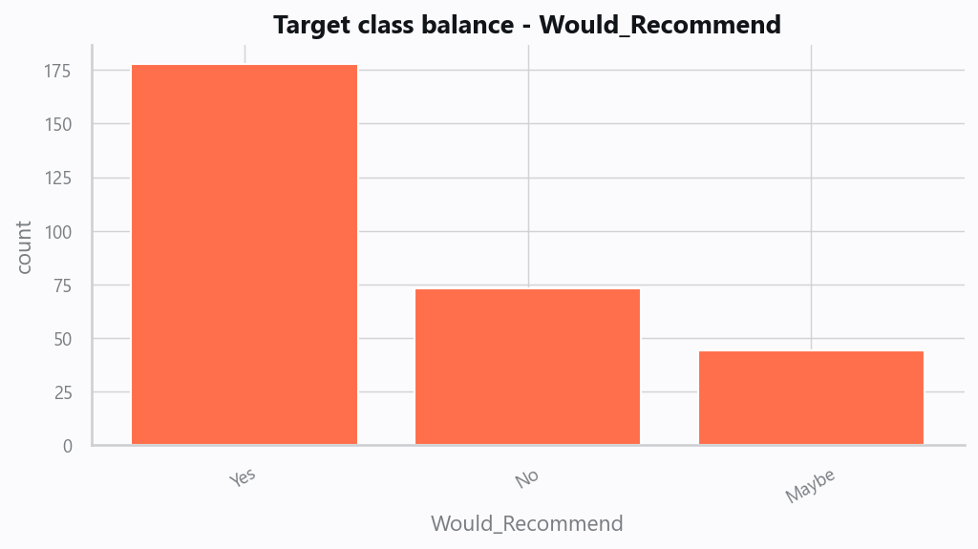
05_target.png
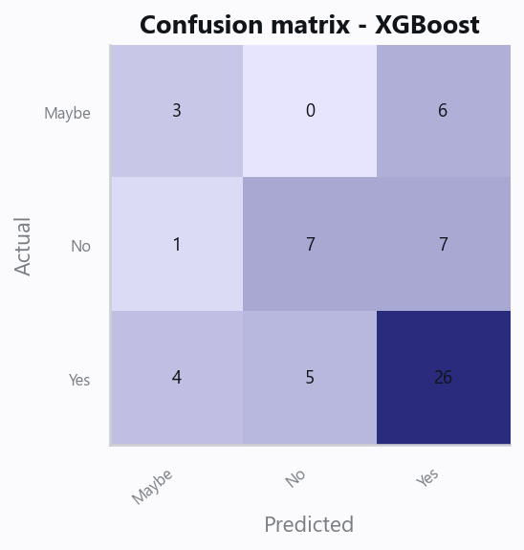
10_confusion.png
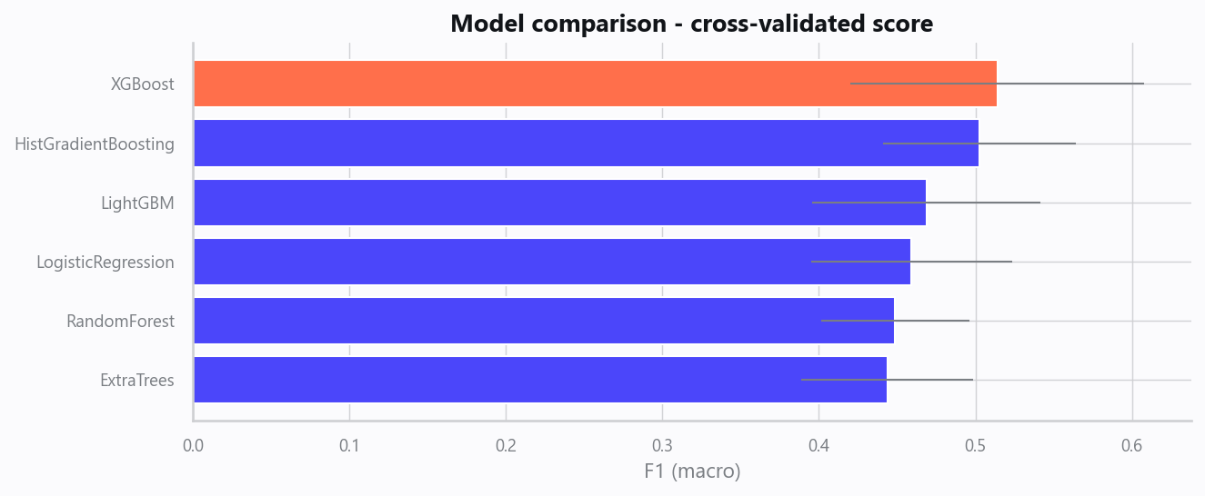
12_leaderboard.png
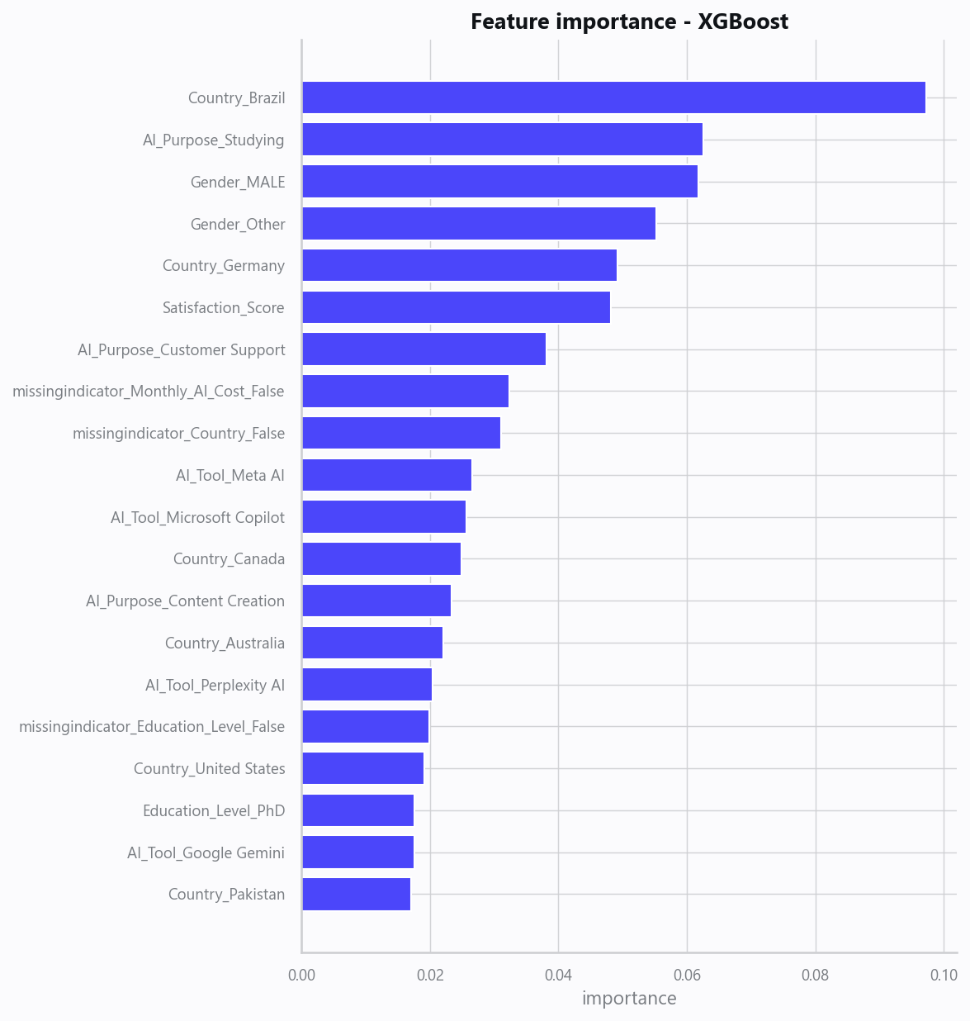
13_feature_importance.png

Limitations, Risks & Next Steps
- Results reflect the data supplied and the assumptions above; validate on a fresh sample before operational use.
- If the input was capped (see the run configuration), re-run with a larger extract to confirm stability.
- Watch for drift over time and re-train on a schedule; keep the versioned rules and audit hash with each release.

Appendix - Run Configuration
Setting | Value
domain | auto
target_column | Would_Recommend
max_rows | 0
test_size | 0.2000
cv_folds | 5
split_strategy | auto
enable_tuning | True
enable_deep_learning | False
compliance_mode | True
dataset_format | csv

